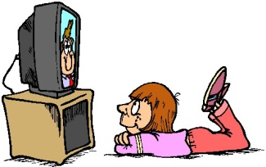
1. Aşağıdaki görsele uygun cümleyi seçiniz.
2017-2018 Eğitim-Öğretim Yılı ……………………………….. Ortaokulu 2. Dönem 5/A Sınıfı İngilizce Dersi 1. Yazılısı
Adı&Soyadı:…………………………………………………………………………………..………. Numarası:……………….

A) I do my homework in the evening.
B) She watches TV at six o’clock.
C) He washes his hands and face.
D)They get dressed.
2. Eksik olan günü bulunuz.
Sunday
……………..
Friday

A)Tuesday B) Wednesday
C) Thursday D) Saturday
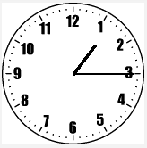
3. Ali: What time is it?
Berat: It is ………………….
A) one o’clock B) half past two
C) quarter past one D) three o’clock
4. Selma: ………………………………………………?
Ece: Turn right. Go straight. Go past the toy shop. It is opposite the play ground.
A) When is your birthday
B) What time do you get up
C) How much is this ticket
D) Where is the supermarket
She is……………………..
5.
A) French B) German
C) Japanese D) Turkish
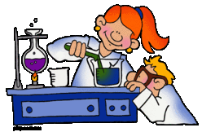
We have …… lesson today.
6.
A) Science B) Music
C) English D) Maths
7. What does she do in her free time?
A) She plays hopscotch.
B) She does origami.
C) She skips rope.
D) She watches TV.
8.What is the matter with him?
A) He has a headache.
B)His throat hurts.
C) He has a broken arm.
D) He has a runny nose.
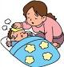
She is ill………………….…….
9.
A) She should go to school.
B) She shouldn’t see a doctor.
C) She should stay at home.
D)She shouldn’t take medicine.
10. Esma: ……………………………….?
Emin:İtfaiyeci Sam. Let’s watch together.
A) What is on TV
B) What should I do
C) How much is it
D) How do you feel
11. Mary:………….……………………..?
Ann: It’s about a man’s adventures.
A) Who are the main characters
B) What is on TV
C) What is it about
D) What time is that movie
12. John: ……………………………………?
Bill: I like animations.
A) What type of movies do you like
B) What is your favorite animation
C)What do you think about Chihiro
D) What time is this animation
13.Metinde hangisinden bahsedilmemiştir?
Dora has a birthday party. She needs a cake, candles, gifts and guests for it.

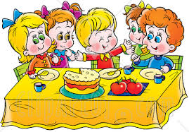
A) B)
C) D)

14. Adam:…………………………………..?
Bill: It’s on 13th November.
A) What is your name
B) How old are you
C) When is your birthday
D)What time is it
15. Eksik olan ayı bulunuz.
May
…………………
March
A) February B) October C) June D) April
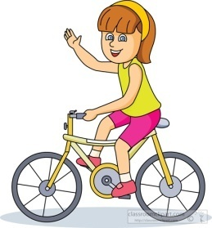
16.
I can ………………………..
A) ride a bike B) swim
C) skateboard D) ski

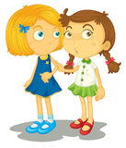
17.
……………………………..?
I’m sorry, I can’t. I don’t like cycling. What about hiking?

A) Would you like to go swimming
B) Let’s go shopping
C) Why don’t we play soccer
D) Shall we ride a bike
18-20. soruları aşağıdaki paragrafa göre yapınız.
18. Mark’s ………….……… doesn’t like hiking.
I’m Mark and this is my family; my mom, my dad, my brothers, my sister and me. We like doing different sports activities. My dad likes hiking, but my mom doesn’t. She loves ice-skating. Jim loves riding a bike, but Steve doesn’t. His favourite activity is playing football. Ann likes playing basketball. I like all sports activities, but my favourite activity is roller skating. I think roller-skating is fun and exciting.

A) mom B) dad C) brother D) sister

19. Steve likes ……………………………………….
A) riding a bike B) ice-skating
C) roller- skating C) playing football

20. How many people are there in Mark’s family?
A) 4B)5C)6D)7

