[](http://img52.imageshack.us/img52/6400/10547tq.gif)

**2017-2018 SECONDARY SCHOOL**

**2nd TERM 1st WRITTEN ENGLISH EXAM FOR 5th GRADERS**

**Name and Surname: Class: Number:**

**Name and Surname: Class: Number: Date: **

A. Write the health problems under the pictures. 5×2= 10 pts.

(Resimlerin altına sağlık sorunlarını yazınız.)

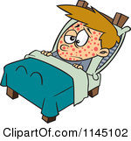

......................... .......................... ......................

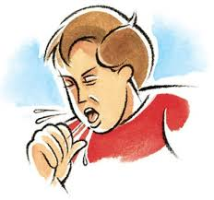

................................ ................................

**___________________________________________**

B. Fill in the blanks with

"*IN, ON or AT* ”. 10x2= 20 pts.

(Boşlukları “ **IN, ON** ya da **AT**” ile doldurunuz.)

1- Children’s Day is …… April.

2- She likes watching romantic movies ….. night.

3- I always have breakfast …... half past 8.

4- Students have lunch ……. the afternoon.

5- Our English exam is …… 7th April.

6- Ceren likes playing dodge ball ........ Friday.

7- Melissa Nur takes the school bus ......... quarter past three.

8- You should do your homework ........ the evening.

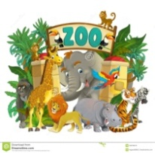9- People have a picknick ....... Saturday and Sunday.

10- We go to the Darıca Zoo

.......... May 22.

C. Answer the questions below.

(Aşağıdaki soruları cevaplayınız.) 5×3= 15 pts.

1- When is your birthday?

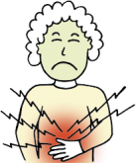....................................................................

2- What is the matter with Melike?

.................................................................

3- What time is the first lesson in your school?

.............................................................................

4- What is your favourite game?

......................................................................

5- Berk has got a toothache.

What ***should*****/ *shouldn’t*** he do?

......................................................................

**___________________________________________**

D. Complete the chart with seasons and months. 15x1= 15 pts.

(Tabloyu **Mevsimler** ve **Aylar** ile doldurunuz.)

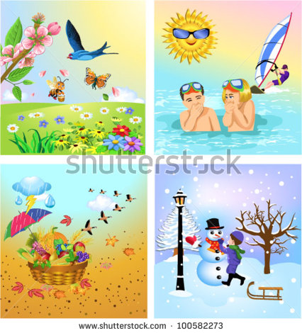

**SEASONS**

**Winter ............ ............ ............**

**MONTHS**

**............ .............. ............. .............**

**............ .............. ............. .............**

**............ .............. ............. .............**

E.Write the ordinal numbers below.

(Aşağıdaki sıra sayılarını yazınız.) 5×2= 10 pts

**17** ¨¨¨ **:...............................**

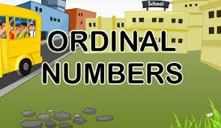

**31**¨¨¨ **:...............................**

**23**¨¨¨ **:................................**

**12**¨¨¨**:...............................**

**4**¨¨¨ **:...............................**

**___________________________________________**

F. Fill in the blanks with the words from the box. 5×2= 10 pts

(Boşlukları kutudaki kelimelerle doldurunuz. )

**CDs – pine tree – Dear – house – New Year’s Party**

......... Friends,

Can you come to my ........................... tomorrow? We dance, sing songs and decorate a ....................... The party starts at 7 p.m. in my ................ Don’t forget to bring some ................

Happy Christmas

**___________________________________________**

G. Choose the best option.

(Doğru seçeneği işaretleyiniz.) 10x2= 20 pts.

1- “ Tom and Jerry” is my favourite ....................

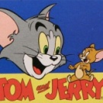a) documentary b) director

c) science- fiction d) cartoon

2- Yasemin has got a birthday party.

She .......... invitation cards to her friends.

a) buys b) sends

c) decorates 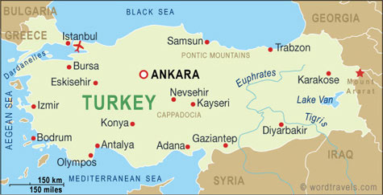 d) prepares

3- **Ali:** ................... is your “pyjamas party” ?

**Kaan:** It is tomorrow.

a) What time b) Where

c) When  d) What

4- My brother doesn’t like musicals**,** ................ he thinks they are boring.

a) dear b) because

c) yesterday d) story

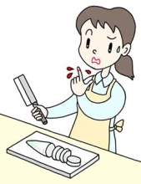5- Nihal has got a cut in her finger.

She needs a ...............

a) blanket b) plaster

c) painkiller d) present

I’ve got a cold, mom!

...............................................

6-



a) You should have a big ice-cream

b) You should go to the school.

c) You should stay in bed today.

d) You should drink cold water

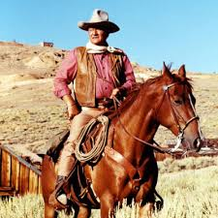7- ................... are very boring. There are always horses, guns and wars in these films. The events mostly happen in Texas.

**Which film is it?**

a) Love movies b) Crime movies

c) Animation movies d) Western movies

8- Özkan is five years old. Today is his birthday. There is five ..................... on the cake.

a) gifts b) candles

c) dresses d) beverages

9- “**Titanic**” is a good romantic film. It is about love. Leanardo Di Caprio and Kate Winslet are the........................... of the film.

a) starrings b) detectives

c) news d) creatures

10- I don’t like horror films because

they are .....................

a) frightening b) entertaining

c) enjoyable d) funny

