2017-2018 EDUCATIONAL YEAR
NECATİ BOLKAN SECONDARY SCHOOL 5th GRADE 2nd TERM 1st EXAM
Name & Surname : Class & Number :

- Resimlerle verilen hastalıkları eşleştiriniz. (5x3=15)

Broken arm – Cough – Runny nose – Headache – Stomachache

 | 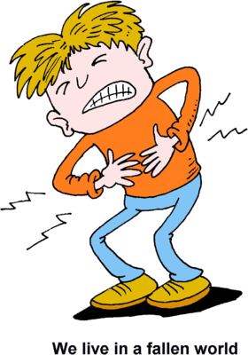 | 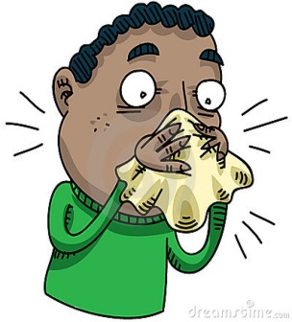 | 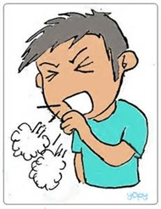 | 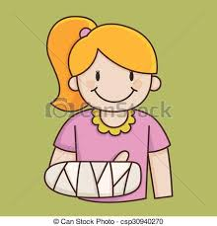

- Aşağıdaki cümlelere should ya da shouldn’t getiriniz.(5x3=15)

- Tom has a toothache. He _______________ eat chocolate.
- We _______________ wash our hands with soap and water.
- I have a sore throat. I ___________________drink cold water.
- We __________________ eat our meal regularly.
- We ___________________ have breakfast every day.

- Verilen soru ve cevapları eşleştiriniz.(5x3=15)

______1. What kind of movies do you like?  ______ 2. What is the movie about?  ______ 3. What is your favorite movie?  ______ 4. What time is the movie?  ______ 5. Do you like horror films? | - It is at 2,30  - It is about students.  - I like comedy films.  - It is Hababam Sınıfı.  - No, I don’t like.
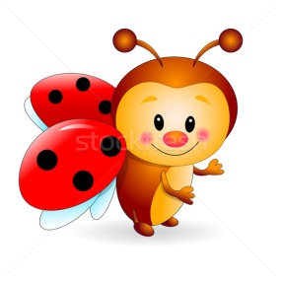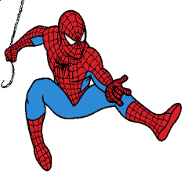
- Verilen film türlerini doğru resmin altına yazınız.(5x3=15)

Horror – Romantic – Comedy – Animation – Science Fiction

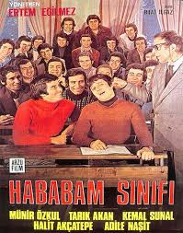 | 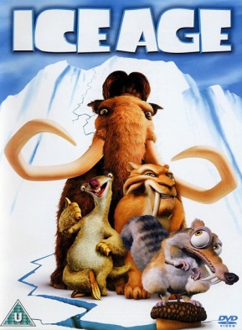 | 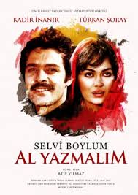 | 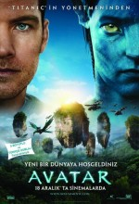 | 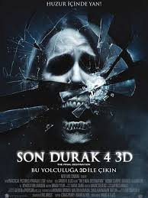

- Verilen cümlelerde koyu renkle yazılan kelimelerden doğru olanı daire içine alınız. (5x3=15)

- I don’t like Garfield because he is lazy / friendly.
- I like seven dwarfs because they are friendly / evil
- Pinocchio is a dishonest / brave character.
- I hate Gargamel because he is funny / evil
- Superman is a lazy / strong character.

- Okla gösterilen vücut bölümlerini yazınız. ( 5x5 =25)

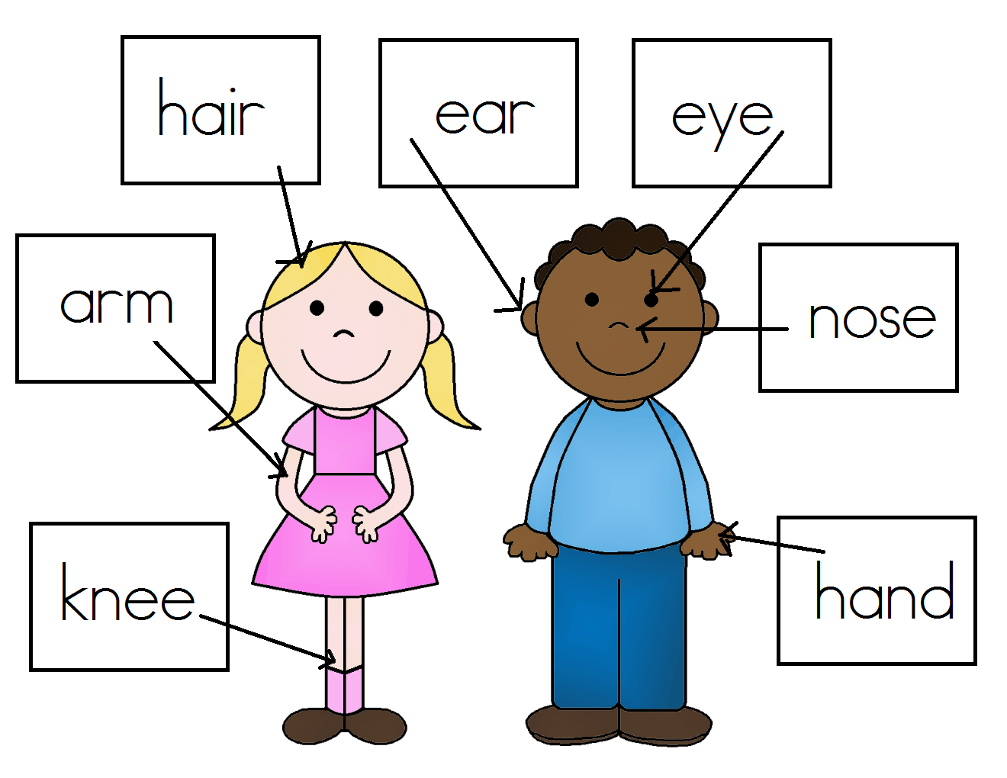
AYLİN ALAV
ENGLISH TEACHER

