**2017-2018 EDUCATION YEAR MALTEPE ÇÖZÜM SECONDARY**

**Name:**

**Surname:**

**SCHOOL 2nd TERM 1st EXAM FOR 5th GRADES**

1. **Match the pictures with the names ( Each question is 2 points.**)

**Horror – Documentary – Comedy – Animation – Science Fiction**

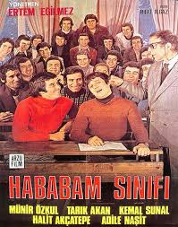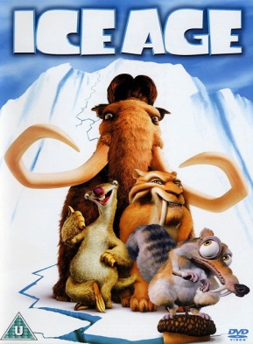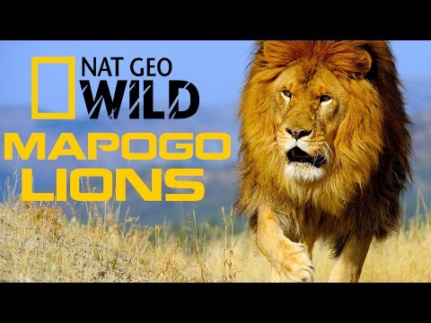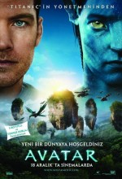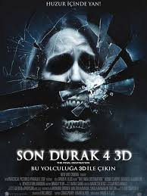

**……………… ……………….. ……………… ……………… ………………**

**B.Write antonyms. ( Each question is 2 points.**)

1. **Hardworking :…………………… 6)Honest : ……………….**
2. **Short :………………….. 7)Brave :………………..**
3. **Weak :………………….. 8)Generous:………………..**
4. **Boring :………………… 9)Sad: ……………………..**
5. **Kind :………………… 10)Evil:…………………….**

**C.Write synonyms ( Each question is 2 points.**)

1. **Frightening : …………………. 5) False :………………….**
2. **Fancy dress party: ………………. 6) Thin : ……………..**
3. **Smart : …………………. 7) Present :……………….**
4. **Enjoyable : ……………………….. 8)Sure :………………..**

**D) Complete the sentences with “in – on – at”) .( Each question is 2 points.**)

**1.** My birthday in ____ March. **2.** His birthday is ____ the 15th of June.

**3.** I get up ____ 7:00 o'clock everyday. **4.** I don't go to school ___sunday.

**5.** Charles's birthday is ____ the 3rd of November.

**E.Answer the questions according to the invitation card.( Each question is 3 points.**)

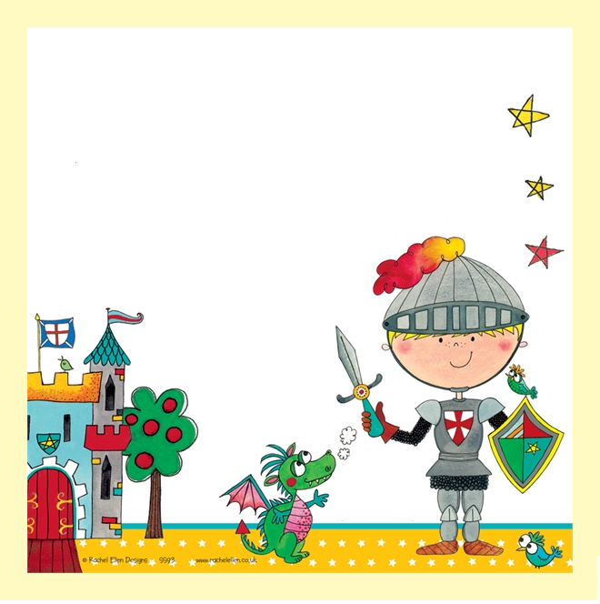

1. Who has the party?

………………………………………..

1. Who is invited to the party?

………………………………………..

1. What kind of party is it?

……………………………………….

1. When is the party?

……………………………………….

1. What time is the party?

……………………………………….

1. Where is the party?

……………………………………….

Dear **Elizabeth,**

Please come to my Fancy dress party

**DATE:** 15th April

**TIME:** 6 pm

**PLACE:** at Star Cafe

Love**, Joe**

**F.Answer the questions ( Each question is 2 points.**)

**1. Mary:………….……………………..?  
 Ann: It’s about a man’s adventures.**

A .Who are the main characters  
B. What is on TV  
C. What is it about  
D. What time is that movie

**2. John: ……………………………………?  
Bill: I like animations.**

A. What type of movies do you like  
B. What is your favorite animation  
C. What do you think about Chihiro  
D. What time is this animation

**3. Metinde hangisinden bahsedilmemiştir?**

Dora has a birthday party. She needs a cake, candles, gifts and guests for it.

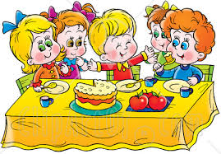A. B.

  
  
C. D.

**4. Adam:…………………………………..?  
Bill: It’s the 13th November.**

A. What is your name  
B. How old are you  
C. What is the date today   
D. What time is it

**5.****A: Would you like to come to my birthday party?**

**B: ……………………but I must finish my homework.**

1. You can help me
2. It’s a good idea
3. Here you are
4. I mustn’t do that

**6.** *“***The party is …… seven o’clock … December***.”*

A. on / in B. at / in C. in/ on D. on / at

**7.** **Put the words in order.**

like1 – my2 – come3 – you4 – party5 – would6 – to7  ?

1. 6 – 4 – 5 – 3 – 1 – 2 – 7
2. 2 - 4 – 6 – 1 – 7 – 3 – 5
3. 6 – 4 – 1 – 5 – 6 – 2 - 4
4. 6 – 4 – 1 - 7 – 3 – 2 – 5

**8.** **A: What is the fourth month of the year?**

**B: It is ………………..**

1. September
2. April
3. October
4. November

**9.** **A: When is your birthday?**

**B: In autumn , it is in ………….…**

1. April
2. July
3. September
4. February

**10. A: When is the comedy film on TV?**

**B: ……………………**

1. It is very funny.
2. Tomorrow
3. It is about war
4. It’s a good idea

**11. I don’t like horror films because**

**they are .....................**

A. frightening C. entertaining

B. enjoyable D. Funny

**12. Yasemin has got a birthday party.**

**She .......... invitation cards to her friends.**

A. buys C . sends

B. decorates 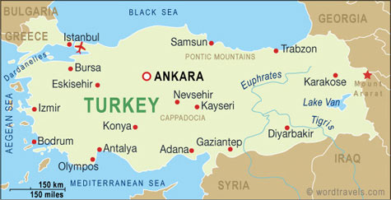 D. Prepares

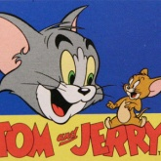

**13.** **“ Tom and Jerry” is my favourite ....................**

A. documentary C. director

B. science- fiction D. Cartoon

Believe in yourself You can do it ☺

English Teacher Miss. KIRMACI

.