2017-2018 HASANPAŞA SECONDARY SCHOOL 2ND TERM 1ST WRITTEN EXAM FOR 5/A
NAME-SURNAME= NUMBER=
- Match the sentences with their suggestion. Then match them with pictures.(Verilen cümleleri önce tavsiyeleriyle sonra resimlerle eşleştiriniz) (3x5=15p)
a. She shouldn’t walk.
b. She shouldn’t lift heavy things c. He shouldn’t drink cold water d. He should put a plaster on it e. He should go to dentist

____1.Ali have got a cut on my finger
____2.Efe has got a toothache.
____3. He has got a sore throat.
____4. She has got broken leg.
____5.Ayşe has got a backache.

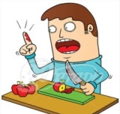
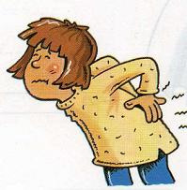
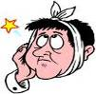

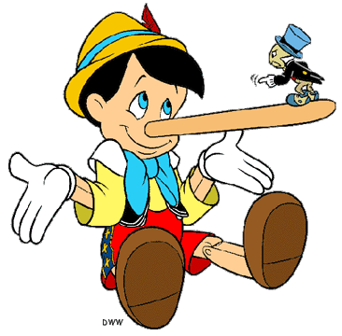
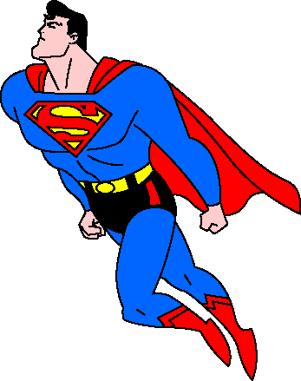
- Look at the pictures and write TRUE or FALSE. (Resimlere göre cümlelere TRUE ya da FALSE yazınız.) (2x4=8p)
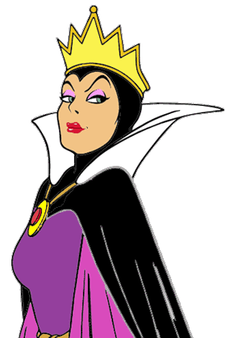
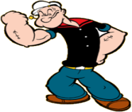

Pinocchio is honest.
Superman is brave.
Popeye is weak.
The queen is evil.

- Fill in the blanks with “in / on / at” (Boşlukları “in / on / at” ile doldurun) (2x4=8p)
1-I have a birthday party ………… Saturday. 3-It’s hot ………… August.
2- He gets up ……………… 8 o’clock. 4-My birthday is ……….. 3rd April.

- Complete the dialogue with the given phrases.(Verilen ifadeleri doğru boşluğa yazınız) (2x5=10p)
1.tired
2. a sore throat
3. get well soon
4. see the doctor
5. eat or drink cold things
Lisa : What’s the matter with you?
Bob : I have (1) _______________ . I feel (2) _____________
and my throat hurts.
Lisa : Well, you shouldn’t(3) _______________.
You should (4) __________________ .
Bob : Alright.
Lisa : (5) _______________.

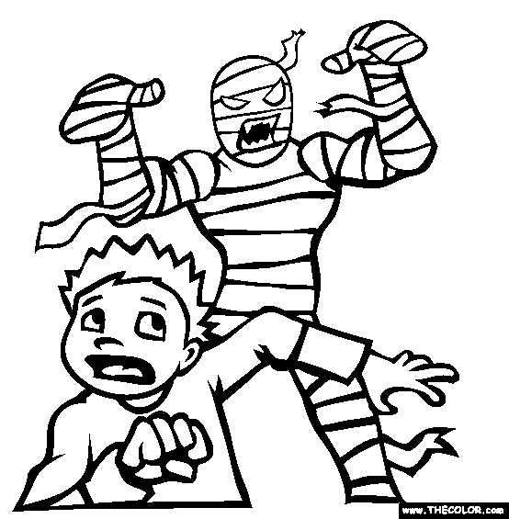
- Match the words with the pictures. (kelimeleri resimlerle eşleştiriniz)(2x4=8p)
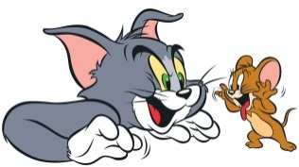
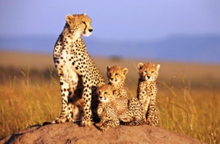
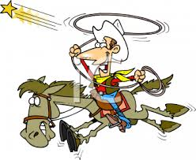

- Cartoon 2. Documentary 3.Horror 4. Western

- Read the invitation card and answer the questions.( Davetiyeyi okuyunuz ve soruları cevaplayınız.) (3x5=15p)
Dear friends,
Can you come to my birthday party this weekend, please? It is at 3 o’clock on Saturday. It is at Blue Cafe. You can bring a friend too.
Loves
Merve

1. What kind of party is it?................................................
2. What time is the party?.................................................
3. When is the party? ……………………………………………………
4. Where is the party?......................................................
5. Can you bring a friend too?...........................................

- Write the seasons and months. (Mevsimleri ve ayları yazınız) (1x16=16p)
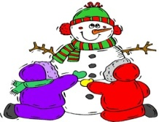
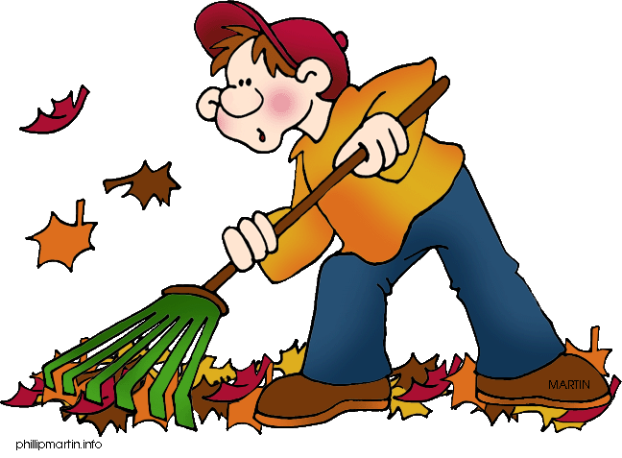
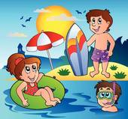
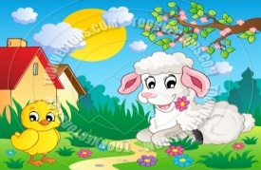

__________
…………………
……………………………………

__________
…………………
……………………………………

__________
…………………
……………………………………

__________
…………………
……………………………………

Spring, February, August, December, Autumn June, March, September, April, July, November, Summer, January , May, Winter, October

- Match the words with the pictures. (2x4=8p)
1. Gift
2. Party hat
3. Guests
4. Candles

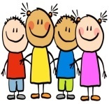
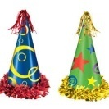

- Match the games with the pictures. (oyunları resimlerle eşletiriniz) (2x6=12p)
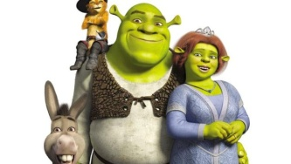
____1. Shrek is fat and green.
____2. The princess is short and fat.
____3. Shrek is the name of the Princess.
____4. Shrek loves the princess.
____5. Shrek is a very handsome.
____6. Donkey is Shrek’s friend.
Shrek is an ogre. He is fat, green and tall. He has got a friend, donkey. He loves princess. Her name is Fiona. She is tall, slim and beautiful. She has got brown hair and beautiful green eyes. Fiona is an ogre, too. Shrek is sad because he is ugly. But Fiona loves him and they get married.

