www.okanelt.com
------------------ SECONDARY SCHOOL 2017-2018 8th GRADES 1st TERM 1st ENGLISH EXAM
NAME: CLASS:8/__ OCT. 22,2017
SURNAME: NUMBER: 40 min.

- A:__________________?
B:It’s five o’clock.
- Where is the clock
- What does it do
- What time is it
- How many clocks are there

- Tell the time
03:15 =It’s _________ three.
- half past
- a quarter past
- a quarter to
- o’clock

- I attend the guitar course ____ Mondays.
a) in
b) on
c) at
d) under

- My birthdate is 30th September, 1985
a) the thirteenth of November , nine eighty five
b) the thirtieth of September, ninety eight five
c) the thirtieth of September, nineteen eighty five
d) the thirteenth of September, ninety eighty five

- The concert starts ___ 10 o’clock.
a) in
b) on
c) at
d) over

- A: Would you like to come to my party?
B:I’m really _________ , I can’t.I have a lot of homework.
a) funny
b) happy
c) cheerful
d) sorry

- There is a birthday party at the weekend.I think we will have lots of ________ .
a) accept
b) shopping
c) excuse
d) fun

- I like Jim.We ______ with him.We have a lot in common.
a) get on well
b) count on
c) response
d) invite

- I am going to be in Madrid next week.
I’m going to___________ my grandparents.
a) share
b) visit
c) decide
d) organize

- I invited him to the party , but he ________ .He is going out of the city.
a) accepted
b) joined
c) refused
d) shared

- Alex: _____________________ ?
Dave : Yes ,please.
a) What would you like to drink?
b) What do you think about it?
c) Would you like to watch a romance or sci-fi movie?
d) Would you like a cup of coffee?

- A true friend always ___________ you up when you’re in trouble.
a) sees
b) takes
c) backs
d) gives

- We are going to go to Rome ______ .
a) last year
b) everyday
c) tomorrow
d) yesterday

- A:Would you like to see a movie this weekend?
B:I ‘d like to , but _________ . I’m going to have guests.
a) fine
b) I can’t
c) great
d) yes

- A:Why don’t you come to the wedding?
B:______ I don’t feel well.
a) Because
b) So
c) But
d) Then

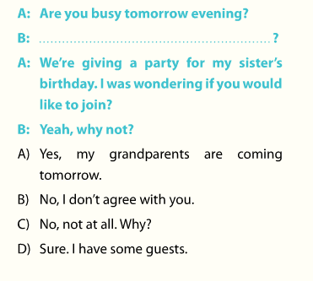

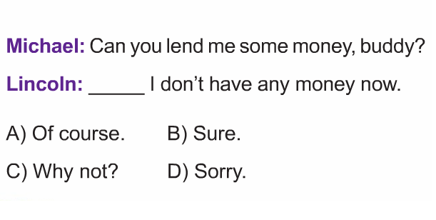

18-20 arasındaki sorular parça içindeki boşluklara göre yapılacaktır.

Kate is my best (18)__________ .I love her.We have so many things in common.I can tell her all my secrets.I know she never tells anybody.I really (19) _________ her.We sometimes go shopping together.We usually (20)__________ friends atthe Sun Cafe and chit chat.

- ______
a) buddy
b) drama
c) response
d) fun

- _____
a) lie
b) count on
c) refuse
d) share

- ______
a) go
b) bring
c) meet
d) apologize

