1. 

**…………….. ORTAOKULU**

**Englısh Lesson 7th Grade Unit 1: Appearance and Personality 1st Quiz**

a)thoughtful

b)generous

c) easygoing

d) stubborn

a) careful

b)quiet

c) easygoing

d) outgoing

1. 
2. 

a)thoughtful

b)generous

c) outgoing

d) stubborn

a)social

b)shy

c) intelligent

d) thoughtful

1. 

a)talented

b)careless

c) funny

d) stubborn

1. 

a)cheerful

b)friendly

c) easygoing

d) talented

1. 
2. 

a)outgoing

b)generous

c) talented

d) stubborn

1. 

a)social

b)generous

c) shy

d) thoughtful

1. 

a)intelligent

b)punctual

c) cheerful

d) stubborn

1. 

a)thoughtful

b)careful

c) cheerful

d) shy

1. 

a)forgetful

b)clumsy

c) careless

d) generous

1. 

a)cheerful

b)punctual

c) intelligent

d) thoughtful

1. 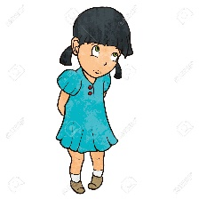

a)social

b)shy

c) intelligent

d) thoughtful

1. 

a)talented

b)shy

c)stubborn

d) forgetful

1. 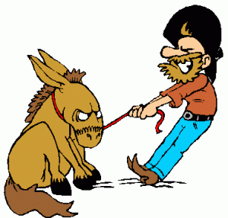

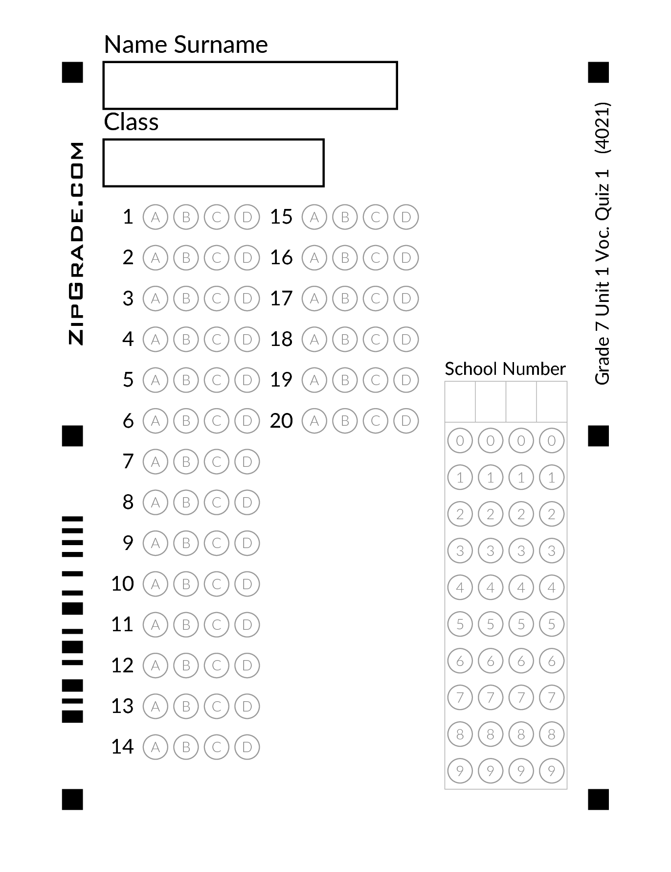

a)social

b)stubborn

c) intelligent

d) easygoing

1. 

a)social

b)selfish

c) intelligent

d) talented

a)He has got blue eyes

b )He has got blond eyes

c) He has got red eyes

d) He has got black eyes

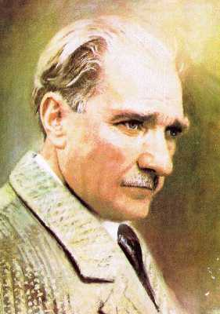

1. 

a)She is fat

b )She is well built

c) She is slim

d) She is overweight

1. 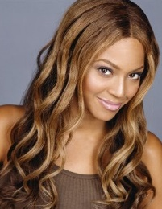

a)She has got straight hair

b )She has got wavy hair

c) She has got short hair

d) She has got curly hair

1. 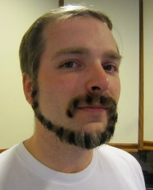

a)He has got long hair

b )He has got beard

c) He is bald

d) He has got curly hair