2017-2018 EĞİTİM ÖĞRETİM YILI
ADI SOYADI:
SINIF:
ORDUZU ELMASUYU ORTAOKULU 2.DÖNEM 1.İNGİLİZCE YAZILISI
- Resimlerle verilen hastalıkların ne olduklarını yazınız. (5x3=15)
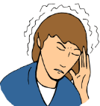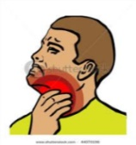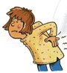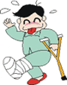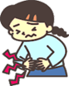
1…………….. 2……………… 3……………... 4…………….. 5……………….

- Aşağıdaki cümlelere should ya da shouldn’t getiriniz.(5x3=15)

- Tom has a toothache. He _______________ eat chocolate.
- We _______________ wash our hands with soap and water.
- I have a sore throat. I ___________________drink cold water.
- You __________________ carry heavy things. You’ve a backache.
- We ___________________ have breakfast every morning.

- Verilen soru ve cevapları eşleştiriniz.(5x3=15)

______1. What kind of movies do you like?  ______ 2. What is the movie about?  ______ 3. What is your favorite movie?  ______ 4. What time is the movie?  ______ 5. Do you like horror films? | - It is at 2,30  - It is about robots.  - I like comedy films.  - It is Hababam Sınıfı.  - No, I don’t.

- Verilen film türlerini doğru resmin altına yazınız.(5x3=15)
Horror – Romantic – Comedy – Animation – Science Fiction

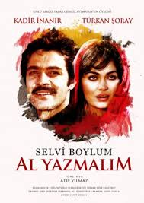 | 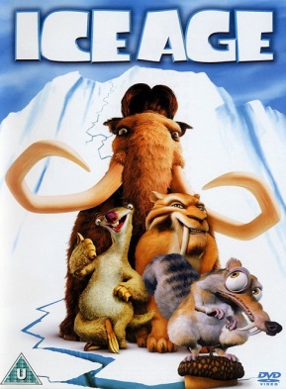 | 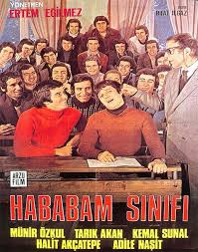 | 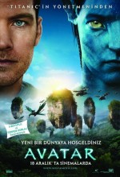 | 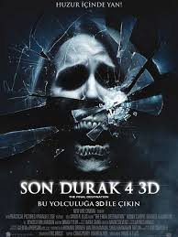

1…………………….. 2……………………. 3……………………… 4………………….. 5………………………
- Verilen cümlelerdeki boşlukları uygun sıfat ile tamamlayınız (5x3=15)
dishonest- lazy – evil – strong - friendly

- Garfield is …………….He sleeps all the time.
- I like Keloğlan because he is ……………..
- Pinokyo is a ……………. character. He tells lies.
- I hate Gargamel because he is ………………..
- Superman is a ……………..character.

- Mevsimlere göre ayları yazınız. ( 5x5 =25)
AUTUMN/FALL
*
*
*
SUMMER
*
*
*
SPRING
*
*
*
WINTER
*
*
*

- Parçaya göre soruları cevaplayınız. ( 5x5 =25)

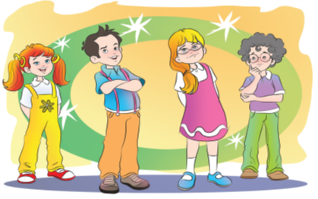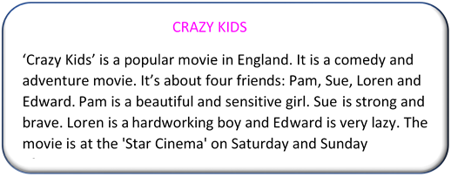

1. What is ‘Crazy Kids’ about? ___________________________________________________
2. Who are the main characters? __________________________________________________
3. Which cinema is it on? ___________________________________________________
4. What type of movie is it? ___________________________________________________
5. When is the movie on? ______________________________________________________

