|  |  |
| --- | --- |
|  | **18 EYLÜL ORTAOKULU** |
| **2017-2018 EDUCATION YEAR 2ND TERM 1ST ELECTIVE ENGLISH WRITTEN EXAM FOR 5TH GRADES** |

**NAME/ SURNAME :………………………………..**

**NUMBER / CLASS :………………………… POINT:…………**

**A) Choosethecorrectanswer. (5x20=100 points)**

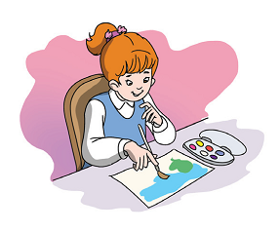**1)Ayça**: My favouritelesson is ____.

**A)**Maths.

**B)**Art

**C)**P.E.

**D)**Music

**2) Ahmet:**What is yourfavouriteactivity?

**[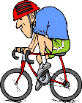](http://www.signsbyyou.com/decals/vinyl-decal-370541.htm)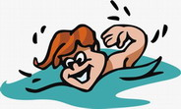 Metin:**It is***swimming*.**

**A) B)**

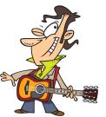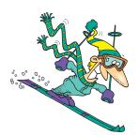

**C) D)**

**3)Hangisi bir film türüdür?**

**A)** funny **B)** boring

**C)** adventure **D)** beautiful

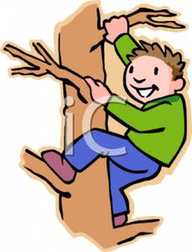

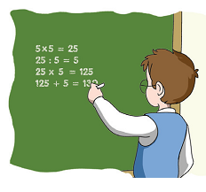**4)He likes……………**

**A)**Maths

**B)** Music

**C)** Art

**D)** P.E

**5) Aşağıdaki kelimeler gruplandırıldığında hangisi dışarıdakalır?**

1. Candles**B)**Birthdaycake
2. Balloons**D)**Comedy

**6) Resimdeki oyunu işaretleyiniz.**

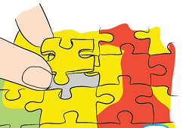**A)**chess

**B)**puzzle

**C)**hopscotch

**D)** origami

**7)Melis:___________________________?**

**Ayşegül : It's on 21st April.**

**A)** When is your birthday?

**B)** What's your name?

**C)** What's the matter with you?

**D)** Can I open the window?

**[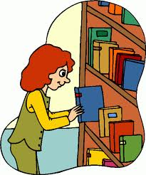](http://www.google.com.tr/imgres?q=library+clipart&hl=tr&biw=1280&bih=652&tbm=isch&tbnid=xJo7DNAP-7HVKM:&imgrefurl=http://www.clipartheaven.com/show/clipart/education_&_schools/cartoons/girl_in_library_3-gif.html&docid=Hzw6Qc8rdTWeYM&imgurl=http://www.clipartheaven.com/clipart/education_&_schools/cartoons/girl_in_library_3.gif&w=490&h=587&ei=sWkAT_iNDMnA8QOBlo39DA&zoom=)**

**8)She is in the _________.**

**A)** canteen **B)** school

**C)** library **D)** bank

**9)Kate: What’s on TV tonight?**

**Brad: Shrek 3.**

**Kate: - - - - ?**

**Brad: It is an adventure and comedy.**

**A)** What time is it?

**B)** Who are the main characters?

**C)** Do you like it?

**D)** What kind of movie is it?

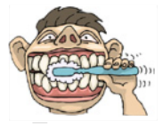**10)He ___________________.**

**A)**brushes his teeth

**B)**goestoschool

**C)**playsbasketball

**D)** eats a sandwich

**11)A:What is thematterwithyou?**

**B: ___________________**

**A)**I think it is funny

**B)**I have a headache

**C)**Thankyou

**D)**It is at sixo’clock

**12)What’sthematterwith her?**

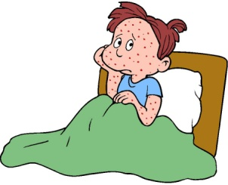

**A)**flu

**B)**earache

**C)**stomachache

**D)**measles

**13)Eşleştirmelerdenhangisiyanlıştır?**

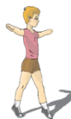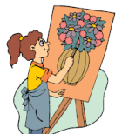

**A)**Maths **B)** Physical Education

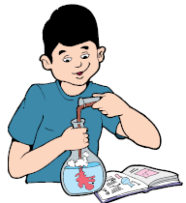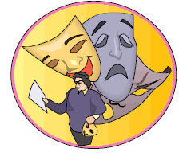

**C)** Drama **D)**Science

**14) Mary: I have a sore throat.**

**Doctor: You shouldn’t - - - - .**

**A)**lift heavy things **B)** do exercise

**C)**drink cold water **D)** take medicine

**15) A: - - - - ?**

**B: He has an earache.**

**A)** What’s the matter with you?

**B)** What’s the matter with him?

**C)** What’s the matter with her?

**D)** What’s the matter with Sibel?

**16)** 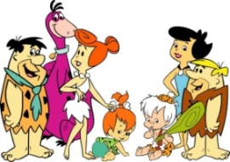

**A)** western **B)** horror

**C)** cartoon **D)** documentary

**17)**  **A)** gift **B)** candles

**C)** cake **D)** partyhats

**18)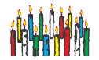A)** gift **B)** candles

**C)** cake **D)** partyhats

**19)** **A)** gift **B)** candles

**C)** cake **D)** partyhats

**20)** 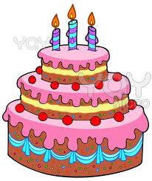

**A)** cake – balloons – beverages

**B)** balloons – cake – beverages

**C)** beverages- balloons – cake

**D)** cake – beverages–balloons

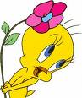

**GOOD LUCK……**