2017-2018 EDUCATION YEAR ERMİŞLER DOSTLUK SECONDARY SCHOOL 6th GRADE SECOND TERM FIRST ENGLISH EXAM QUESTIONS
Name : Surname : Number: Class :6/
- Match the pictures with the words ( 2X 5 : 10 pts.)
*Forest * Mountain * River * Lake * Seaside
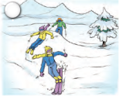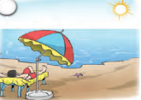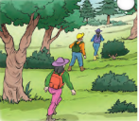

- Look at the dilogue and chose the pictures for Eşref and Zeynep (2x5 :10 pts)

Zeynep : Did you go on holiday this summer Eşref?
Eşref : Yes. I went to Antalya with my family.
Zeynep : Great. What did you do there?
Eşref : We stayed at a big hotel. It was near the sea. I swam a lot and I played at the beach. My mother wanted to go sightseeing and we went out. What did you do?
Zeynep : We didn’t g oto a different place.I was in London.I visited a few museums and I went to a tennis course so I learned playing tennis.

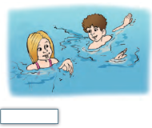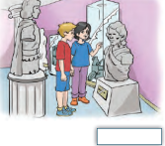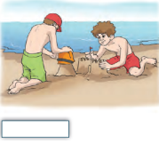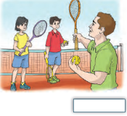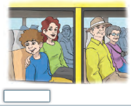
- Readthe dialogue again and complete the sentences with the names (2x9 :18 pts.)

- …………went to Antalya.
- ………….stayed at a big hotel.
- ………….didn’t g oto a different place.
- ………….was in London.
- ………….swam a lot.

- ………….visited a few museums.
- …………played at the beach.
- ………....went sightseeing.
- ………….learned playing tennis

- Read Tom’s diary and write True (T) or False (F) (3*6 : 18 pts)

Monday : It was sunny. I played at the beach all day.

Tuesday : It was sunny again. I played basketball with my friends

Wednesday : It was windy. I went to the lake and I saled a boat.

Thursday : It rained. I went to the cinema and I watched a film.

Friday : I stayed at home and I played computer games.

Saturday : It was sunny. I went to the seaside and I collected some shells.

Sunday : I visited my grandparents.

1. Tom played at the beach on Monday.______
2. It was sunny on Tuesday. ______
3. He sailed a boat in the sea. ______
4. He went to a museum on Thursday. ______
5. He collected shells on Saturday. ______
6. He played basketball with his friends on Sunday. ______
E- Match the pictures with the words. (1x10:10pts.)
*Tailor * Doctor * Teacher * Architect * Fireman * Nurse * Lawyer * Engineer * Policeman * Mechanic

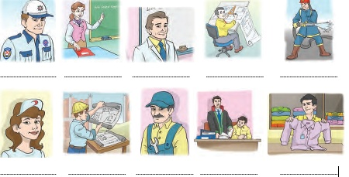
F- Match the occupations in column A with column B (2X10 : 20 pts.)
Column A Column B

1. A waiter …...
2. An architect ……
3. A teacher …...
4. A manager ……
5. A salesperson …...
6. A pilot ……
7. A mechanic …...
8. A vet ……
9. A taxi driver ……
10. A farmer ……
a- repairs cars or buses.
b- serves food at a restaurant.
c- is a doctor for animals.
d- manages a restaurant or a hotel.
e- sells clothes etc.
f- designs buildings.
g- teaches subjects to the students at a school.
h- flies an airplane.
i- drives a taxi.
j- grows vegetables.

G- Complete the days of the week ( 1x7 :7 pts)

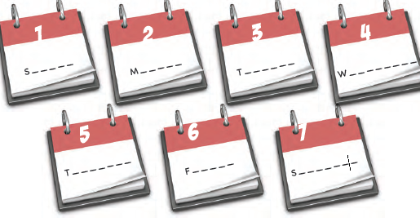
H- Match the dates to their sayings (2x4:8pts.)
- nineteen forty seven ….. a- 2012
- eighteen eighty one .…. b-1947
- nineteen sixty nine ….. c-1881
- two thousand twelve ….. d-1969

GOOOOOOOOOOOD LUCK ;)
ELT

