2017-2018 ACADEMIC YEAR TEZER TAŞKIRAN SECONDARY SCHOOL 2nd TERM 1st ENGLISH EXAM FOR 6th GRADERS
NAME & SURNAME:
A. Fill in the blanks with the PAST FORM of the verbs given in parathesis.
(Boşlukları parantez içindeki fiillerin “GEÇMİŞ ZAMAN” halleriyle doldurunuz.) 10×2= 20 pts.
1- We .................... (visit) the museums
and art galleries in Italy two years ago.
2- Yesterday, Fatmagül ..................... (find)
50 on the street.
3- Aslı Tohumcu .................... (write) the book
“ Eksimus Serüvenleri ” in 2011.
4- My little sister, Eslem .................(cry)
very much last night.
5- Sıla .............. (feel) ill last lesson and went
home with her father.
6- They ...................... (buy)
a new house in Aydınlı last year.
7- In summer holiday, Enes ................... (pick)
blackberries and rode on a donkey.
8- Yaren and Sinem ................... (eat)
a big pizza in the lunchtime.
9- Students ..................... (hurry) to buy toast
in the canteen line.
10- I ................ (sleep) for long
hours last weekend
B. Write the occupations.
(Meslekleri yazınız.) 5×3= 15 pts.
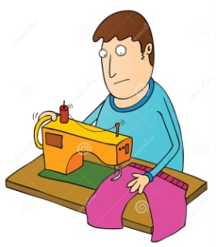

..................... ...................... ...................
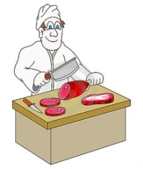

..................... ......................
CLASS & NUMBER:
C. Circle the correct one from the words written in bold. (Koyu yazılan kelimelerden doğru olanı yuvarlak içine alınız.) 5×2= 10 pts.
1- We went to the funfair yesterday. The
ghost train was very frightened / frightening
2- My English Teacher was very excited /
exciting on the bumper car.
3- I think soap operas are more bored /
boring than cartoons.
4- I usually feel nervous / thrilling before
Maths exams
5- Şeyma is a hardworking student. She is
very interesting / interested in English.

D. Fill in the blanks with “ WAS - WASN’T
WERE - WEREN’T ”
(Boşlukları “WAS - WASN’T / WERE - WEREN’T” ile doldurunuz.) 5×2= 10 pts.

1- Tom and I ............... at the concert last night
2- Mary is very happy today, but
yesterday she ............... happy.

3- My family went to Greece last summer.
It ............. very hot and sunny there.

4- Ersan and Kadir didn’t come to school
yesterday. They .............. in the classroom.
5- We ............... at university in 2008
but, we are teachers now.
E. Number the funfair rides. 5×2= 10 pts
(Lunapark araçlarını numaralandırınız.)
1- Bumper Cars 4- Carousel
2- Wave Swinger 5- Roller Coaster
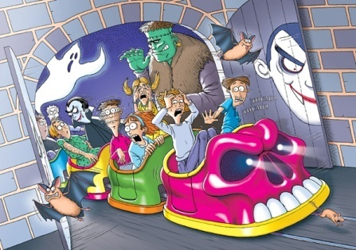
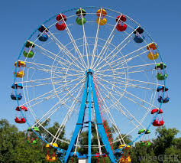
3- Big Wheel 6- Ghost Train
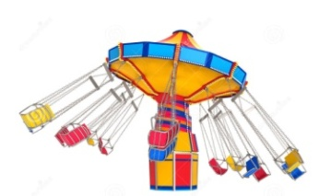
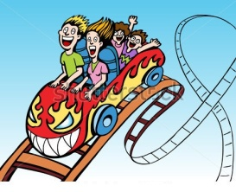
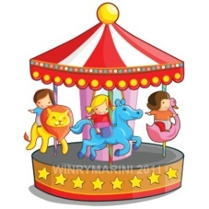
( ) ( )

( ) ( ) ( )

F. Write the years below. 5×3= 15 pts.
(Aşağıdaki yılların okunuşunu yazınız.)
1900: ..............................................................
1493: ..............................................................
2011: ..............................................................
1802: ..............................................................
2006: ..............................................................
G. Choose the best option. 10×2= 20 pts.
(Doğru seçeneği işaretleyiniz.)
1- Taz is a ........................ It is a cartoon
character and runs very fast.
a) skeleton b) monster
c) breath d) vampire
---------------------------------------------------------
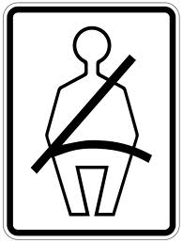
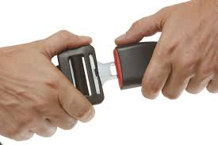
2- What does the sign mean?
a) Insert your token here!
b) Danger !
c) Fasten your seatbelt !
d) Pay here !
3- Can an elephant fly? - .......................
Can a whale swim? - .......................
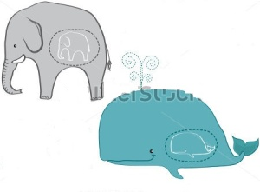
a) Yes, it can. / Yes, it can
b) No, it can’t / No, it can’t
c) Yes, it can / No, it can’t
d) No, it can’t / Yes, it can.
---------------------------------------------------------
4- Student: What did you do last summer, sir?
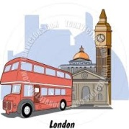
Teacher: I was in England and went to a
.........................tour in London.
a) skiing b) sailing
c) sightseeing d) diving
---------------------------------------------------------5- Where were you yesterday?
a) I was at the cinema
b) He was at the cinema
c) I were at the cinema
d) I am at the cinema
---------------------------------------------------------
6- Gözde always wears a ................ at school.
She hates wearing trousers or jeans.
a) fabric b) skirt
c) bed cover d) sign
---------------------------------------------------------
7- Were you at the theatre 2 years ago? -...........
a) Yes, I was. b) No, I was.
c) Yes, I wasn’t. d) No, I weren’t.
---------------------------------------------------------
8- The corridor is very crowded. Please,
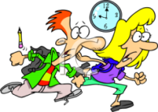
don’t run fast because it is ............................
a) traditional b) comfortable
c) nutritious d) dangerous
---------------------------------------------------------
9- Furkan is a/an ........................
He works in a bank and loves his job.
a) scientist b) stewardess
c) accountant d) salesperson
---------------------------------------------------------
10- Bolly is my pet dog. My grandpa built a
................ in the garden and Bolly stays in it.
a) tent b) hut
c) tower d) kite
---------------------------------------------------------
Duration: 40 mins.

