Name-Surname: Number: Class: 6/
G.H.V. AYSEL ABDULLAH ÖĞÜCÜ SECONDARY SCHOOL 2017-2018 EDUCATION YEAR
ENGLISH LESSON 6th GRADE 2nd TERM 1st WRITTEN EXAM

Number: Class:
:

Score:

A) Match the words with the pictures. (Resimlerle kelimeleri eşleştiriniz.) 8x2=16 pts.
Sunbathing - Skiing - Snowboarding - Shopping - Hiking - Ice skating - Diving - Sightseeing

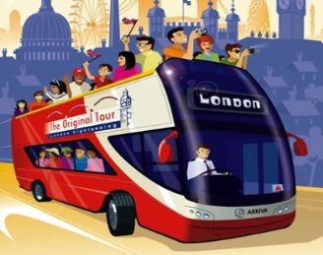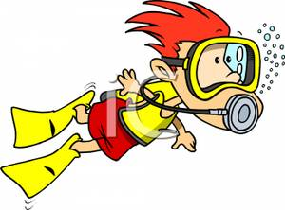
_____________________ _____________________ __________________ ___________________
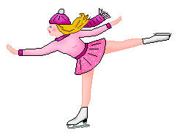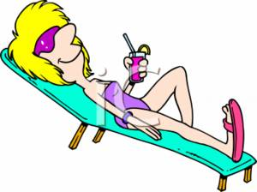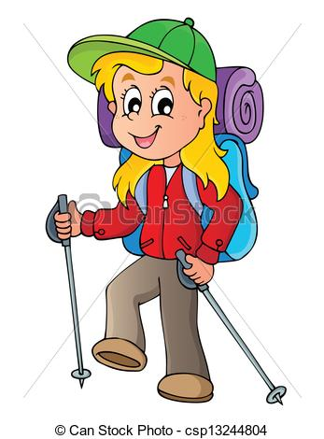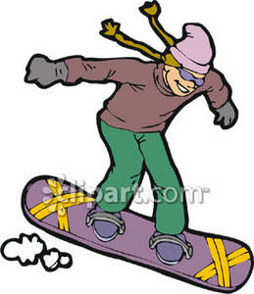
__________________ ____________________ ________________ ________________
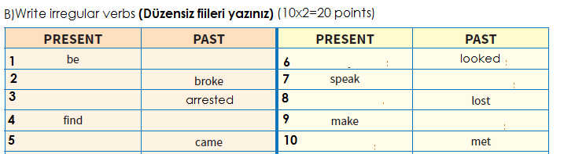
C) Fill in the blanks by using the given verbs. (Boşlukları ‘Past Tense’ kurallarına uyarak verilen fiillerle doldurun). (5x2=10pts)
Last summer holiday.I………………(be) in İstanbul. I…………….(go) there with my family. I…..…………(visit) the Blue Mosque and Topkapı Palace. I…………….(swim) in the sea but I…………………….(not learn) diving. My holiday was great.

D) Fill in the blanks with “was – were – wasn’t – weren’t” (Boşlukları doldurunuz) (8x1=8pts)
1- Atatürk ............... born in Salonika in 1881.
2- I ................... at school yesterday, because I .................. ill.
3- Where ...................... you last night?
4- Pelin and Osman ................. at the party on Saturday night.
5- You ..................... at the office an hour ago! You ............... at the cinema! I saw you there!
6- Today it is sunny, but it .............. sunny yesterday, it ................ rainy.
7- I think the film ................... very funny. I liked it!
8- I ……………….. very good at swimming last summer. I won alot of medals.
E | Write the jobs under the pictures (10X2=20)
artist – secretary – cook – singer – pilot – farmer - architect – tailor – vet – driver

1.____________2.________________3.______________4.________________5._____________
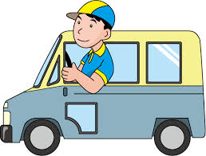

6.________________7.____________8._______________9.______________10._____________

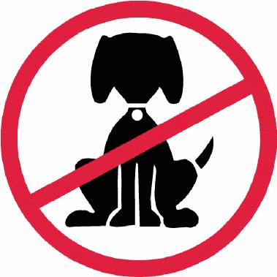
F | Match them. ( mesleklerle cümleleri eşleştiriniz) (5X2=10)
____Fireman
____Teacher
____Barber
1.He cuts hair.
2.He puts out fire.
3.She teaches at school.

4.He cooks in a restaurant.
5.She sings a song.
____Singer
____Cook

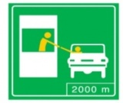

G)Match .Eşleştirin.(6pts)
- DANGER!
- PETS ARE NOT ALLOWED!
- NO PHOTO!
- FASTEN YOUR SEAT BELT!
- PAY HERE!
- TURN OFF YOUR MOBILE PHONE!

I) Write True or False(5pts)
İ) Match the pictures with the given words. (resimleri verilen kelimelerle eşleştiriniz). (5 pts.)

1. Burglar 2.fingerprints 3. jewelry 4.detective 5.magnifier
1._______Laura is a teacher.
2._______Laura went to England.
3._______Laura had photos in Disney World.
4._______The holiday was boring.
5._______She went to Florida with her family.
I am Laura. I am a student.I am from England.I am 14 years old.Last summer , I went to Florida with my family.
It was exciting.I visited my uncle.I visited Disney World and I took photos with my friend there.

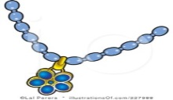
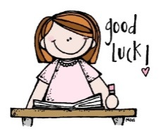

NEJLA YİĞİT

