2017-2018 EDUCATION YEAR SELİMPAŞA AHMET ZİYLAN SECONDARY SCHOOL

6th GRADES 2nd TERM 1st ENGLISH EXAM

**NAME – SURNAME : NUMBER : CLASS:**

**A) WRITE THE OCCUPATIONS UNDER THE PICTURES ( Meslekleri resimlerin altına yazınız (2×10=20)**

Nurse – cleaner – pilot – hairdresser – farmer – artist – secretary – soldier – vet – dentist

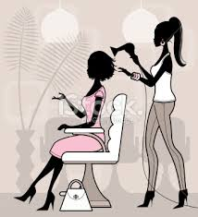   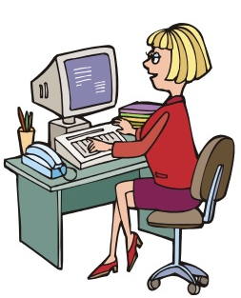 

………………………. ………………………. ………………………. ………………………. ……………………….

    

………………………. ………………………. ………………………. ………………………. ……………………….

**B) MATCH THE JOBS WITH THE DEFINITIONS (Meslekleri tanımlarla eşleştirin (6x2=12)**

**Teacher – Mechanic – Architect – Fireman – Doctor – Tailor**

|  |
| --- |
| **(__________) 1)**I can cut and sew fabrics, and I can make new dresses.  **(__________) 2)**I can write prescriptions. I operate on ill people.  **(__________) 3)**I can design and draw building plans.  **(__________) 4)**I work at school. I can teach you new things.  **(__________) 5)** I can put out fire.  **(__________) 6)**I can repair cars and buses. |

**C) Reac the text and write TRUE/ FALSE (Metni okuyun ve TRUE/FALSE yazın)(2x5=10)**

I am Laura. I am a student.I am from England.I am 14 years old.Last summer , I went to Florida with my family.

It was exciting.I visited my uncle.I visited Disney World and I took photos with my friend there.

1._______Laura is a teacher.

2._______Laura went to England.

3._______Laura had photos in Disney World.

4._______The holiday was boring.

5._______She went to Florida with her family.

**D) COMPLETE THE SENTENCES IN SIMPLE PAST TENSE.( Geçmiş zamana göre tamamlayınız.) (10 x 2= 20)**I …**went**... **(go)** to Konya with my friends last weekend. We **……………………(stay)** at a big hotel.We **……………(have)** a great time. The weather was hot and nice. We **………………………..(visit)** Mevlana Museum and Alaaddin Mosque. We **……………………(take)** lots of photos. We **…………………….. (drink )** some fruit juice at the Alaaddin Tepe Cafe. It **…………………(be)** very delicious. We **……………….( taste)** traditional food and **………………………..(eat)** Etli Ekmek at a restaurant. On Sunday, we **…………………(do**)shopping .I **……………….( buy)** a nice dress for my mother.

**E) ANSWER THE QUESTIONS( Yukarıdaki paragrafa göre soruları cevaplandırınız.) (5x 2= 10)**

1)How was the weather in Konya ? _________________________________

2) Where did they stay ?___________________________________________

3)When did they go to Konya?_____________________________________

4)Did they visit Mevlana Museum?____________________________________

5)What did they do on Sunday?__________________________________________

**F) FILL IN THE BLANKS WITH “WAS” OR “WERE” ( Boşlukları “was” veya “were” ile doldurun) 5×2=10)**

a) I___________ at home yesterday.

b) They ____________ at the park last weekend.

c) My grandfather ____________ a farmer in 1975.

d) My sister_________ at the seaside last summer.

e) Mehmet and I ___________ in the hospital last night.

**G) FILL IN THE BLANKS WITH “on/in/ at/”(Boşlukları “on/in/at” ile doldurun) (5x2=10)**

**1.** I didn’t go to school ………..Monday.

**2.** The film started ………. half past eight.

**3.** I was born ………. August.

**4.** Did you have breakfast ………. the morning?

**5.** I became a teacher ………2010

**H) WRITE THE YEARS IN ENGLISH (Yılların İngilizce okunuşunu yazın)(4x2=8)**

**2018:** …………………………………

**1923:** …………………………………

**1903:**………………………………….

☺☺☺ **GOOD LUCK !!!**☺☺☺

TUFAN SAY

**1900:**………………………………….