

2017-2018 EDUCATIONAL YEAR YAVİ SECONDARY SCHOOL 1ST TERM 1ST EXAM FOR THE 6TH GRADES

**NAME:**

**SURNAME:**

**CLASS:** 6/….

**GRADE:**

**A) Write the food under the pictures. (2x6 =12 pts)**

|  |
| --- |
| Egg / Bread / Croissant / Bagel / Olives / Cheese |

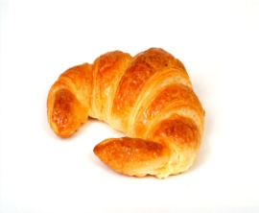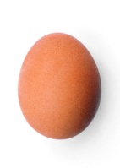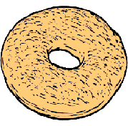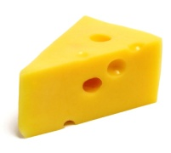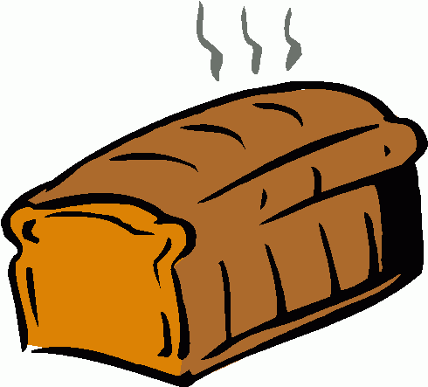

**B) Match the answers to the questions. (2x5=10 pts.)**

**1)** What time does she get up?  **_____** No, not really.

**2)** Does he play basketball?  **_____** She gets up at 7 o’clock.

**3)** What do you do after school? **_____** I like drinking tea, of course.

**4)** What do you drink at breakfast? **_____** Only two.

**5)** How many eggs are there? **_____** I go to a dance course.

**C) Write daily routines under the pictures. (3x8=24 pts)**

|  |
| --- |
| have breakfast - play football - take guitar course - go to school  watch TV - go to bed - do homework - brush teeth |

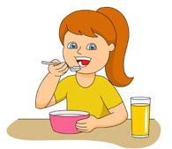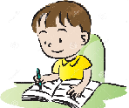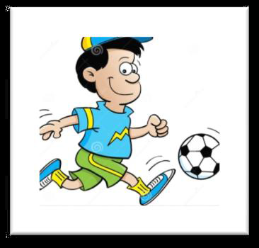

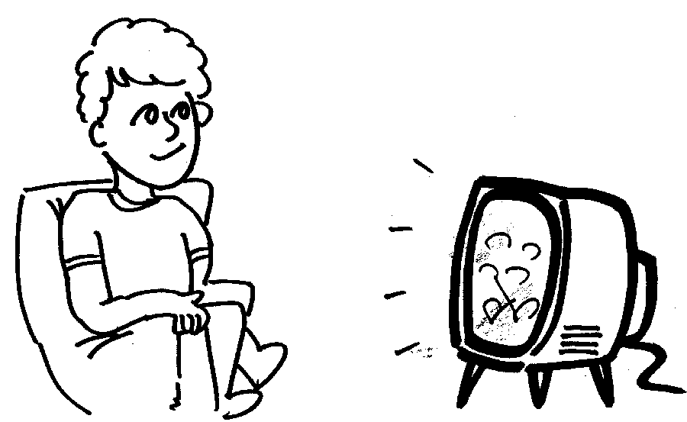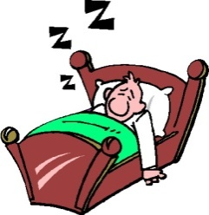

**D)Read the text and write TRUE or FALSE. (2x6=12 pts)**

**My name is Elif. I am 10 years old. I’m a student. I get up early in the mornings. I have breakfast and brush my teeth. I go to school by school bus. I have got 6 lessons each day. In the evenings, I do my homework and watch TV. I go to bed at 9.30 pm. At the weekends, I sometimes go to the cinema with my friends. I like my friends very much.**



**1)** Elif is eleven years old. ( ………….….)

**2)** She is a teacher. (……….……..)

**3)** She goes to school by school bus. (…………..….)

**4)** She has got six lessons. (………….…..)

**5)** She likes her friends very much. (…………..….)

**6)** She always goes to the cinema at the weekends. (………….…..)

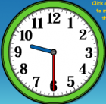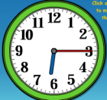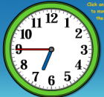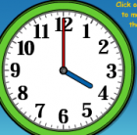**E) What time is it? (4x4=16 pts)**

***1 2 3 4***

**1)** ___________________________________.

**2)** ___________________________________.

**3)** ___________________________________.

**4)** ___________________________________.

**09.30 06.15 18.45 04.00**

**F) Read the text and answer the questions below. (4x4=16 pts)**

**Hello! I'm Cem. I get up at 07.00 in the mornings. Then, I have breakfast at 07.30. I eat cheese, honey, bread and I drink milk at breakfast. I go to school at 07.45 by school bus. I have lunch at canteen. I take guitar course after school. In the evenings I have dinner with my family and do my homework. I go to bed at 10.00. I have football course on Saturdays. I sometimes go online in the evenings.**

**1) Where does he have lunch? 2) What does he drink at breakfast?**

**A)** in the canteen **B)** by school bus **A)** cheese **B)** at 7.00

**C)** in the mornings **D)** Cem **C)** in the mornings **D)** milk

**3) What does Cem do after school?**

......................................................................................

**4) What time does Cem go to bed?**

..........................................................................................

**G) Answer the questions according to yourself. (2x5=10 pts)**

**1)** What time do you have breakfast? **2)** What do you eat at breakfast?

**_______________________________. _________________________________.**

**English Teacher**

*Lütfullah YILDIRIM*