**2017-2018 HASANPAŞA SECONDARY SCHOOL 2ND TERM 1ST ENGLISH EXAM FOR 6/A**

**NAME-SURNAME= NUMBER=**

1. **Write their jobs and match the sentences with the pictures (4x6=24p)**
2. I am a______________. I can operate on ill people and write prescription.
3. I am a ______________. I can cut and sew fabric. I make new clothes for people.

Dentist

Doctor

Pilot

Architect

Tailor

1. I am a ________________. I care for people’s teeth.
2. I am a ________________.I work at airport. I can fly the plane.
3. I am a ________________. I can design and draw building plans.

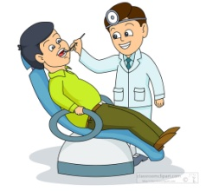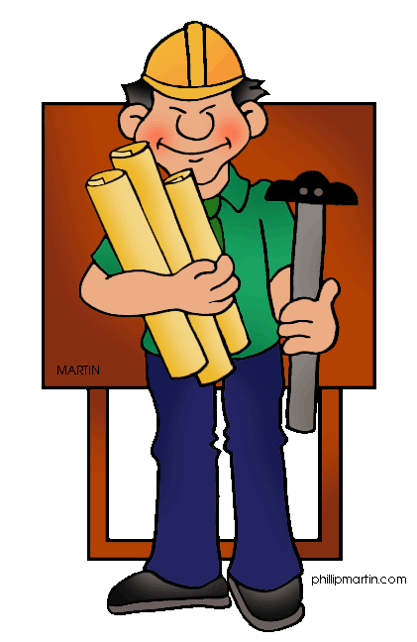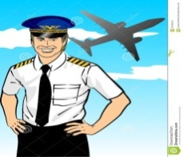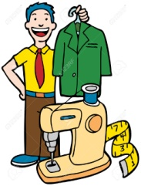

1. 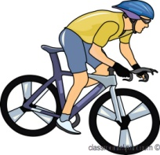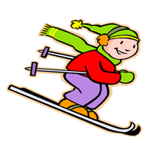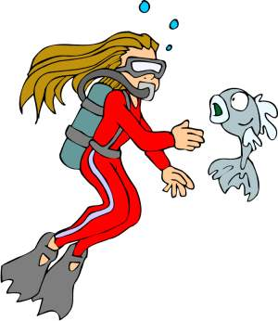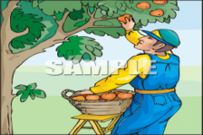**Match the words with the pictures. (2x5=10p)**

1.diving 2.cycling 3.ice-skating 4.skiing 5.picking fruits

1. **Read the text and write TRUE or FALSE. (2x5=10p)**

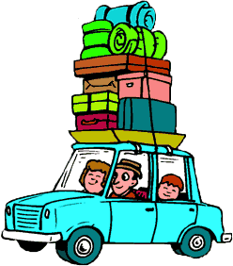

**Cindy:** Hi. How was your holiday?

**Kevin:** We went to Bodrum with my family.It was very good.

**Cindy:** What did you do?

**Kevin:** I swam in the sea. I climbed to the mountains.

I rode bicycle.

**Cindy:** Where did you stay ?

**1.** Kevin went to Bodrum with his family ……….

**2.** He didn’t swim in the sea ………..

**3.** Kevin and his family didn’t stay in a hotel …….

**4.** Cindy went to Bodrum in the holiday ……..

**5.** Cindy played volleyball with her friends ……..

**Kevin:** We stayed in a hotel.

**Cindy**: How was it?

**Kevin**: It was amazing.What did you do in holiday?

**Cindy**:We went to İzmir. I swam in the sea. I read book

and I played volleyball with my friends.

**Kevin**: Amazing. See you later. Good bye!

**Cindy**: Good bye!

1. 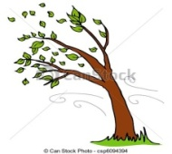**Write the weather conditions. (2x5= 10p)**

1. **Match the phrases with the pictures. (2x4=8 p)**

1.Fasten your seat belt.

2.Don’t eat or drink.

3.Danger

**4.**Pets not allowed

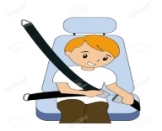

1. **Read the text and answer the questions. (2x6=12)**

Hi, I am Emre. I’m 12 yeard old and I’m a student. I live in Ankara with my family, but I am bored in London because I have a few friends and I feel lonely. My father, Musa is policeman and he is always busy. He catches the criminals and he comes home at night. My mother, Aysel is a nurse. She usually works at the hospital. She helps the doctors and looks after ill people. She sometimes comes home early but she is very tired at home. My sister, Saliha is a university student and she always does homework and she wants to be an English teacher.

1. What does Musa do?............................................................
2. How old is Emre? …………………………………………………………..
3. Where does Aysel work? …………………………………………………
4. Is Saliha a dentist? …………………………………………………………..
5. Why is Emre bored? ………………………………………………………..
6. How often does Saliha do homework? ………………………………………..
7. **Choose the correct option . (3x2=6 p)**
8. I am **frightened / frightening** of the ghost train. It makes me fearful .
9. I think Carousel is **bored / boring** . I don’t want to get on it .
10. Roller coaster is **amazed / amazing** . It’s one of my favourite .
11. **Write the past form of the verbs in the brackets with the right form.(2x5=10p)**
    1. We______________________ play after school yesterday**. (play/-)**
    2. He _______________________ TV. **(watch/+)**
    3. Sue _______________________ her report. **(finish/-)**
    4. My mother _______________________ a cake**. (make/+)**
    5. _________ he ____________ swimming last week. **(go/?)**
12. 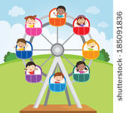**Match the fun rides with their pictures. (2x5=10p)**

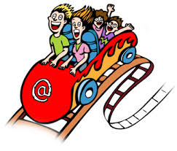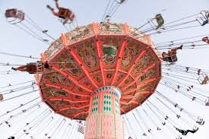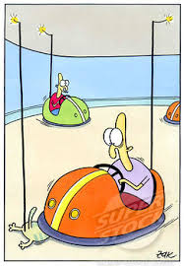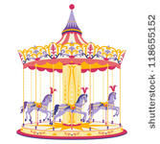

1)wave swinger - 2) roller coaster - 3)carrousel - 4)bumper cars - 4.big wheel

**GOOD LUCK**

Time 40’

Hatice BİÇER

English Teacher