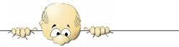
2016/2017 EDUCATION YEAR KUDRET DEMİR SECONDARY SCHOOL
2nd TERM 1st ENGLISH EXAM FOR GRADE 6
NAME-SURNAME: DATE:
CLASS-NUMBER: MARK:
A)WRITE THE WORDS UNDER THE PICTURES.(KELİMELERİ RESİMLERİN ALTINA YAZINIZ)(2*10=20)
*token *bumper cars *seat your belt *ghost train *wave swinger *carousel
*roller coaster *big Wheel *pets not allowed *do not eat or drink
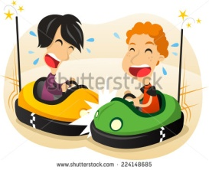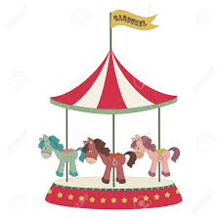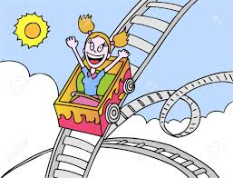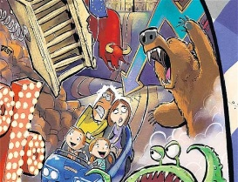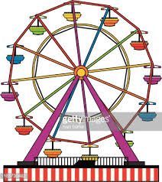
a.________________ b. _____________ c._______________ d._________________ e._________________
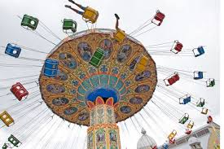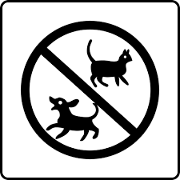
f.______________ g._____________ h.____________ ı.______________ j.______________
B)FILL IN THE BLANKS USING “WAS” “WERE”.(BOŞLUKLARI WAS WERE KULLANARAK DOLDURUNUZ)(2*5=10)
1.The cars____in front of the house yesterday.
2.My family and I ____at the cinema last night.
3.Sally _____ on a picnic last weekend.
4.Jack and his grandma_____happy.
5.Jim_____at home last night.

C)ANSWER THE QUESTION(SORULARI CEVAPLAYINIZ.)(3*5=15)
1.Were you at school last Saturday afternoon?(at the swimming pool)____________________________________
2.Was she at the museum one hour ago?(at school)___________________________________________________
3.Were they at the party two weeks ago?(at the party)________________________________________________
4.What did she do last night?( do homework)________________________________________________________
5.Where did you go last weekend?(to Ankara)_______________________________________________________

D)WRITE THE PAST FORM OF THE REGULAR AND IRREGULAR VERBS.
(DÜZENLİ VE DÜZENSİZ FİİLLERİN 2. HALLERİNİ YAZINIZ)(2*10=20)
1.write:________ 4.finish:________ 7.begin:________ 10.make:________
2.study:________ 5.go:_________ 8.see:_________
3.take:_________ 6.talk:________ 9.cut:_________

E)FILL IN THE BLANKS ACCORDING TO “SIMPLE PAST TENSE”
(BOŞLUKLARI GEÇMİŞ ZAMANA GÖRE DOLDURUNUZ)(2*5=10)
1.The shormaker______a perfect pair of shoes.(make)
2.Last year, I________to England on holiday.(not go)
3.She________lots of interesting places. She ______with two friends of mine(visit-be)
4.It__________to rain heavily two hours ago.(start)

F) WRITE THE WORDS UNDER THE PICTURES(KELİMELERİ RESİMLERİN ALTINA YAZINIZ)(1*10=10)
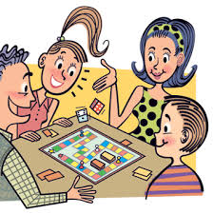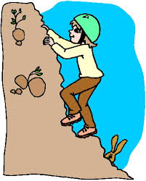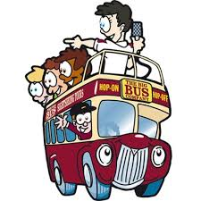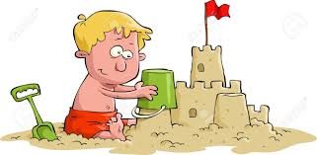
*cycle
*pick berries
*stay in a tent
*cook
*visit museums
*make sand castle
*sightseeing tour
*learn skiing
*climp mountains
*play games
a.__________ b.__________ c._________ d.__________ e.__________
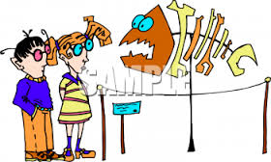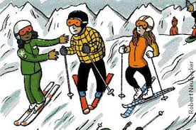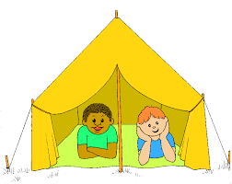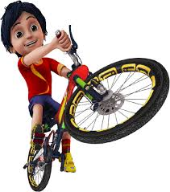
f._____________ g._____________ h.__________ ı._________ j._______

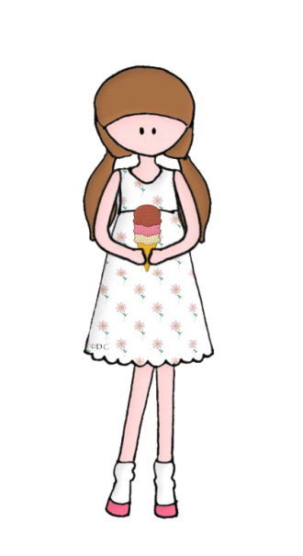
G)READ THE TEXT AND ANSWER THE QUESTIONS(SORULARI METNE GÖRE CEVAPLAYINIZ)(3*5=15)
Meera was a student in grade eight at Umm Ayman School. She was a hardworking student. She was always the first in her class. All of her classmates liked her a lot. She was also excellent in sports. She played tennis, basketball and volleyball. On her birthday party, she invited all her friends to come and enjoy with her. She bought a beautiful dress and her mother made for her a big cake decorated with chocolate chips. All of her friends were happy and they had a great time at the party.

1.Was she a hardworking student?______________________________________________
2.did her classmates like her?__________________________________________________
3.Which sport activities did she play?____________________________________________
4.what did she do for her birthday party?_________________________________________
5.did they have a great time at the party?__________________________________________

