2016-2017 ŞEMSETTİN SAMİ SECONDARY SCHOOL 2ND TERM 1ST ENGLISH EXAM FOR 6/H

Name/ Surname: Number :

- Write their jobs and match the sentences with the pictures (4x5=20p)

- I am a______________. I can operate on ill people and write prescription.
- I am a ______________. I can cut and sew fabric. I make new clothes for people.
- I am a ________________. I care for people’s teeth.
1.Dentist
2. Doctor
3. Pilot
4. Architect
5. Tailor
- I am a ________________.I work at airport. I can fly the plane.
- I am a ________________. I can design and draw building plans.

B.Read the text and write TRUE or FALSE. (3x5=15p)

Cindy: Hi. How was your holiday?
Kevin: We went to Bodrum with my family.It was very good.
Cindy: What did you do?
1. Kevin went to Bodrum with his family ……….
2. He didn’t swim in the sea ………..
3. Kevin and his family didn’t stay in a hotel …….
4. Cindy went to Bodrum in the holiday ……..
5. Cindy played volleyball with her friends ……..

Kevin: I swam in the sea. I climbed to the mountains.
I rode bicycle.
Cindy: Where did you stay ?
Kevin: We stayed in a hotel.
Cindy: How was it?
Kevin: It was amazing.What did you do in holiday?
Cindy:We went to İzmir. I swam in the sea. I read book
and I played volleyball with my friends.
Kevin: Amazing. See you later. Good bye!
Cindy: Good bye!

C.Rewrite the sentences in the Simple Past Tense. (5x3=15)

- watched/ yesterday/ a football match/ I
__________________________________
- She/ to school/ last Monday/ didn’t go
__________________________________
- play/ they/ did/ football/ ?
__________________________________
- broke/ my computer/ You
__________________________________
- We/ our work/ last week/ finished.
__________________________________

D.Match the dates. (5x2=10 pts. )

- 19 Mayıs 1919 ……. a. Twenty fourth of November nineteen twenty eight
- 23 Nisan 1920 ……. b. Thirtieth of August nineteen twenty two
- 10 Kasım 1938 ……. c. Nineteenth of May nineteen nineteen
- 24 Kasım 1928 ……. d. Twenty third of April nineteen twenty
- 30 Ağustos 1922 ……. e. Tenth of November nineteen thirty eight

E.Choose the suitable one. (5x2=10 pts.)

- Hakan was / were in Antalya last summer.
- I and my family was/ were on vacation last month.
- My cat wasn’t / weren’t at home yesterday.
- Amelia was/ were happy last weekend
- Was/ Were they busy on Friday evening?

F.Complete the text with in, at, on. (5x2=10)

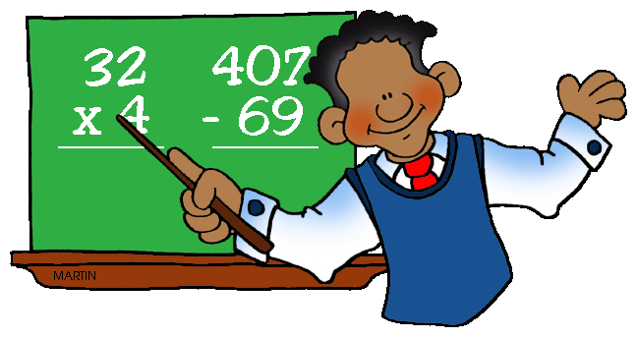
My father’s name is Jack. He is a maths teacher. He usually gets up ______ 6.30 ______ Tuesdays and Thursdays. He has lunch ____ the afternoon, because he has a lot of lessons. ______ the weekend he gets up late. My father has his summer holiday ______ August. He has a difficult job, but he loves it!

G.Read the text and answer the questions. (2x6=12)

Hi, I am Emre. I’m 12 yeard old and I’m a student. I live in Ankara with my family, but I am bored in London because I have a few friends and I feel lonely. My father, Musa is policeman and he is always busy. He catches the criminals and he comes home at night. My mother, Aysel is a nurse. She usually works at the hospital. She helps the doctors and looks after ill people. She sometimes comes home early but she is very tired at home. My sister, Saliha is a university student and she always does homework and she wants to be an English teacher.

- What does Musa do?............................................................
- How old is Emre? …………………………………………………………..
- Where does Aysel work? …………………………………………………
- Is Saliha a dentist? …………………………………………………………..
- Why is Emre bored? ………………………………………………………..

