**2017-2018 ACADEMIC YEAR**

**TEZER TAŞKIRAN SECODARY SCHOOL 2nd TERM**

**1st ENGLISH EXAM FOR THE 6th GRADE**

**Name: Surname: Number: Class:**

Name: Surname: Number/Class: Class:

A. Read the passage and put “T” or “F” before the sentences below. **5×2=10 pts.**

(Metni okuyunuz ve aşağıdaki cümlelerin önüne **T** ya da **F** yazınız.)

My name is Karen. I`m from England. Tomorrow is my eleventh birthday. My friends are going to come to my house and we are going to have a party. My mother is going to decorate our room and make a big cake. I’m going to buy some beverages, party hats and candles. But, It is always rainy and cold in England. You should usually take your umbrella before you go out.

**1- (.....) It is Karen’s tenth birthday.**

**2- (.....) Karen is going to have a birthday party.**

**3- (.....) The weather is always sunny and hot in England.**

**4- (.....) Karen is going to buy candles and drinks.**

**5- (....) Karen’s sister is going to decorate the room.**

**___________________________________________**

B. Combine the sentences using

“ *BEFORE or AFTER* ” **5×3=15 pts.** (“BEFORE ya da AFTER” kullanarak cümleleri birleştiriniz.)

1- I always wash my hands. I go to the toilette.

**................................................................................**

**2-** You should do your homework. You come to the school.

**................................................................................**

3- Stand up! Teachers enter the classroom.

**................................................................................**

4- Ceyda drinks hot milk. She goes to bed.

**................................................................................**

5- He brushes his teeth everyday. He has dinner.

**................................................................................**

Mark:

C. Write the names of the animals below. **5×3=15 pts.**

(Aşağıdaki hayvanların isimlerini yazınız.)

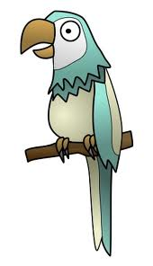



**...................... ...................... .....................**



........................................ ...................................

**___________________________________________**

D. Fill in the blanks with “*PRESENT CONTINUOUS TENSE* ”. **5×3=15 pts.**

(Boşlukları “Şimdiki Zaman” a göre doldurunuz.)

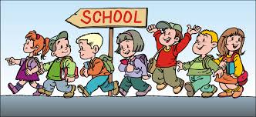**1-** The students .............................(go) to school.

**2-** Salih and Melih..............................

(**not** / listen) to the English Teacher now.

**3-** ......... she ....................(wash) the carrots ?

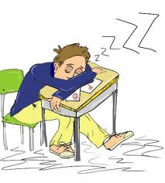**4-** I ............................ (**not** / do) my Maths homework at the moment.

**5-** Mehmet ......................... (sleep)

in the classroom.

E. Fill in the blanks with “ MUST ” or “ MUSTN’T ” **5×2=10 pts.**

(Boşlukları MUST ya da MUSTN’T ile doldurunuz.)

**1-** Students .................. be quiet in the classroom.

**2-** Özgür has got a high temperature.

He ..................... go to a hospital.

**3-** Teachers .................... wear uniforms at school

**4-** You ............... take a shower before swimming in a swimming pool.

**5-** People .................... make noise at a library.

**___________________________________________**

F. Fill in the blanks with “*FUTURE TENSE”* **5×3=15 pts.**

(Boşlukları “Gelecek Zaman” a göre doldurunuz.)

1- ........... you .......................... (come) to the cinema tonight?

2- He ........................... ( **not** / work) on the farm.

3- Nazar and Şura ...............................

(make) a birthday cake.

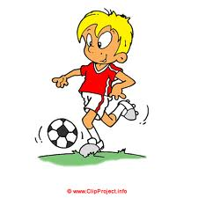4- Your sister ........................... (clean) the bathroom tomorrow.

5- Gökhan .............................. (**not** / play)

football in the evening.

**___________________________________________**

G. Choose the best option.

(Doğru seçeneği işaretleyiniz.) **10×2=20 pts**

1- What is the .............. like in İstanbul?

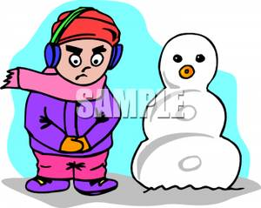- It is snowy in İstanbul.

a) autumn b) temperature

c) weather 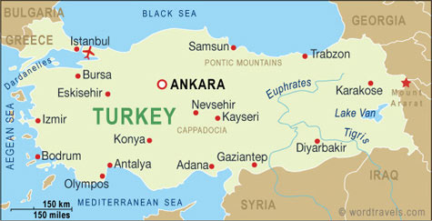d) windy

2- Burak has got a new ...........................

a) raincoat b) long sleeved shirt

c) shoes d) short sleeved shirt

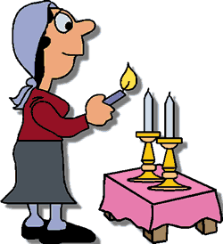3- There are two............... on the table.

a) beverages b) party hats

c) guests d) candles

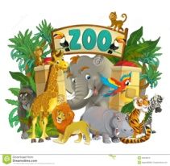4- ................... go to the Darıca Zoo at this weekend?

a) Shall we b) Have got

c) How about d) Has got

5- Kadirhan should wash his hands with ..............



a) handkerchief b) towel

c) toothbrush d) soap

6- **Arda**: It’s sunny and hot today.

..................... swimming on Tuzla Beach?

 **Emre:** Great idea!

a) Can b) Let’s

c) What about d) Shall we

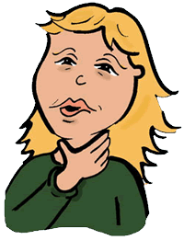7- Sema has got a .......................

She shouldn’t drink cold water.

a) Cough b) Sore Throat

c) Backache d) Runny Nose

8- ..................... are small, lovely animals. They have got a tail, four legs and whiskers. They can run fast, climb trees and jump very high.

**Which animal is it** ?

a) Cats b) Turtles

c) Squirrels d) Swans

9- There is a ...................... party in our school next week. 8th grade students finish their education.

 a) birthday b) beach

c) graduation d) hygiene

10- Tigers are wild and ......................... animals. They live in African jungles.

a) delicious b) small

c) hard-working d) dangerous

