- Match the words with the pictures.(5x2=10 points)
birthday party | wedding party | pyjamas party | halloween party | fancy dress party
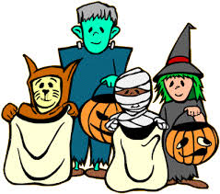

- Match the words with the pictures.(5x2=10 points)
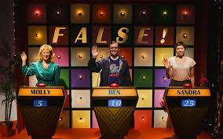
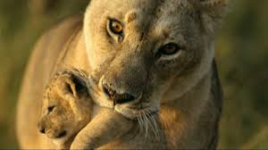
documentary – quizshow - TV series – news - cartoon

C) Circle the correct one. (10x2=20 points)

1.How many / How much eggs do youneedforthecake? 8. A: Would you like some / a few tea?
2. I don’thave a lot of / any milk for preparing a milkshake. B: Just a lot of / a little.
3. We have little / few sugar. We need to buy some. 9. How much/ many cheese have we got?
4. I need any / some bananas for the cake’s decoration.
5. Would you like many / some salt for your soup?
6. There are a lot of / a little bananas in the fridge.
7. There are a few / a little children in the classroom.

D) Complete the conditional sentences. (5x2=10 points)

1-If your right hand itches, ……………………………………………………………………...
2-If you find a four-leaf clover, …………………………………………………………………..
3-If you walk under a ladder, …………………………………………………………………..
4-If you break a mirror, …………………………………………………………………………..
5-If you open an umbrella indoors, ………………………………………………………….

E.Match the questions and answers. (5x2=10 points)
1.What kind of Tv programs do you prefer watching? ……a)She prefers cookery program
2.What kind of Tv program is İnsan Doğaya Karşı? ……b) It is a documentary
3.Do you like watching soap operas? ……c)No, he doesn’t
4.What kind of Tv programs does your mother prefer? ……d)I prefer sport programs
5.Does he like watching cartoon? ……e) Yes, I do

F) Complete the sentences with “Let’s”, “ Why don’t” “should”. (5x2=10 points)

1. A: I’m thirsty.
B: ______________________ you drink some lemonade?
2. A: It’s cold outside.
B: You ______________________ wear your coat.
3. A: I am bored.
B: ______________________ play a game.
4. A: I don’t know the meaning of “manage”.
B: ______________________ we look up a dictionary?
5. A: Tomorrow is our parents’ wedding anniversary.
B: ______________________ we prepare a surprise party?
6. A: I have a stomachache.
B: You ______________________ see a doctor immediately.
G) Fill in the blanks with appropriate word. (5x2=10 points)
Couch potato – boring –fortune telling –present -educational

1.Today is my brother’s birthday. I should buy a ________________________ for him.
2.I don’t believe ___________________________ because it is nonsense.
3. I prefer watching documentaries because I think they are __________________________.
4. My father is a ________________________. He always watches TV all day.
5.I don’t like watching soap operas because I think they are _________________________.

H) Put the words in correct box.( 10*1=10 points)
Palm reading -Four leaf clover- seeing black cat –horseshoe- magic ball –opening umbrella indoors –lucky number –blue bead –walking under ladder –coffee reading

Fortune telling
Evil eye
Bad luck
Good luck

- Write 5 predictions about your future (5x2=10 points)
1-
2-
3-
4-
5-
GOOD LUCK Serkan SÜREK English Teacher

