2015-2016 ACADEMIC YEAR TEZER TAŞKIRAN SECONDARY SCHOOL
2nd TERM 1st ENGLISH EXAM FOR 7th GRADERS

NAME & SURNAME: / CLASS & NUMBER: / MARK:

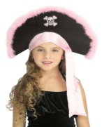
A. Answer the questions according to the text below. (Metni okuyun ve soruları metne göre cevaplayınız.) 5×4= 20 pts.
Hi! I’m Sandy from Canada. I must go shopping immediately because we have a Halloween party on 31st October.
We need a lot of pumpkins, some sweets, a few pirate hats and different monster costumes. There is only a little coke in the fridge. So, I should also buy lots of beverages. But, fizzy drinks are too expensive in Canada. For example; a bottle of coke is 10 $! Can you believe it? Anyway, we want to have a nice party and enjoy it together.
(Fizzy: asitli)
1- How much is coke in Canada?
..............................................................
2- What do they need for the party?
.................................................................
3- When is Sandy’s Halloween party?
..............................................................
4- How much coke is there in the fridge? ..............................................................
5- How many pirate hats do they need? ..............................................................
B. Write the TV programmes. 5×2= 10 pts.
(Resimlerin altına Tv programlarını yazınız.)
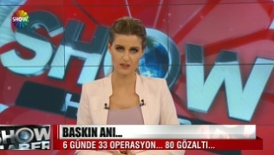

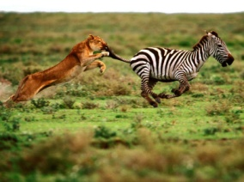
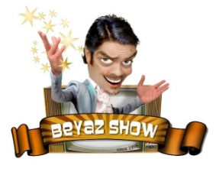
...................... ......................

................ .................. .................
C. Combine the sentences using
“prefer (s) ......... to.......”
(Cümleleri “ prefer (s) ... to ...” kullanarak birleştiriniz.) 5×3= 15 pts.

1- I don’t like Science, but I like English.
........................................................
2- Ceyhun likes drinking ayran. He hates
eating “çiğ köfte”.
........................................................
3- Edanur loves horse riding. But, she doesn’t
like volleyball.
........................................................
4- Lions eat meat, but they never eat plants.
........................................................
5- Playing the piano is boring, but
playing the drums is fun. ........................................................
D. Fill in the blanks with “ Let’s ... /
Why don’t we ... / Should / Would you like ”
(Boşlukları “ Let’s... / Why don’t we ... /Should ya da Would you like ” ile doldurunuz.) 5×2= 10 pts.

1-) Anıl: What a nice party!
Naz: .................. dance together!

2-) İdaal: ........................... some more cake?
Cansu: No, thanks.

3-) Ebrar: Tomorrow is our parents’ wedding
anniversary!
Melis: ........................ throw a surprise party?

4-) You .................. wear your coat.
It’s very cold outside.

5-) ............. have some lemonade. I’m thirsty.
E. Fill in the blanks with the suitable word
from the box below. (Boşlukları kutudan
uygun kelimeyle doldurunuz.) 5×3= 15 pts.
I don’t agree with you According to
I agree with you How many
In my opinion How much
Fancy-dress Wedding
Guest list To-do list

1- ......................... me, the exam was very easy. The teacher cheated us!
2- .................... plates did you put on the table?
3- Nihal: I think English is very exciting!
Beyza: No, it isn’t. .........................................
4-Yesterday, my friends gave a ...........................
party. We wore colourful clothes and hats.
5-İrem: Who shall we invite to the party?
Gizem: Why don’t you prepare a .........................
F.Circle the right word written in bold.
(Koyu yazılan kelimelerden doğru olanı
yuvarlak içine alınız.) 5×2= 10 pts.
1- There is a little / a few honey on the table
2- We have a little / some candles for the party.
3- She doesn’t have much / many money.
4- Supermarkets and shopping malls don’t sell
no / any flour in my country.
5- Her uncle won a few / much prizes on Tv
quiz shows last year.
G. Choose the best option.
(Doğru seçeneği işaretleyiniz.) 10×2= 20 pts.
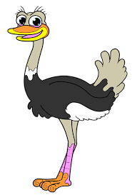
1- Put the animals in order.
-- --

a) seal - ostrich - owl b) ostrich – owl - seal
c) seal - owl - ostrich d) owl - seal - ostrich
--------------------------------------------------------
2- BJK fans will ........................ the
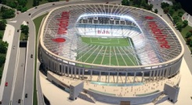
championship in VODAFONE ARENA.
a) invite b) prepare
c) celebrate d) order
3-What is the meaning of the TV sign below?
a) contains violence
b) suitable for general audiences
c) contains negative behaviors
d) suitable for ages 13 and over
---------------------------------------------------------
4- Semanur: What does “decorate” mean?
Rabia: I don’t know. You should ......................
an English dictionary.
a) collect b) look up
c) bake d) request
--------------------------------------------------------
5- Sunay has a birthday party on 18th March.
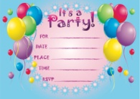
She sent me an ..........................
a) watch b) invitation card
c) candle d) guest
---------------------------------------------------------
6- Gökhan: Do you like soap operas ?
İbrahim: No, I don’t. They are very ...............
a) amusing b) exciting
c) excellent d) nonsense
---------------------------------------------------------
7- Teacher: Study hard! It is a difficult exam.
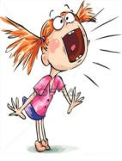
Şevval: Oh, no. Why is it difficult?
Teacher: Don’t ................., please!
a) deliver b) hire
c) complain d) spend
---------------------------------------------------------
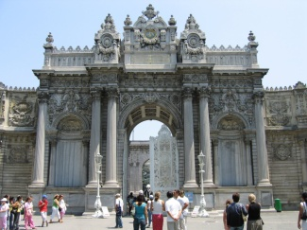
8- Dolmabahçe Palace is an important ................. building. It has 285 rooms and a lot of expensive .......................
a) historical / furnitures
b) scientific / pockets
c) educational / crew
d) harmful / baskets
---------------------------------------------------------
9- My daughter .................. a director in 2007. Now, she works for Star Tv and TRT.
a) happened b) became
c) donated d) turned
---------------------------------------------------------
10- This morning, I didn’t have a breakfast.
I ate only .............. bagels and drank tea.
a) a little b) much
c) a lot of d) a few

İBRAHİM ÖZTÜRK
ELT

