2014-2015 ACADEMIC YEAR TEZER TAŞKIRAN SECONDARY SCHOOL
2nd TERM 1st ENGLISH EXAM FOR 7th GRADERS

NAME & SURNAME: CLASS & NUMBER: MARK:

A. Answer the questions according to the text below. (Metni okuyun ve soruları metne göre cevaplayınız.) 4×5= 20 pts.
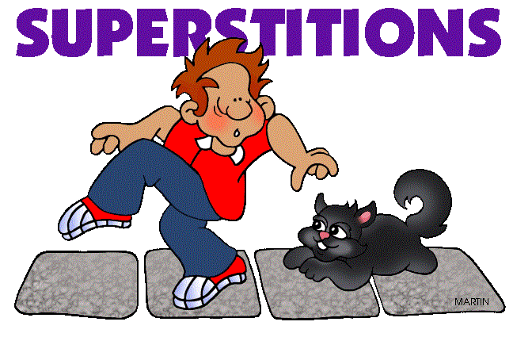
There are a lot of different superstitions in the world. For example; in Russia, you shouldn’t wash your head before an exam. Turkish people believe that seeing a black cat is bad for you, but in England or Japan, it brings good luck. When people find a four-leaf clover in Africa, they get happy because they think they’re lucky. They also don’t walk under a ladder or open an umbrella indoors because these actions mean bad luck.
1- What is considered bad luck in Turkey?
..............................................................
2- What shouldn’t you do before an exam in Russia?
..............................................................
3- What is considered good luck in Africa?
..............................................................
4- Is a black cat good luck or bad luck in Japan? ..............................................................
°°°°°°°°°°°°°°°°°°°°°°°°°°°°°°°°°°°
B. Circle the correct word in bold.
(Koyu yazılan kelimelerden doğru olanı
yuvarlak içine alınız.) 5×2= 10 pts.

1- There is a little / a few honey on the table
2- I have a little / some candles for the party.
3- There are one / a lot of forests in Rize
4- My uncle bought a few / a lot houses in Şile
5- She drank some / a few coffeé at café
C. Match the program types with the pictures below. (Program türleriyle resimleri eşleştiriniz.) 5×3= 15 pts.
TV SERIES - QUIZ SHOW - CARTOON - NEWS - TALK SHOW – DOCUMENTARY - SIT-COM - REALITY SHOW - COMMERCIAL

...................... ......................
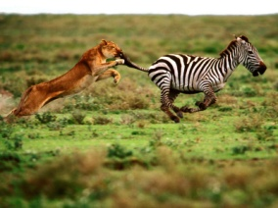
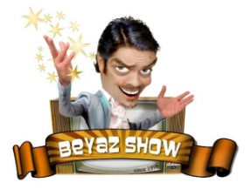
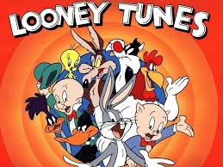

................. ................ .................
°°°°°°°°°°°°°°°°°°°°°°°°°°°°°°°°°°°

D. Fill in the blanks with “ Let’s... / Why don’t ... / Should”
(Boşlukları “ Let’s... , Why don’t ... , ya da Should” ile doldurunuz.) 5×2= 10 pts.

1- Ceren: I’m bored.
Ezgi: .................. go to the cinema.

2- You .................. wear your raincoat. It’s raining heavily today.

3- .................... we give a surprise birthday party for our teacher, Mrs. Lütfiye Ovacık?

4- ............. go to the canteen. It’s lunchtime !

5- İrfan: I have got a terrible cold!
Gökhan: .................... you see a doctor?

E. Fill in the blanks with “WILL or WON’T ” (Boşlukları “ WILL ya da WON’T” ile doldurunuz.) 5×2= 10 pts.
1-If you study hard, you ............. be very
successful at English lesson.
2- I ............. buy this house because it is very
expensive
3- How old ............. you be next year?
4- In the future, cars ............... be faster.
Technology is improving fast.
5- Dilara has no ticket. I think she .................
come to the cinema tonight.
°°°°°°°°°°°°°°°°°°°°°°°°°°°°°°°°°°°
F. Combine the sentences using “prefer (s) ......... to.......”
(Cümleleri “ prefer (s) ... to ...” kullanarak birleştiriniz.) 5×3= 15 pts.
1- I don’t like Maths, but I like English.
........................................................
2- She likes drinking milk, but hates coke.
........................................................
3- Ali loves baseball. He doesn’t like sailing
........................................................
4- Lions eat meat, but they never eat plants
........................................................
5- We like reading palms, but we don’t like reading coffeé.
........................................................
G.Choose the best option.
(Doğru seçeneği işaretleyiniz.) 10×2= 20 pts.

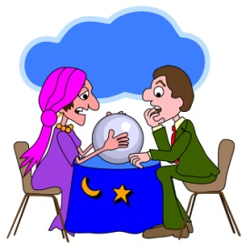
1- I had a bad dream last night. I should go to a .................... and ask her.

a) celebrity b) director
c) fortune teller’s d) blue bead
--------------------------------------------------------
2- Acun and Angelina are going to get married tonight. Will you come to their ........................ party?
a) halloween b) pyjamas
c) birthday d) wedding

3- Canan: The English exam was too difficult.
Nazar: ..................................... I think it
was very easy!
a) I don’t agree with you b) OK.
c) Yes, it was. d) Great idea!
--------------------------------------------------------
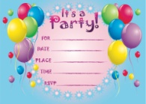
4- Tina is going to give a birthday party next Sunday. She sent me an ................................
a) gift b) invitation card
c) beverages d) guest
--------------------------------------------------------
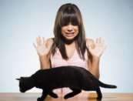
5- My sister is a .......................... girl. She always believes in good and bad luck.
a) charm b) misfortune
c) superstitious d) evil - eye
--------------------------------------------------------
6- Umut: It is sunny today. Let’s go to the park and play with the dogs there
Arda: ......................................
a) I don’t agree with you b) Thank you.
c) Yes, it was. d) Yes, let’s.
--------------------------------------------------------
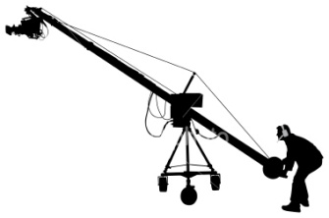
7- Tarık is a .......................... he works for NTV and Star TV Channels
a) jimmy jib operator
b) set decorator
c) costume designer
d) director
--------------------------------------------------------
8- Boy: There is no food in the fridge. Let’s
make a shopping list.
Mom: ........... buy some coke. .............., order pizzas. ................ , buy a lot of fruits.
a) Finally-Then-First b) First-Then-Finally
c) Second-First-Then d) First-Finally-Second
--------------------------------------------------------
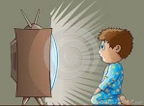
9- Scientists think that Tv can be very ................. for children between ages 4-8
a) behaviour b) nonsense
c)historical d) harmful
--------------------------------------------------------
10- I watch ............. to learn about the
events in the world.
a) soap opera b) news
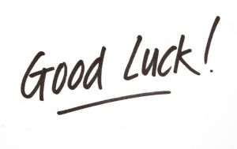
c) sit-coms d) quiz shows

