MATCH THE SENTENCES (2 points)
1-Who are you arranging a surprise party for? a)Depends on the weather.It is usually rainy.
2-Would you like to go to a pyjama party? b)I’m sorry,I can’t.I am very tired.
3-Let’s have an outdoor party! c)that’s not a good idea .I don’t like board games
4-What about playing backgammon? d)Yes,let’s.We can cook lasagne.
5-Would you like to go shopping? e)Not more than 10.Just my close friends.
6-Let’s invite some friends! f)Sure!Where is the party?
7-How many friends do you want to invite? g ) Let’s make a shopping list.
8-Would you like to come to our best friend’s graduation party? h)My sister.
9-What do we need for the dinner? İ)Of course!I love fruit.
10-Would you like some strawberries? J) I am afraid,I can’t.I have alot of work to do.
1 | 2 | 3 | 4 | 5 | 6 | 7 | 8 | 9 | 10

FILL IN THE BLANKS WITH THE TV PROGRAMMES(3 points)
1------------------------------: I don’t enjoy stories about people’s everyday lives because they are usually dramatic.
2------------------------------: This programme is about ordinary people’s everyday lives.I enjoy itbecause watching people in real situations is fun.
3------------------------------:It is an amusing TV series about fictional and funny characters.
4-----------------------------: The guests talk about themselves and their works.
5----------------------------: People compete with each other by trying answer questions.
FILL IN THE BLANKS WITH THE WORDS IN THE BOX.(3 points)
Keen on sitcom remote control snacks skip

My name is Greg.I’m 12 years old.In my free time ,I prefer watching TV.I’m ---------------------- sports programmes and --------------------------. I sometimes ----------------------- meals.I like having …………………
while watching TV.The ------------------------- is always in my hand.I have a look at channels all the time.

MULTIPLE CHOICE(2 points)
1-Your friend invites you to his party.Refuse the invitation:
a)Okay.ıt sounds better. b)Who do you invite*
c)Sorry,but it is not a good idea. d)Yes,let’s.Great idea
2)Suggest decorating the room:
a)Could you please decorate the garden? b)Why don’t we decorate the garden?
c)what is the exact number? d)Okay.It sounds better.
3)Your friend ask sif you want some more juice.Accept the offer:
a)Do you want a glass of juice ? b)No,thanks.
c)Yes,just a little,please. d)No,I am not thirsty.
4)Your sister is preparing the invitation cards,and you want to learn the names of the guests:
a)What is the exact number? b)Who do you invite?
c)Yes,let’s.Great idea d)Not more than 10. Just my close friends.
5)You need to wrap the presents.Ask for help:
a)Could you help me wrap the presents? b)Do you need help to wrap the presents?
c)I can help you to wrap the presents d)Sorry.I can’t help you.
READ THE PARAGRAPH AND STATE TRUE OR FALSE(2 points)
Emily has some superstitions .She believes that number 5 brings good luck to her.When she travels to another city she prefers buying number 5 seat on the plane because she thinks she will have a safe flight.Emily has also a lucky object.If she has an important business meeting,she wears her blue scarf.She forgot to wear it for the meeting last Monday and she failed to get the job.When she returned home she was unhappy.she promised herself not to forget it again.
1-Emily is not a superstitious person. ------------
2-She thinks she will have an accident when she buys number 5 seat. ------------
3-She got the job because she didn’t forget her blue scarf. -------------
4-She likes wearing her blue scarf. -------------
5-She didn’wear her blue scarf last Monday. -------------

WRITE THE WORDS UNDER THE PICTURES(3 POİNTS)

–FourleafClover – Fortune Teller - Palm Reading – EvilEyeBead - Ladder– BrokenMirror
Candles beverages invitation card gift

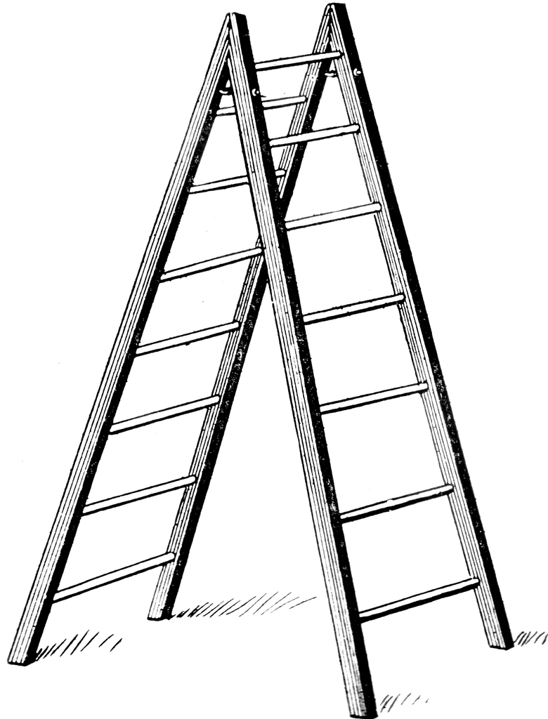

----------------------- ------------------ --------------------- ---------------------- -------------
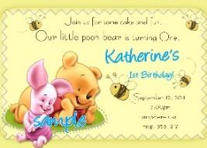

----------------- ----------------------- --------------------------- ----------------------- -------

GOOD LUCK!

