**_____________SECONDARY SCHOOL**

**2017-2018 EDUCATION YEAR**

**7th GRADE 2nd TERM 1stENGLISH EXAM**

**Name :______________________ Number : _______ Date :__/03/2017**

**Surname :______________________ Class :7 / Mark :**

**A) Write the party types under the pictures.** (Partitürleriniresimlerinaltınayazın)**(4x5=20pts)**

**birthday party - wedding party - pyjamas party - halloween party - fancy dress party**

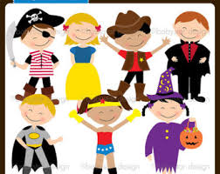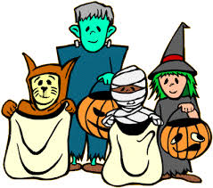

**1)________________ 2)_______________3)_____________________ 4)_________________ 5)_________________**

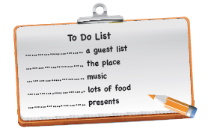**B. Complete the “TO DO LIST”** (Yapılacaklarlistesini doğru kelimelerle tamamlayınız)**(2x5=10pts)**

**buy**

**decorate**

**prepare**

**prepare**

**arrange**

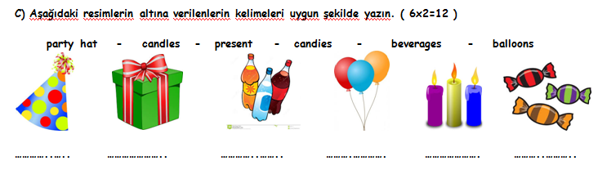

**D)Verilen diyaloğa göre Tina’nın babası doğum günü pastası için marketten neler alacak?’Shoppinglist’i en doğru şekilde hazırlayınız. (2x5=10 puan)**

***shoppinglist***

*……………………

*……………………

*…………………….

*……………………..

*………………………

**Father:** Mary, I am at thesupermarket. What do weneedforthebirthdaycake?

**Mother**: Well, let me look at thefridge! Wedon’thaveanyeggs. Buy 5 eggsandsomemilk.

**Father**: OK. 5 eggsandsomemilk. What else?

**Mother**: Oh, buy a littlebutterandflour. Also, buy somesugar.

**Father**: OK. I’ll be at home in an hour.

**E) Matchthewordstothepictures**(Resimlerle kelimeleri eşleştirin)**(3x5 = 15pts)**

1. Coffee- Reading **B)** Palm-Reading **C)** Magic Ball **D)** Astrology **E)** Tarots



_____________ ______________ ______________ _____________ ____________

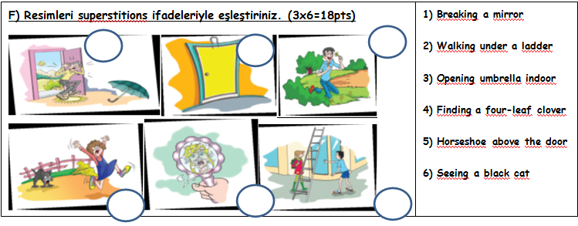

**G)KOYU YAZILANmiktarifadelerindenDOĞRU OLANIyuvarlakiçinealın.(3x5=15pts)**

**1.** There is ***a little / a few*** cheese on the plate.

**2.** There are ***a few / a little*** apples in the basket.

**3.** I need**any / some**sugarforthecake.

**4.** How**many/ much**milk is thereforbreakfast?

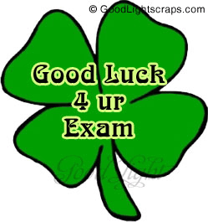**5.**How**much/ many**tomatoesarethere in thefridge?

**English Teacher**