BİLAL YAŞAR SECONDARY SCHOOL 2017/2018 ACADEMIC YEAR 7TH GRADES
2ND TERM 1STWRITTEN EXAM
Name&Surname: Number: Class:

- Matchthewordswiththepictures.(5x2=10 points)
a) birthdayparty | b) weddingparty | c) pyjamasparty | d) halloweenparty | e)fancydressparty
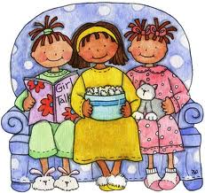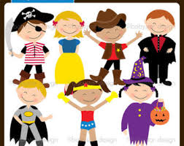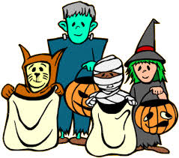

B) Davetiyeye göre soruları cevaplayın. (4x3=12 pts)
1. Whattype of party is it?
-

2. Where is theparty?
-

3. What time is theparty?
-

4. Is theparty in theafternoon?
-
C) Complete thesentenceswith “Let’s”, “ Whydon’t” “should”. (5x2=10 points)

1. A: I’m thirsty.
B: ______________________ youdrinksomelemonade?
2. A: It’scoldoutside.
B: You ______________________ wearyourcoat.
3. A: I am bored.
B: ______________________ play a game.
4. A: I don’tknowthemeaning of “manage”.
B: ______________________ welookup a dictionary?
5. A: Tomorrow is ourparents’ weddinganniversary.
B: ______________________ weprepare a surpriseparty?
6. A: I have a stomachache.
B: You ______________________ see a doctorimmediately.

D) Matchthequestionswiththeiranswers. (5x2=10pts)

1. Wouldyouliketojoinourparty? …… a. Mom can makedeliciouscakes.
2. Can youhelp me todecoratetheroom? …… b. Talha. He will buy fruitjuice.
3. Who is responsibleforthebeverages? …… c. It’s on thetable. Let’swriteinvitationcards.
4. Who can make a birthdaycake? …… d. I’dloveto. I loveparties.
5. Where is theguestlist? …… e. I’m sorry I can’t. I have an exam on Friday.

E) Choosetheright Word andwriteunderthe Picture. (7x2= 14pts)

Horseshoe – Black cat – FourleafClover – Fortune Teller - ThirteenthFriday - Palm Reading – EvilEyeBead - Coffee Reading – Umbrella - Ladder – BrokenMirror – Touchwood

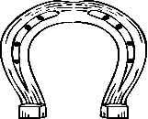
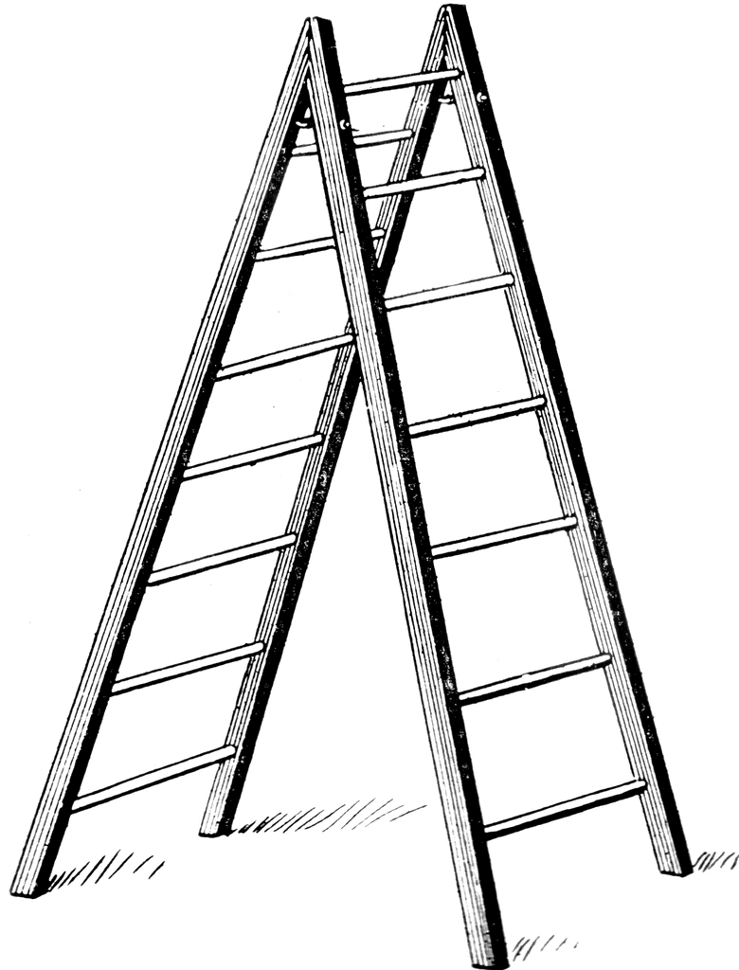

…………………………………………………………………………………………………………

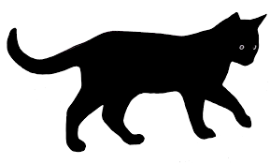
F) Cümlelerin diğer yarılarını bulun. (5.2=10 pts)
1. Ifyousee a blackcat, …… a. he/shewillavoidthebadluck.
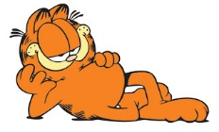
2. Ifsomeoneknocksthewood, …… b. it meansyouwillhavebadluck.
3. Ifyoufind a fourleafclover, …… c. it bringsyougoodluck.
4. Ifyouarefat, …… d. you can havegoodmarks.
5. Ifyoustudy hard, …… e. youshould do sports.

G) Circlethecorrectone. (10x2=20 points)

1.How many / How mucheggs do youneedforthecake? 8. A: Wouldyoulikesome / a fewtea?
2. I don’thavea lot of / anymilkforpreparing a milkshake. B: Justa lot of / a little.
3. Wehavelittle / fewsugar. Weneedto buy some. 9. How much/ many cheese have we got?
4. I needany / somebananasforthecake’sdecoration.
5. Would you like many / some salt for your soup?
6. There are a lot of / a little bananas in the fridge.
7. There are a few / a little children in the classroom.

H) Choosetherightanswer. (7x2=14 points)
4)Fortune teller: “You will be very rich in the future.”
Mehmet: _____________.
a) I hope so. b) Your are lucky.
c) I hope not. d) I think

1) People believe that “a broken mirror………..”
a) brings bad luck
b) protects from evi l eye
c) brings good luck
d) is a horoscope name

Canan GÜNGÖREN (ELT)
7)Arda: Would you like some lemonade?
Tuna: Yes, _______________please.
a) many b) just a few
c) one or two d) just a little

6) It is a………………..
a) palm reading b) coffee reading
c) magic ball d) tarot cards

5) A: Would you like to come to my party?
B: Thanks for …………….. me. But I’m sorry, I can’t.
a) joining c) inviting
b) sending d) preparing

3) do/ next/ you /will/ weekend /what?
Bu cümlenindoğrusıralanışıhangisidir?

a) Will what you do next weekend?
b) You will do what next weekend?
c) What do you will next weekend?
d) What will you do next weekend?

2) Tina: We are having a party for Ted on Saturday evening . ……………………..….?
Joe: Yes, I’d be happy to.
a) Why don’t you join us b) I’m sorry, I can’t c) Would you drink anything d) Where is it

