2017-2018 ACADEMIC YEAR OSMANCIK SECONDARY SCHOOL
2ND TERM 1STWRITTEN ENGLISH EXAM FOR THE 7TH GRADES

Name-Surname: Class: 7 / No: MARK:

- Soru ve cevapları eşleştirin. (5.3=15pts)

1. Wouldyouliketojoinourparty? …… a. Mom can makedeliciouscakes.
2. Can youhelp me todecoratetheroom? …… b.Talha. He will buy fruitjuice.
3. Who is responsibleforthebeverages? …… c.It’s on thetable. Let’swriteinvitationcards.
4. Who can make a birthdaycake? …… d.I’dloveto. I loveparties.
5. Where is theguestlist? …… e.I’m sorry I can’t. I have an exam on Friday.

- Tablodan seçtiğiniz kelimeleri resimlerin altına yazın. (7.3= 21pts)

Horseshoe – Black cat–FourleafClover – Fortune Teller - ThirteenthFriday - Palm Reading – EvilEyeBead - Coffee Reading – Umbrella - Ladder– BrokenMirror – Touchwood

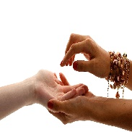
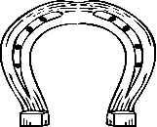
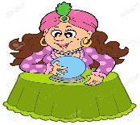
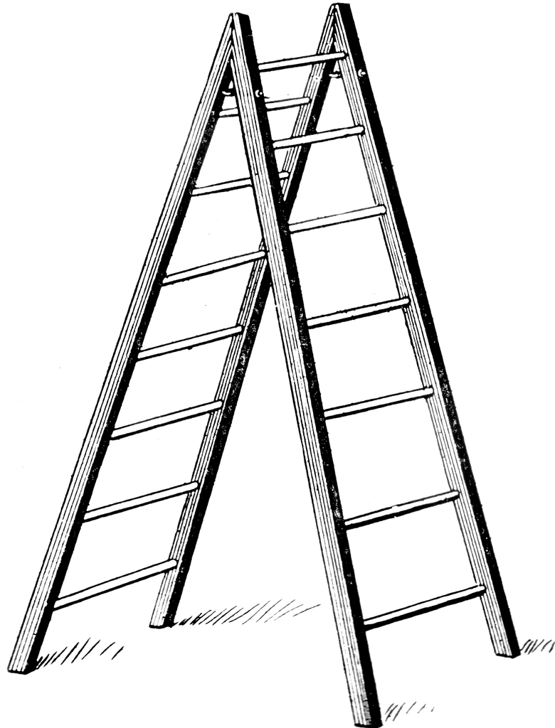

…………………………………………………………………………………………………………

- Davetiyeye göre soruları cevaplayın. (4.3=12 pts)
1. Whattype of party is it?
- ………………………………………

2. Where is theparty?
- ………………………………………

3.What time is theparty?
- ………………………………………

4. Is theparty in theafternoon?
- ………………………………………

- Koyu yazılmış olan kelimelerden doğru olanı yuvarlak içine alın. (5.2=10 pts)

1. How much / manywaterhavewegot?
2. Thereisn’tany / manymilk in thefridge.
3. Therearea little / a fewtomatoes in the basket.
4. Let’sgotothe market and buy some / anyoil. There is nooliveoil in thekitchen.
5. Thereisn’tsome / anycheeseforthebreakfast. Pleasegoandbuysome.

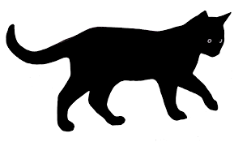
- Cümlelerin diğer yarılarını bulun.(5.2=10 pts)

1.Ifyousee a blackcat, …… a. youshoulduseevileyebead
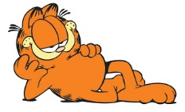
2.Ifsomeonelooks at you in a badway, …… b. it meansyouwillhavegoodluck
3. Ifyoufind a fourleafclover, …… c. youshouldpullyourhair
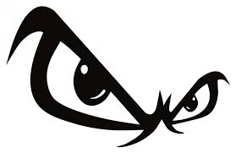
4.Ifyouarefat, …… d. you can havegoodmarks
5. Ifyoustudy hard, …… e. youshould do sports

F. Resimlerin altına isimlerini yazın. (4.2=8pts)
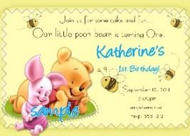

………………. ………………. ………………. ……………….

G. Choosethecorrectoption. (8.3=24pts)

1. Whatdoes Meltem looklike?
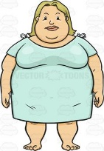
a. She’sgenerous
b. Shelikes hamburger
c. She is fatandblonde
d. She is anhonestgirl

2. What’swrongabout Marie Curie?

a. ShewasPolish
b. Shewas a famoussinger
c. Shewas a chemist
d. Shewonthe Nobel prize

3. Racket, ballandtrainersare
……….fortennis.

a. spectators
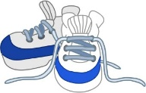
b. equipments
c. individuals
d.outdoors

4. Boşluklara hangisi gelmez?
‘ ……….., ………….. , ……………..
areoutdoorsports.’

a. karate
b. roller-skating
c. golf
d. skateboarding

5. Hangi seçenek doğrudur?

a. Carnivoreseatleaves.
b. Rabbit is a wildanimal
c. Deerhavehorns
d. Dolphins’s habitat is theair

6. Can: Doelephantshunttigers?
Osman: No, ………………
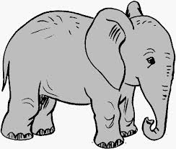
a. theylikelions
b. theyarecarnivores
c. theyarethereptiles
d. theydon’teatmeat

7. Gizem: Do youlike ‘Arka Sokaklar’?
Tuğba: Yes, ………………….
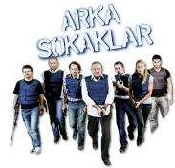
a. I likehorrormovies
b. I likeseries
c. I hatenews
d.It’smyfavoritedocumentary

8. Boşluğa hangisi gelemez?

A: How often do youwatchsportsprogrammes?
B: ……………………………
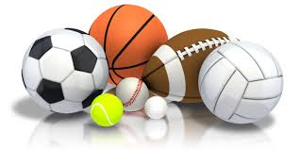
a. Once a week
b. At 8 p.m
c.EveryWednesday
d. On Sundays
GOOD LUCK

