# Rainbow Baby Owl Cartoon Stock Photo - 17613838 2016-2017 ACADEMIC YEAR

**7.**

**SINIF**

**………………………………………………………….**

**2ND TERM 1ST  WRITTEN EXAM**

**NAME: CLASS: NUMBER:**

**1.** **Boş bırakılan yere uygun düşen seçeneği işaretleyiniz.**

What should we buy for Hilal?

_________.



No, she has a bird.

OK. then let’s buy her a phone.

|  |  |
| --- | --- |
| **A)** Let’s buy a CD. | **B)** Why don’t we buy a book? |
| **C)** Shall we buy jeans? | **D)** How about buying a pet? |

**2.** **Boş bırakılan yere aşağıdakilerden hangisi uygun düşmez?**

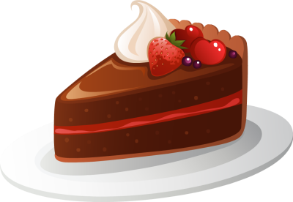

**Ahmet :** Would you like some cake?

**Asya : __________**I’m on a diet.

|  |  |
| --- | --- |
| **A)** No, thanks. | **B)** I think it’s a good idea. |
| **C)** Great idea! | **D)** Sounds great. |

**3** **. Boşluklara uygun sıralamayı seçiniz.**

* I haven’t got______time to read books. I’m very busy.
* Can I have______cookies? Yes, but just_____please.
* There is _______milk in the fridge. Don’t buy it.

|  |  |
| --- | --- |
| **A)** some-any-much-many | **B)** a few-some-any-much |
| **C)** a lot of-any-many-some | **D)** any-some-a few-a lot of |

**4.Resimleri verilen parti türlerinin isimlerinin doğru sıralandığı seçeneği işaretleyiniz.**

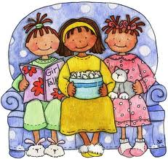 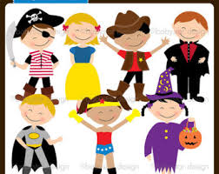 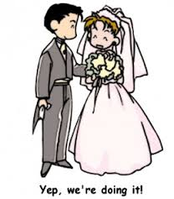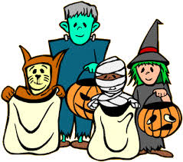

**a)** halloween party / wedding party / pyjamas party / birthday party

**b)** pyjamas party / fancy dress party / wedding party / halloween party

**c)** wedding party /pyjamas party / halloween party / fancy dress party

**d)** fancy dress party / pyjamas party / wedding party / halloween party



**5.Yandaki liste seçeneklerden**

**hangisi ile *tamamlanamaz?***

**It’s Kemal’s graduation party.**

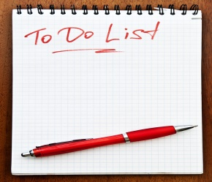

|  |
| --- |
| **A)** Decorate the room. |
| **B)** Order the cake. |
| **C)** Wear your pyjamas and bring pillow. |
| **D)** Arrange the music. |

**6. Boş bırakılan yere uygun düşen seçeneği işaretleyiniz.**

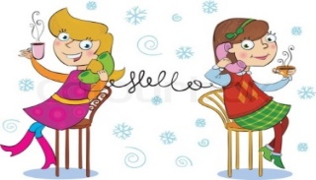

_______I have an exam tomorrow.

Would you like to eat out tonight?

**a)**Sounds great! **b)**That's a good idea. **c)**Sure. **d)**I'm sorry but I can't.

**7. Boş bırakılan yerlere uygun düşen sıralamayı seçiniz.**

– I’m hungry. - ……………… eat the cake?

- I’m bored. - ……………… play chess.

- I have a toothache. – You ……………… see your dentist.

**a)** should / Shall we / Let's  **b)** Let's / should / Why don't we

**c)** Why don't we / Let's / should **d)** Shall we / should / Let's

**( 8. ve 9. soruları verilen davetiyeye göre yanıtlayınız.)**



**Dear Ceylin**

**I am turning 13.**

**Come and enjoy my party.**

**Love**

**Ege**

**3rd May Thursday**

**02.30 p.m**

**Flower Cafe**

**8. What kind of party is it?**

|  |  |
| --- | --- |
| **A)** It's a halloween party. | **B)** It’s a wedding party. |
| **C)** It's a birthday party | **D)** It's a fancy dress party. |

**9. Davetiyeye göre hangi ifade yanlıştır?**

|  |
| --- |
| **A)** The party is at half past two in the afternoon. |
| **B)** The party is in Flower Cafe. |
| **C)** It is Ege's birthday party. |
| **D)** It is on 13th May. |

**10. Konuşmadaki boşlukları tamamlayınız.**

** **

…………… oranges are there?

There are only ..... oranges**.**

**a)** How many / a few **b)** How often / a little

**c)** How much / a few **d)** How many / a little

**11**. **Aşağıdaki paragrafta *bahsedilmeyen* nesne hangi seçenektedir?**

In Turkey, there are interesting beliefs. If you open an umbrella in the house, you’ll have bad luck. If you take scissors from someone’s hand, you’ll fight with him / her. If you wear blue beads, it’ll protect you from the evil eye.

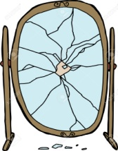



|  |  |  |  |
| --- | --- | --- | --- |
| **A)** | **B)** | **C)** | **D)** |

**12**. **Görsele göre cümledeki boşluğu doldurunuz.**

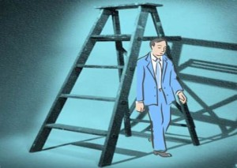

**Oh no!________. It will bring me bad luck.**

|  |  |
| --- | --- |
| **A)** I broke my mirror | **B)** I walked under a ladder |
| **C)** I cut my nails at night | **D)** I saw a crow in my dream |

**13. Aşağıdaki cümleler doldurulduğunda hangi kelime dışarıda kalır?**

* Seda is very _____.She always breaks plates and glasses in the kitchen.
* My _______number is 16.
* Emir turned 13 last week so there were 13 _____on his birthday cake.

**a) lucky b) candles c) clumsy d) surprise**

Don’t worry!______.

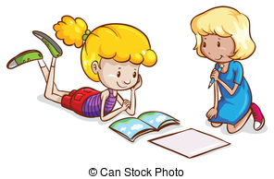**14.Konuşmayı tamamlayınız.**

Mum, these problems are difficult I can’t solve them.

|  |  |
| --- | --- |
| **A)** You’re a lazy student | **B)** I’m very busy now |
| **C)** I will help you | **D)** You won’t get a high mark |

**15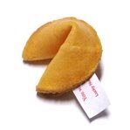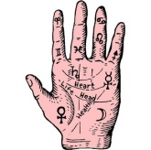. Aşağıda resimleri verilen nesnelerin isimlerinin bulunduğu seçeneği işaretleyiniz.**

|  |
| --- |
| **A)** scissors - four leaf clover – horseshoe - umbrella |
| **B)** horseshoe - fortune cookies - four leaf clover - umbrella |
| **C)** palm - four leaf clover – horseshoe – fortune cookies |
| **D)** four leaf clover – horseshoe – palm reading – fortune cookies |

**16. Ecem’in cümlesini uygun şekilde tamamlayınız.**

**Yaren:** Let’s go to a fortune teller after school.

**Ecem:** I’m sorry I can’t.________________

|  |  |
| --- | --- |
| **A)** Coffee reading or palm reading? | **B)** Sounds great. |
| **C)** I don’t believe in fortune telling. | **D)** I love fortune tellers. |

**17. Aşağıdaki cümle hangisi ile *tamamlanamaz?***

This week will be good for you._____________.

|  |
| --- |
| **A)** You will have an accident |
| **B)** Your father will give you 500 Liras |
| **C)** Your friends will give a surprise party |
| **D)** You will get 100 from the English exam |

**18. Konuşmanın doğru sıralaması hangi seçenektedir?**

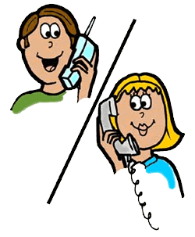

**1.**Let me look at the fridge. Hmmm. I need some cheese.

**2.**Ok. mum. See you at home.

**3.**Ok. What else?

**4.**And some butter, please.

**5.**Hi, mum. I am at the market. Do you need something?

**20. Aşağıdaki diyaloğu uygun şekilde tamamlayınız.**

**Deniz:** Shall we go to the cinema?

**İhsan:** I'd love to but _________.

|  |
| --- |
| **A)** I prefer going to the cinema |
| **B)** I don’t want to study |
| **C)** I will study for the exam |
| **D)** I love watching movies |

**21. Seçeneklerden hangisi “BAD LUCK” kategorisi için uygun değildir?**

|  |  |
| --- | --- |
| **A)** place a blue bead | **B)** friday 13th |
| **C)** walking backwards | **D)** black cat |

**22. Cümleleri tamamlayan seçeneği işaretleyiniz.**

* My parents went to İzmir ________ week.
* We weren't at home _________.
* I visited my grandparents two weeks _______.

**a)** last / yesterday / ago  **b)** ago / last / yesterday

**c)** yesterday / ago / last **d)** ago / yesterday / last

**23.Doğru eşleştirmenin olduğu seçeneği işaretleyiniz.**

|  |  |
| --- | --- |
| **1.** You go this place to have rest and have a cup of coffee. | a. pharmacy |
| **2.** In this place you read or borrow books | b. greengrocer's |
| **3.** You go this place to buy some medicine when you are ill. | c.cafe |
| **4.** You go to this place to buy some fruit and vegetables. | d. library |

**a)** 1-a / 2-b / 3-c / 4-d **b)** 1-c / 2-d / 3-a / 4-b

**c)** 1-d / 2-c / 3-b / 4-a **d)** 1-b / 2-a / 3-c / 4-d

**24.Boşlukları doğru tamamlayan seçeneği işaretleyiniz.**

I and my mother __________ to the shopping mall yesterday. I __________ a white t-shirt and a pair of shoes. My mother didn't buy anything. Then, we ______ tired and ________ some coffee in a cafe.It was a nice day.

**a)** went / bought / got / drank **b)** go / bought / get / drank

**c)** went / buys / got / drink **d)** go / buy / get / drink

**25**.**Boşlukları doğru olarak tamamlayan seçeneği işaretleyiniz.**

My birthday is _____ 18th April.

M.Kemal Atatürk was born _____ 1881.

I go to school _______ 8 o'clock.

a) at / on / in b) in / on / at

c) at / in / on d) on / in / at

|  |  |  |  |
| --- | --- | --- | --- |
| **A)** 3-4-1-5-2 | **B)** 5-1-4-2-3 | **C)** 5-1-3-4-2 | **D)** 3-4-5-1-2 |

**19. Konuşmadaki boşlukları doğru tamamlayan seçeneği işaretleyiniz.**

 

**GOOD LUCK !!!**

ELÇİN ECE

ELT



No thanks. I prefer _______ documentaries

Would you like ______ a movie?

**a)** watching / watching **b)** to watch / watching

**c)** watch / to watch **d)** watching / to watch