1. **Write the words under the correct Picture (5x2=10 points)**

*Fancy dress party- halloween –graduation party –wedding party –birthday party-sleepover party-christmas party*

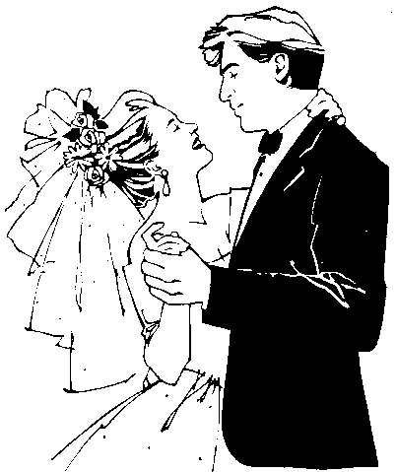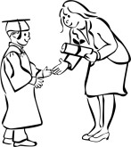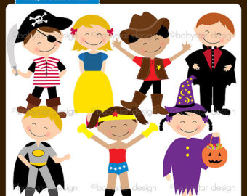

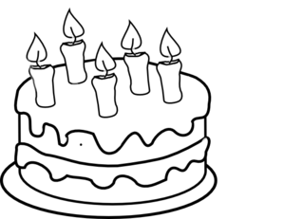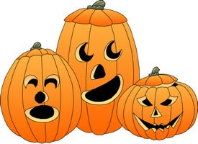

**B) Fill in the blanks with appropriate word (5x3=15 points)**

**1)**_______________________ room

*Send –order –buy –ask- decorate*

**2)**_______________________cake

**3)**_______________________beverages

**4)**_______________________invitation cards

**5)**_______________________permission from parents

**C) Fill in the blanks with appropriate word.(5x3=15 points)**

*What about –Why don’t–Let’s –*

*should-Would you like*

**1.**__________________________ giving a surprise party?

**2.**__________________________ we arrange the music?

**3**.We_________________ write invitation cards.

**4.**________________________ prepare a lot of food.

**5.**_________________________ to join my pyjamas party?

**D) Write under the pictures(5x2=10 points)**

|  |
| --- |
| **A.**Tarots- **B.**Coffee Reading - **C.** Palm-Reading - **D.** Magic Ball - **E.**Astrology |

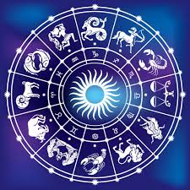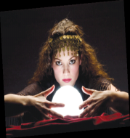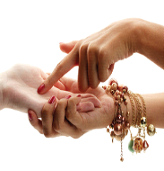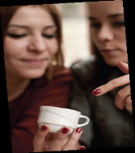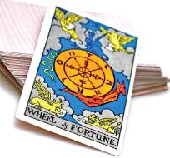

**E) Match the TV programmes with the pictures. (5x3=15 points)**

|  |
| --- |
| **Quiz show / news / sports programme / documentary / TV series / cartoon** |

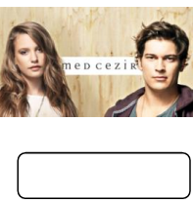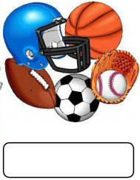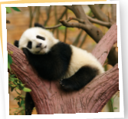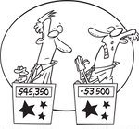

**F) Completethe sentences with the given phrases. (5x3=15 points)**

put a horseshoe

above the door

break a mirror

see a blackcat

walkingunder a ladder

find a four- leaf clover

**[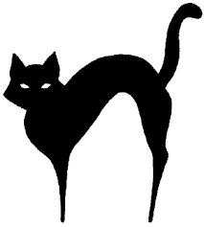](http://www.google.com.tr/imgres?imgurl=https://miljoanne.files.wordpress.com/2012/08/blac.gif&imgrefurl=https://miljoanne.wordpress.com/tag/black-cat-pass/&h=333&w=300&tbnid=yB2YpBORronsoM:&zoom=1&docid=0BLB2DPPFo41iM&ei=h4b8VLG4BIneaujvgbgP&tbm=isch&ved=0CFsQMyg3MDc)**

**1.** In Japan and Britain it is good luck to ……………………. but in Turkey it is bad luck.

**[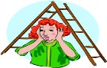](http://www.google.com.tr/imgres?imgurl=http://www.hcpl.net/sites/default/files/superstitious.jpg&imgrefurl=http://www.hcpl.net/category/tags/superstitions&h=323&w=350&tbnid=7UP2VrqR1TF1tM:&zoom=1&docid=-ZdM5XIo0-kVsM&ei=-ob8VL_4EMmOaKjRgPgG&tbm=isch&ved=0CEwQMygrMCs)2.** In many countries it is bad luck to ………………………………

**3.** If you ………………………………… [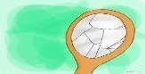](http://www.google.com.tr/imgres?imgurl=http://pad1.whstatic.com/images/thumb/e/ef/Get-Rid-of-Bad-Luck-Step-13Bullet01.jpg/670px-Get-Rid-of-Bad-Luck-Step-13Bullet01.jpg&imgrefurl=http://www.wikihow.com/Get-Rid-of-Bad-Luck&h=503&w=670&tbnid=TSfsz98E7luRtM:&zoom=1&docid=bIFydOCBQyW8UM&ei=U4f8VOfuGobjaOmkgagH&tbm=isch&ved=0CCgQMygPMA8), it will bring bad luck in many countries.

**4.**In some countries people …………………………………………. for good luck. [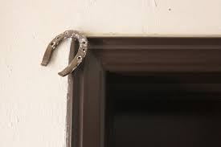](http://www.google.com.tr/imgres?imgurl=http://www.destinationeurope.net/wp-content/uploads/2011/10/albaniangoodluck_thumb.jpg&imgrefurl=http://www.destinationeurope.net/category/frifotos/&h=400&w=600&tbnid=Oy_Zm3uJdvruxM:&zoom=1&docid=twnMa_6tJjui9M&ei=wof8VLitGpftaLOVgOgP&tbm=isch&ved=0CEoQMygpMCk)

**5.** In many countries it is good luck to ………………………………………….[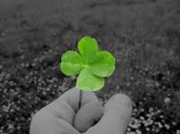](http://www.google.com.tr/imgres?imgurl=http://fourleafclovergoodluckcharms.weebly.com/uploads/2/7/5/7/2757581/4849630.jpg&imgrefurl=http://fourleafclovergoodluckcharms.weebly.com/&h=187&w=250&tbnid=tg0kR_h0BoRtuM:&zoom=1&docid=ot5J95TcQnQ8gM&ei=8Ij8VP36BZPdataugpAF&tbm=isch&ved=0CEAQMygfMB8)

**G) Complete the sentences and then match them to the pictures. 10x2=20 points**

|  |  |  |  |  |  |
| --- | --- | --- | --- | --- | --- |
|  |  |  |  | |  |
| **1. Seeing a black cat …………………………………………………**  **2. Putting horseshoes on the door…………………………….**  **3. Blue Bead …………………………………………………..**  **4. Breaking a mirror ……………………………………………….**  **5. Finding a four leaf clover ……………………………………..** | | | | **brings bad luck**  **protects against evil eye**  **brings good luck** | |