………………………….. ORTAOKULU 2017-2018 EĞİTİM-ÖĞRETİM YILI 8.SINIF İNGİLİZCE DERSİ 2.DÖNEM 1.YAZILI SINAV SORULARIDIR.

NAME-SURNAME :
NUMBER-CLASS :

A) Kelimeleri doğru resimlerin altına yazınız. (8x2=16)
motor racing hang gliding
diving with sharks ice-skating
rock climbing mountain biking
rafting hot air balloon
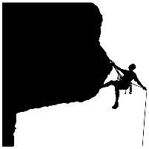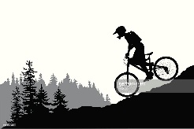

………………………. …………………………
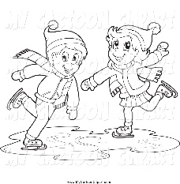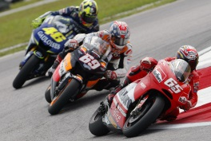

………………………. …………………………

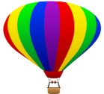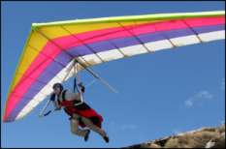

………………………. …………………………

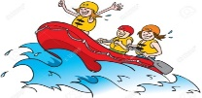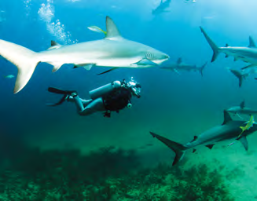

………………………. …………………………

B) Doğru seçeneği işaretleyiniz. (10x4=40)

1. I would rather visit historic sites. …………… , they are more interesting.

a) Or b) To me c) But d) However

2. Dangerous activities such as rafting, bungee jumping, ice climbing are called …………..…… .

a) adrenalin junkies c) extreme sports
b) business venture d) sky sports
3. I prefer trekking to jogging because it is more entertaining and ……………… for me.

a) embarrassing c) thrilling
b) boring d) disappointing

4. Ali : How about going to Erzincan for rafting on
holiday?
Carl: ……………… I like doing extreme sports.

a) You can go alone. c) What a bad idea!
b) I’m afraid I’m busy. d) That would be great!

5. Yazıya göre hangisi doğrudur?

“In Fort Boyard TV programme, contestants try to collect keys by taking part in dangerous games in a castle.”

a) Fort Boyard games are all easy.
b) Contestants are hungry.
c) Fort Boyard is a TV show.
d) Fort Boyard is an extreme sport name.

6. Mert : ………………………………………?
Taylor : I joined a boat tour and saw some interesting buldings. Also, I visited historical sites of the city.

a) What did you do on your last trip?
b) Did you like Istanbul?
c) What was the weather like?
d) What will you see?

 | Tim | Sue
Rafting | √ | x
Kayaking | x | √
Sky Diving | x | x
Canoeing | √ | x
7. Aşağıdaki tabloya göre doğru ifadeyi işaretleyiniz.
A) Sue prefers going rafting to kayaking.
B) Tim would rather go rafting than canoeing.
C) Sue prefers kayaking to sky diving.
D) Tim prefers sky diving to rafting.
8. ………….. is the house of sultans, kings and queens.
a) advertisement c) tower
b) lake d) palace

9. Ruby : I went to Mardin on my last summer holiday.
Henry: ………………………………..
Ruby : It was really hot and sunny.

a) How many people live in Mardin?
b) When was it?
c) What was the weather like?
d) How many days did you stay there?

10. Amy: What are the most important ………… of
London?
Nate: Big Ben, the London Eye, the Buckingham
Palace and the Bridge Tower.

a) tourist attractions c) after-school activities
b) hotels d) adventures

C) İtalik ve kalın yazılmış kelimelerden doğru olanı yuvarlak içine alınız. (4x2=8)

1) He prefers going / go bungee jumping to trying skiing
2) She would rather go kayaking to / than canoeing.
3) I would rather stay / staying at home than go out.
4) I prefer sky diving to / than canoeing because it is more fascinating.

D) Doğru seçeneği seçiniz. (3x3=9)

1)Ahmet is ………………… than Ali.
a) taller b) talling c) more tall
2) It is ……………………… than this film.
a) interestinger b) interest c) more interesting
3) This book is ………………… than that book.
a) gooder b) better c) more good

E) Yazıyı okuyunuz ve Doğru için “D”, yanlış için “Y” yazınız. (9x3=27)

Sunday / 11.03.2018
Dear Jenny,
Have you ever been to Bursa? It is an amazing city. It has a warm weather but sometimes it’s windy. In fact, Bursa is famous for its culture but you know me, I am an adrenalin junkie. So far, I’ve tried paragliding and skiing. Paragliding was fascinating, Uludağ has a spectacular view. Two days ago, we went hiking in the national park, it was tiring. Yesterday we went to Tophane. Our tour guide told us about the clock tower and cannons there and we watched the sunrise. Today, we’ve had many places to visit. We have just visited green and grand mosque and now we are going to our hotel. I haven’t bought anything, yet. So tomorrow, we are going to city square for shopping. See you in few
days. Take care.
Mark

1. Mark has tried water sports. …..
2. He loved a sky sport there. …..
3. He watched the sunrise in Grand Mosque . …..
4. They went to Tophane on Sunday. …..
5. He took a tour in Bursa. …..
6. Cannons are in Tophane. …..
7. The weather was boiling hot. …..
8. Green mosque is a museum. …..
9. He bought many things for his friends. …..

