**Fill in the blanks with the ‘comparative’ forms of the adjectives in the brackets.**

**(5x2= 10 points)**

1. Kayaking is _____________________(easy) rafting.
2. Cycling is _______________________ (entertaining) golf.
3. Rafting is ________________________ (challenging) canoeing.
4. Skateboarding is _______________________ (fascinating) cycling.
5. Bungee jumping is ________________________ (hard) kayaking.

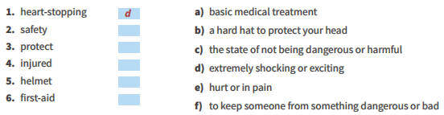 (2 **x6=12)**

**The City of Civilizations ( 3 x5=15 )**

Mardin is located in the Southeastern Anatolian region. It has a continental climate. Hot summer months follow the cold winters. Temperatures in summer usually increase to 40oC. The city is one of the oldest settled areas in upper Mesopotamia. It was home to different civilizations such as Babylonians, Hittites, Assyrians, Romans, Byzantines, Abbasid Caliphate and Seljuk Turks. It’s a popular tourist destination with its cultural mosaics and unique architecture. Mardin is the crossroad of different religions and cultures. There are many historic mosques, churches and madrassas in Mardin. Great Mosque and Virgin Mary Church are the most popular tourist attractions in the city. Mardin is also well-known for its unique cuisine. İkbebet, sembusek and harire are the best examples of its cuisine. In recent years Mardin has become a center of attraction for many people from different parts of the world. It is now a candidate for UNESCO’s List of “Cities of World Heritage.” You can stay at hospitable guest houses in Mardin.

1. What is the weather like in Mardin?____________________________________________________________________________
2. Why is Mardin a famous tourist destination?_________________________________________________________________________
3. Where can you stay there?______________________________________________________________________________
4. What is the traditional dishes of Mardin?____________________________________________________________________________
5. Where is Mardin?____________________________________________________________________________

True /false ( 3 **x6=18)**

mardin is located in the southeast region( )

mardin summers are cold ( )

mardin is located in the black sea ( )

there are no historical places in the mardin ( )

nuts grow in mardin ( )

many civilizations hosted ( )

1. **Write the correct word under the correct picture. (10x2= 20 points)**

|  |
| --- |
| **cycling- hang gliding – caving – climbing - motor racing - bungee jumping - parkour running - rafting – skateboarding- kayaking** |

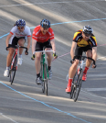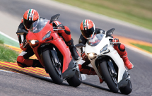



.……………………… …………………… ………………………. ……………………. ……………………….

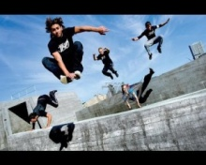 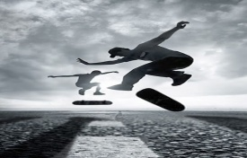 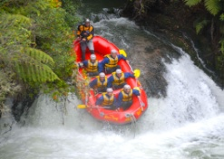 

……………………… ………………………. ……………………… …………………. …………………….

MATCH THE WORDS WITH THE DEFINITIONS.(TANIMLARLA KELİMELERİ EŞLEŞTİR)6x3=16

**1.** heart-stopping…. **a)** basic medical treatment

**2.** safety…. **b)** a hard hat to protect your head

**3.** protect…. **c)** the state of not being dangerous or harmful

**4.** injured…. **d)** extremely shocking or exciting

**5.** helmet…. **e)** hurt or in pain

**6.** first-aid…. **F)** to keep someone from something dangerous or bad

**. MATCH THE WORDS İN THE BOX WİTH THE PİCTURES BELOW (10 Pts.)**



**--------------------------- --------------------------- ------------------------- ------------------- ------------------------**

**--TRANSLATE –LEAVE A NOTE --PHONE CALL --TEXT MESSAGE --SOCIAL NETWORK**

