2017-2018 EĞİTİM-ÖĞRETİM YILI 8.SINIF İNGİLİZCE DERSİ 2.DÖNEM 1.YAZILI SINAV SORULARIDIR.
NAME-SURNAME :
NUMBER-CLASS :

A) FILL IN THE BLANKS WITH THE FOLLOWING. (4x2=8)

hang-gliding parkour running
motor racing sky-diving

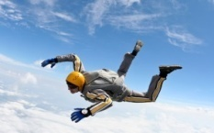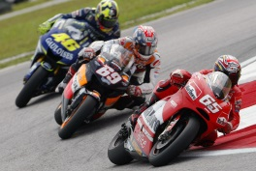
…………………………. ……………………………..

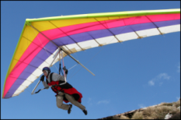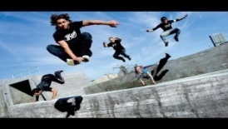
…………………………. ……………………………..

B) FILL IN THE BLANKS WITH THE FOLLOWING. (4x2=8)

How often – When – Where – What

1) A: ………………… are they going to visit İstanbul?
B: Next week.

2) A: ………………… do you usually do at the weekends?
B: I usually watch TV and read a book.

3) A: …………….……would you like have breakfast?
B: In the garden.

4) A: ………………… does Jack play tennis?
B: Once a week.

C) CHOOSE THE CORRECT ANSWER. (3x2=6)

1)Ahmet is ………………… than Ali.
a) taller b) talling c) more tall

2) It is ……………………… than this film.
a) interestinger b) interest c) more interesting

3) This book is ………………… than that book.
a) gooder b) better c) more good

D) READ THE INFORMATION ABOUT JESSICA AND WRITE TRUE OR FALSE. (4x2=8)

Jessica is an adrenalin-seeker. She likes all kinds of extreme sports, but her favorite is sky-diving. She has a lot of friends and she enjoys doing different activities together.

1) Jessica doesn’t like extreme sports. ………
2) Jessica would rather stay at home than go out. ………
3) Jessica prefers sky-diving to rafting. ………
4) She prefers heart stopping activities ……....

E)Circle the correct one. Doğru kelimeyi daire içine alın) (8p)
1. I prefer eat / eating traditional Turkish dishes.
2. I would rather go / going cycling than trekking.
3. I prefer Topkapı Palace to / than Sumela Monastery
4. Would you like to go / going to İstanbul?

F) Tablodaki kelimeleri boşluklara doldurunuz (12 pts)
-do -empty -dust - take out – feed--set

_______ the dishwasher _______ the garbage
_______ the shelves _______ the cat
_______ the ironing _______table

G. Fill in the blanks with the words in the box (7x2=14 pt)
-helmet -vacation -mild -accommodation -extreme -taking risks -first aid kit
-helmet -vacation -mild -accommodation -extreme -taking risks -first aid kit

- When you ride a motorbike, you should always wear a ……………………..
- John likes doing ………………………… sports like bungee jumping and rafting.
- Take a ……………………… when you go trekking because you may need medical help.
- Paris has every type of ………………………….. from hotels to hostels.
- Adrenalin seekers like pushing themselves and …………………………..
- I was in London on my last …………………………..
- Antalya has a ………………………….. climate in winters.

Not : toplam doğru cevap100puan ve bölümlerin puan değerleri yanlarında yazmaktadır.Sınav bir ders süresi kadardır.test 36p+klasik 64p =100p

