Name : Number: Class: Mark:
2016/2017 EDUCATION YEAR TÜRK TELEKOM SECONDARY SCHOOL 2nd TERM 1st EXAM QUESTIONS OF 8TH GRADERS

A) Match the words 10x1 = 10pts
- Parkour___ 1-tower
- Ski___ 2- engine
- Clock___ 3-activities
- Extreme___ 4- sports
- Sandy___ 5- running
- Recreational___ 6-modem
- Adrenaline___ 7- attractions
- Search___ 8- beaches
- Wireless___ 9-resort
- Tourist___ 10-seeker
B) Choose the correct answer.(18x5=90 pts)
1. Emel : What do you think about - - - - ?
Sema : I really love it because it is nice to explore the city
from the air.
A) pocket bike racing B) go-karting
C) parachute diving D) white-water rafting

2. I prefer - - - - to skydiving because it is more exciting.
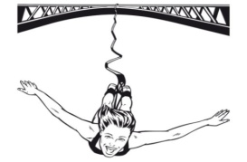
A) bungee jumping B) scuba-diving
C) rock climbing D) skateboarding

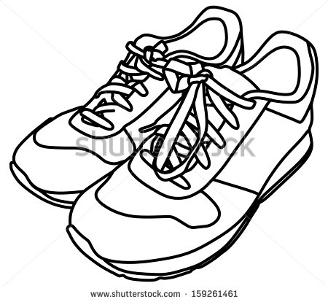
3. Aysu : Do you need any special equipment for parkour running ?
Esra : We need just - - - - .
A) a hard hat B) a first aid kit
C) an adventure trip D) a pair of trainers

4. Sally : ………………………………
Suzy : About two hours a day .
a) Do you like surfing on the Net?
b) How do you access the Net ?
c) How many hours do you spend on the Net ?
d) What do you do on the Net ?

5. A : Why don’t you use “SMS” ?
B : ……………………………. ?
A : It is “Short Message Service”.
a) How do you use it ? b) What does it mean ?
c) When do you send it ? d) Why do we use it ?

6. If you want to …, you need a smartphone and Internet. Hangisi boşluğa getirilemez ?
a) text a message b) send a letter
c) send an e-mail d) use social networks

7. Emre : What is Adana’s -- - - - - like ?
Sena : It has hot summers and mild winters.

- climate B) currency C) location D) local food

8. Buse : What is the - - - --- of Jamaica ?
Sıla : I guess, they speak English.
A) official language B) total population
C) traditional dish D) recreational activity

9. Hande : Where did you - - - - when you were on vacation? Emine : In an all-inclusive hotel. It was fascinating.
A) build B) live C) visit D) stay

10. Pınar : - - --- - is the registration fee ?
Ahmet : It is $10 and includes some snacks.
A) How long B) How many C) How often D) How much

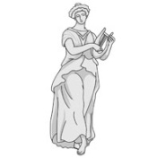
11. We saw ……………………… in the museum .They all were historic . I liked them very much .
a) a lot of statues b) high skyscrapers
c) new technology d) many new things

12. Jane: I would rather do rafting than canoeing because it is more exciting and - - - - .
a) boring b) tiring c) fascinating d) dangerous

13. (I) Adrenalin seekers love taking risk very much. (II) They want to see how far they can go and also they like pushing themselves. (III) They are fond of adventure and challenge. (IV) Base jumpers should take some safety items.
Paragrafın anlam bütünlüğünü bozan cümle hangisidir?

a) I b) II c) III d)IV

14. Mardin has a very rich - - - - . You can taste a lot of local food such as ikebet, harire and sembusek.

a) accommodation b) climate c) cuisine d) location

15. “Rafting is more dangerous than kayaking.”
Yukarıdaki cümleleye anlamca en yakın cümle aşağıdakilerden hangisidir?
a) Kayaking is more dangerous than rafting.
b) Rafting is less dangerous than kayaking.
c) Rafting is safer than kayaking.
d) Kayaking is less dangerous than rafting.

16. Matt: - - - - ?
Karl: It is in central north of Turkey.

a) Where is Sinop located b) Did you taste any local food
c) What is Mersin’s climate like d) How is the accommadation

17. I am not an adrenalin seeker so I - - - - .
a) like pushing myself b) prefer safer sports
c) enjoy taking risk d) want to see how far I can go

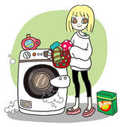
18. Ceren’s favorite chore is - - - - .
A) doing the ironing
B) watering the flowers
C) sweeping the leaves
D) doing the laundry
20/ 03/ 2017

