2016-2017 EĞİTİM ÖĞRETİM YILI BAĞCILAR BORSA İSTANBUL ORTAOKULU
8. SINIFLAR 2.DÖNEM YABANCI DİL 1. YAZILI YOKLAMA SINAVI

Name Surname : Class-Number :

- Choose the correct options . (10x4=40pts.)
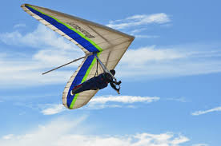
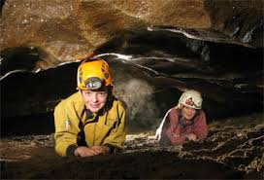
X

I prefer …………………… to ……………….. because
It is more mysterious.
- hiking/ base jumping
- hiking/hang gliding
- caving/ hang gliding
- caving/base jumping
- Clarke : I prefer pocket bike racing to real size motor racing :
Bellamy : Why?
Clarke : ……………………………
- Because , it is faster and more dangerous
- Because , it is slower and safer
- To me, it is less exciting
- I think , it isn’t fun.
- Finn : I think rafting is more enjoyable than mini golf.
Murphy : What do you mean?
Finn : I mean, ………………………..
- Rafting is less boring than mini golf.
- Mini golf is less boring than rafting.
- Mini golf is funnier than rafting.
- Rafting is less enjoyable than mini golf.
- Abby : I like …………………. because I think I am an adrenalin seeker.
- minigolf C) nature walking
- volleyball D) bungee jumping
- Kane : How is the climate of İstanbul ?
Wells : What do you mean ?
Kane : I mean ………………………..
- What is the weather like year around ?
- What is the currency of Turkey ?
- Where can you stay in İstanbul ?
- What are the traditional dishes ?
- Roan : How is the accommodation in Alanya ?
Jasper : What do you mean ?
Roan : I mean……………………………
- How is the weather In Alanya ?
- What is the total population of Alanya ?
- Is there any hostels or hotels ?
- How many people visit Alanya in a year ?
- Monty : ……………..............
Octavia : Approximately 83 million.
- How is the climate in Germany ?
- How is the accommodation in France ?
- What is the currency of France ?
- What is the total population of Germany?

- I prefer visiting ………………….. because it is a natural structure and it is not man-made .
- Burj Khalifa C) Taj Mahal
- Niagara Falls D) Great Pyramids
- Lincoln : Where were you last week ?
Paul : I was in İstanbul and I visited historical places such as ………………….
- Great Wall C) Tower Bridge
- Blue Mosque D) Sapphire
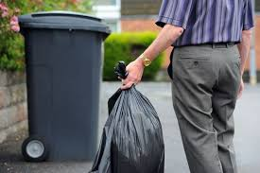
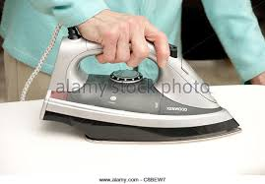

Alie : Do you do any chores at home ?
Jaha : Yes I ………………………. and ……………………….
- do the ironing/take out the garbage
- wash the dishes/ vacuum the floors
- clean the windows/ feed the cat
- set the table/ fold the clothes

- Fill in the blanks with the words in the box. (5x2=10)
Challenging - helmet - accommodation - extreme first aid kit

1) When you ride a motorbike, you should always wear a ……………………..
2) John likes doing ………………………… sports like bungee jumping and rafting.
3) Take a …………………………… when you go trekking because you may need medical help.
4) Parkour running is a very ………………… . you need to be careful.
5) Paris has every type of ………………………….. from hotels to hostels.

- Write the question words .(5x2=10 pts.)
How long - What - How often - How much -Who

- A : ______________ do you usually do at the weekends?
B : I go for a walk.
2) A: ______________ is responsible for the music?
B:Robin.
3) A: ______________does a bicycle weigh?
B : 20 kilos.
4) A :______________ does it take to construct a clock tower?
B : For about 5 years.
5) A : ______________ does she eat out with her family?
B : At least once a week.

- Write the tourist destination names in the correct places.(5x2=10pts.)
Big Ben / The Blue Mosque / The Great Pyramids/ The Statue of Liberty / Taj Mahal

1- ___________________is the symbol of love.It 's in Agra,India.It's a mixture of Persian ,Turkish and Indian.
2- ___________________is a an architecture miracle! It's the world's most amazing mosque in İstanbul.
3-___________________ was the tallest historical man-made structure in the world for over 3.800 years.
4-___________________ is one of the most famous clock towers on Earth.
5-___________________ is an icon of America.It's a living symbol of the freedom.

E) Group the rules (10x2=20 pts.)
-Be a good listener. -Follow the directions.
-Wash your hands before the meals. -Take off your shoes when entering.
-Keep your desk tidy and neat. -Be kind to your friends.
-Don’t jump on the couches. -Be nice to your siblings.
-Raise your hands to speak. -Don’t eat in the bedrooms

HOUSE RULES | CLASSROOM RULES

- Write about your favourite tourist destination . You can include the informations about (10pts.)
- Climate
- Accommodation
- Tourist Destination
- Dishes
My favourite tourist destination is …..
