2016-2017 EDUCATION YEAR HIZIRBEY SECONDARY SCHOOL 8TH GRADES ENGLISH LESSON II.TERM I.WRITTEN EXAM _-A GROUP-
Name&Surname: Class: Number:

A. Choose the best answer (33X3=99 )
1-17. sorularda boş bırakılan yere gelebilecek uygun kelime ya da ifadeyi işaretleyiniz.

1. You can always count on Jack because he
never - - - -.

a) shares your secret with someone else
b) tells the truth
c) backs you up
d) gets on well with his friends

2. Henry: - - - - ?
Selen: Twice a week. On Sundays and Wednesdays.

a) Where do you go after school
b) How often do you go to the karate club
c) What time does your lesson start
d) Why do you go to bed late

3. Mark: - - - - ?
Dursun: Corn flour, different kinds of cheese, butter and salt.

a) How do you make Kuymak
b) Do you like eating Kuymak
c) What’s your favorite snack
d) What are the ingredients of Kuymak

4. Bob: Hi, this is Bob. Can I talk to Mr. Jeff?
Ann: I am sorry. He’s gone out. - - - - ?
Bob: No,thanks.I ‘ll call him later.

a) Can I ask who is calling
b) Would you like to leave a message
c) Can you say it again
d) Could you call back again

5. Paul: - - - - ?
Dany: From my desktop PC because I use a cable modem.

a) Who uses the internet most in your family
b) What do you usually do on the Internet
c) How do you access the internet
d) Are you always online

6. Fırat: Diyarbakır is a multicultural province.
Betty: Multicultural? What do you mean?
Fırat: I mean, - - - - .

a) Its history goes back over 7000 years
b) It has dry and hot summers
c) It has many hotels and hostels
d)It homes to different cultures and religions.

7. Matt: Could I speak to Mr. Hoffman?
Secretary: She is on a meeting.
Matt: Could you say him to call me back?
Secretary: - - - - ?
Matt: Matt Humprey. 0555 123 45 67

a) Can I take your name and number
b) Can you call back later
c) Can you repeat it, please
d) Would you like to leave a message

8. Amy: Are you an internet addict?
Buse: No, I am not. - - - - .

a) I have different accounts on social networks
b) I spend most of my time on the internet
c) I rarely use it to check my emails.
d) I play online games, make live chats and watch videos

9. Dany:There is a winter sport fest in Uludağ.
Ken: - - - - ?
Dany: It is free.

a) Are you joining, too
b) Where is it
c) When is it
d) How much is the registration fee

10. Ann:What are the most important - - - - of Moscow?
Linda: Kremlin Palace, Red Square and Bolsoi Theatre.

a) tourist attractions b) accommodation
c) cuisine d) location

11. Murat:There is a book fair in exhibition hall. Let’s visit it!
Cenk: I would love to but I have a terrible headache.
Murat: I’m sorry to hear that. - - - - .

a) Sounds fine
b) You are very lucky
c) Congratulations
d) I hope you get better soon

12. George: - - - - ?
Fred: Yes, many. A helmet, elbow and knee pads, ankle protection and first aid kit.

a) Do you like doing skateboarding
b) Are you interested in skateboarding
c) Do you need any special equipment for skateboarding
d) Is skateboarding safe

13.Cem:Ankara is the capital city of Turkey. It is a modern city with many skyscrapers and shopping malls.
Buket: - - - - ?
Cem: It is typical continental climate. Dry and hot summers, chilly wet winters.
a) Is is a crowded city
b) How about weather
c) Is there any ancient sites
d) Is accommodation easy

14. Kaan: - - - - ?
Ali: It is very far from my home, so I usually ride my bike but sometimes I take the school bus when it is rainy.

a) What do you do after school
b) Do you usually go out in the evenings
c) What time do your lessons start
d) How do you go to school

15.I am not an adrenalin seeker. I - - - - .

a) like pushing myself
b) want to see how far I can go
c) enjoy taking risk
d) prefer safer sports

16.Selin always follows the fashion. She always wears - - - - clothes.

a) trendy b) ridiculous
c) old d) casual

17. Buse: - - - - ?
Derya: It ‘s everywhere now. In cafes, parks, schools even in the mountains.People access it easily.

a) What’s the best thing about internet
b) How often do you usually use the internet
c) Is your PC online
d) Do you have an email address

18. “Roll the dough using a rolling pin.”

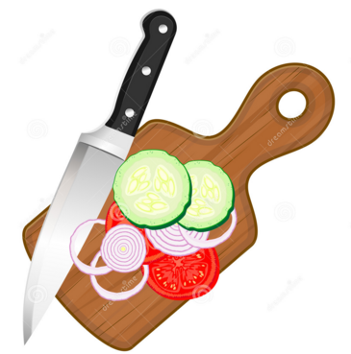
Yukarıdaki cümleyi ifade eden görsel aşağıdakilerden hangisidir?
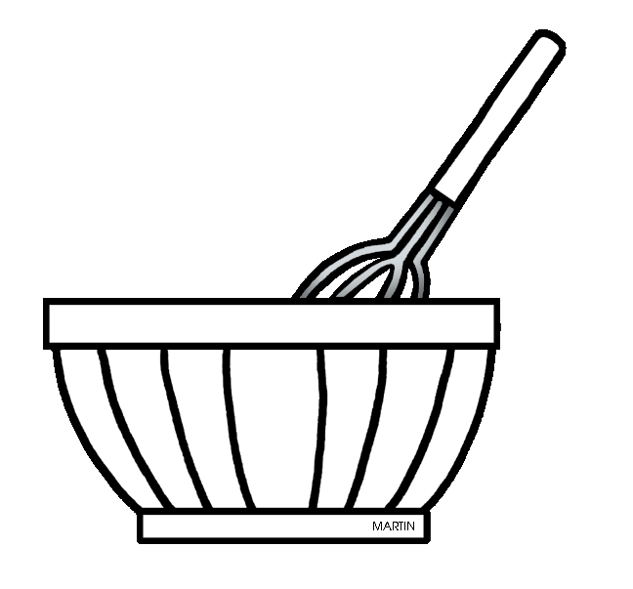
a) b)

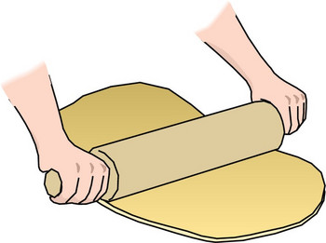
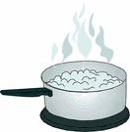
c) d)

19. “Jogging is safer than parkour running.”

Yukarıdaki cümleleye anlamca en yakın cümle aşağıdakilerden hangisidir?

a) Parkour running is more dangerous than jogging.
b) Jogging is more dangerous than parkour running.
c) Parkour running is safer than jogging.
d) PArkour running and jogging are safe sports.

20. “Alin is going to be physically active this weekend.”

Yukarıdaki cümleyi ifade eden görsel aşağıdakilerden hangisidir?
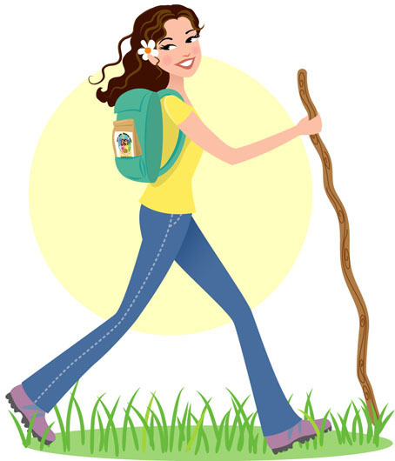

a) b)

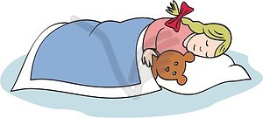
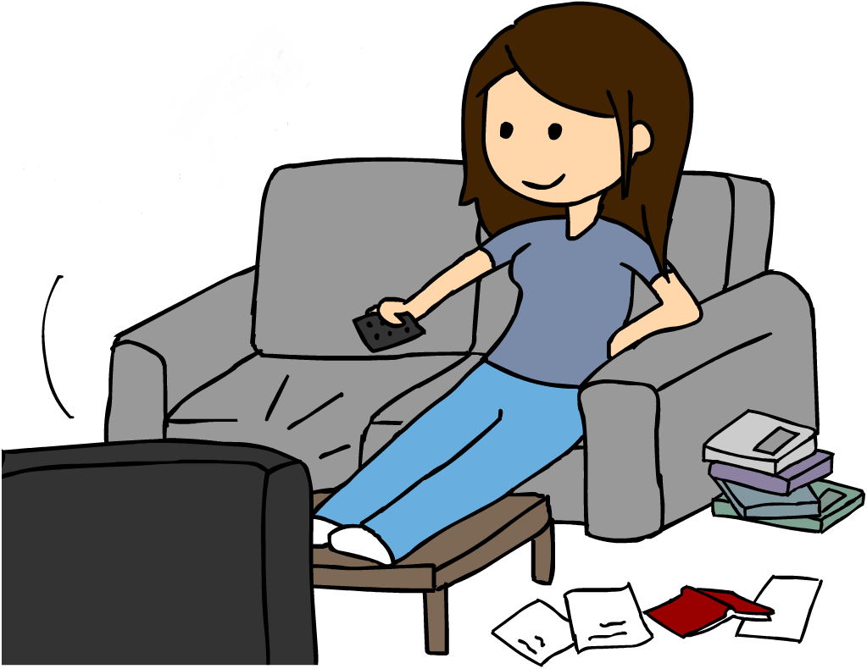
c) d)

21. One of your friends asks you what you are doing on Saturday evening.You don’t have any plans. So say;

a) I am going to be out of city.
b) No,thanks. I am not feeling well today.
c) Nothing special. Why do you ask?
d) Sure, I’d love to come.

22. “ I would rather a vacation in the nature.”
Yukarıdaki cümlede anlatılmak isteneni aşağıdakilerden hangisi en iyi ifade eder?

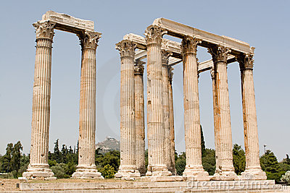
a) b)

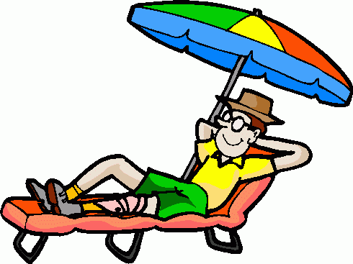
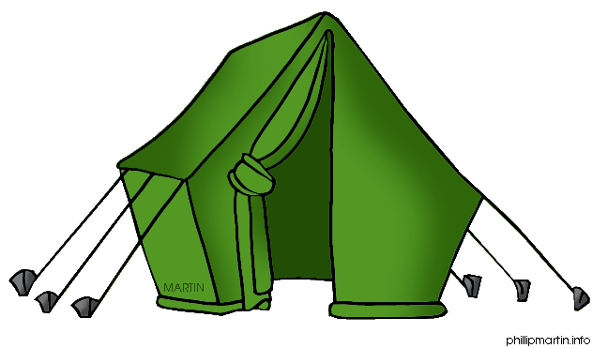
c) d)

(I) I prefer a vacation by seaside and in an all inclusive resort hotel. (II) I like sunbahting and swimming, also I want to try water sports.(III )Last year, I had a safari tour in Africa.(VI) I want to do rafting , canoeing ,windsurfing.
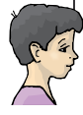
23.

Konuşma balonunda anlam bütünlüğünü bozan cümleyi bulunuz.

a) I b)II c)III d)IV

24. “I usually send text messages and emails but sometimes I leave message notes.”
Yukarıdaki cümlede yer almayan görsel aşağıdakilerin hangisinde doğru olarak verilmiştir?

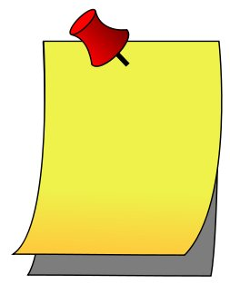
a) b)

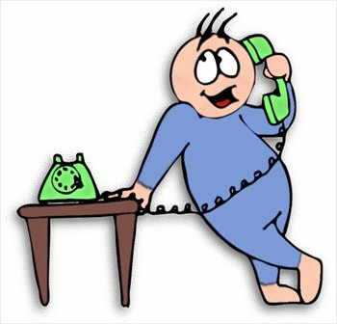
c) d)



25 ve 26. Soruları aşağıdaki konuşma balonlarına göre cevaplayınız.
My favorite extreme sports are hang gliding, base jumping and parachuting.


Tina
I don’t like heart stopping activities. I am not an adrenalin sekeer.

Amy

I like pushing myself. I prefer doing rafting, kayaking and waterskiing.


Kate
I am interested in volleyball, gymnastics and yoga.

Betty

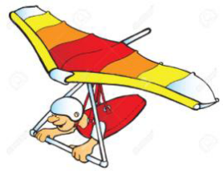
25. Which one isn’t Tina’s favorite sport?

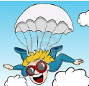
a) b)

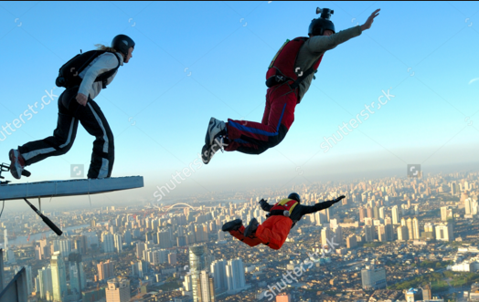
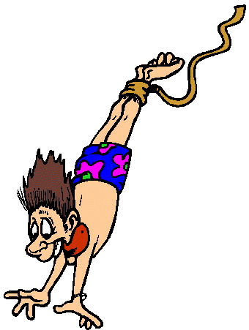
c) d)

26. Which one is false?

a) Tina is an adrenalin seeker.
b) Amy prefers safer sports.
c) Kate doesn’t like doing water sports.
d) Betty would rather indoor sports.

27.
GOOD EATING HABITS
- - - - - - - - - - - - - - - - - - - -
- - - - - - - - - - - - - - - - - - - -

Yukarıdaki liste aşağıdakilerin hangisiyle tamamlanamaz?

a) Don’t eat junk food
b) Wash fruit and vegetables before eating
c) Eat something before sleeping
d) Don’t drink fizzy drinks

28. I was in a winter sports camp in February. I tried
snow tubing”

Yukarıdaki cümlede yer alan görsel aşağıdakilerin hangisinde doğru olarak verilmiştir?
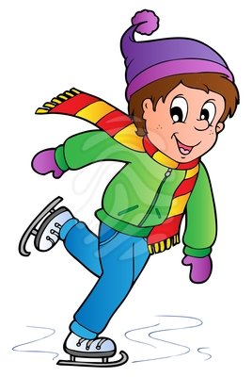
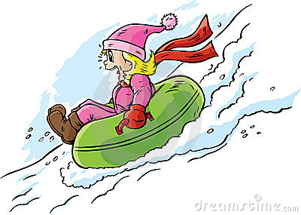
a) b)

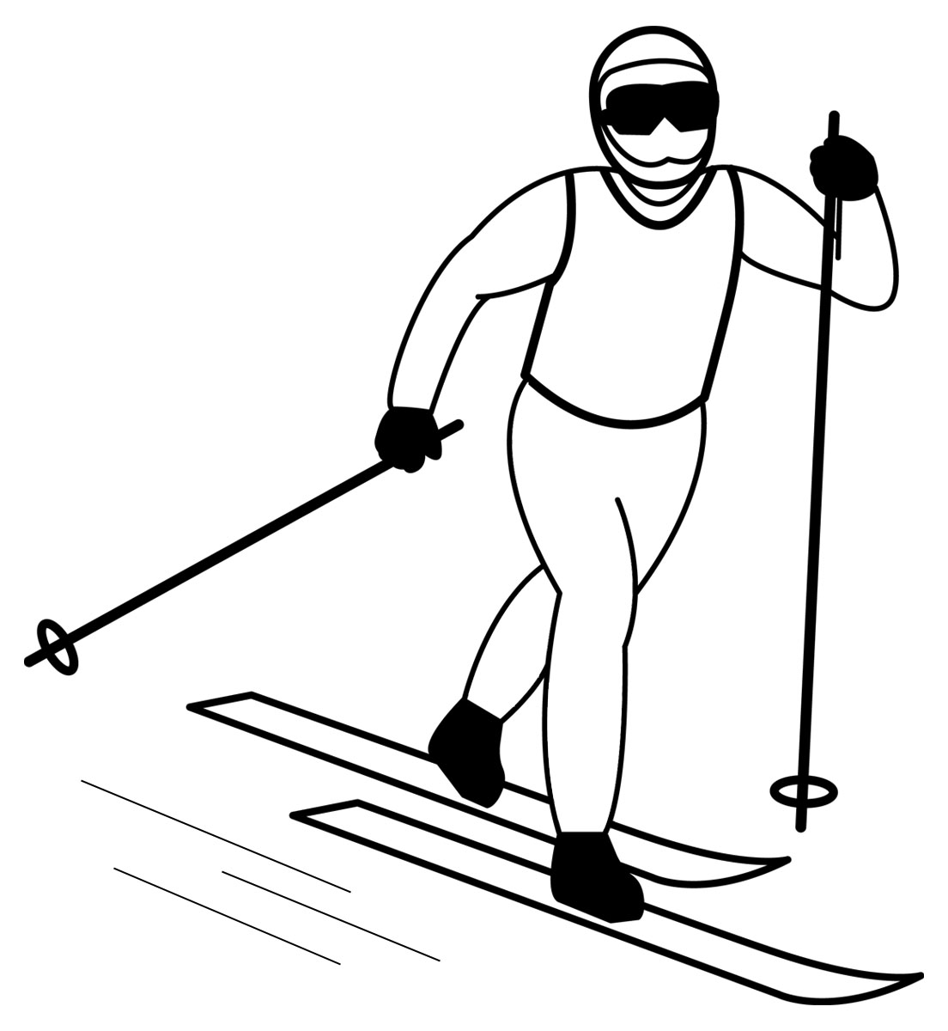
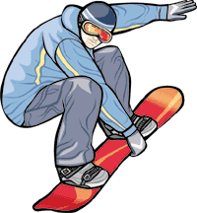
c) d)

29. Aşağıdaki eşleştirmelerden hangisi yanlıştır?

a) awful terrible
b) cuisine dishes
c) make a phone call leave a voicemail
d) offline no connection

30. soruyu aşağıdaki tabloya göre cevaplayınız.

 | Vacation | Recreational Activities
Betty | Riverside | Rafting, kayaking
Jane | mountain | Rock climbing, hiking
Richard | Modern city | Base jumping, parkour running
Ted | Historic site | Taking photo, visit museums

30. Which one is true?

a) Betty would rather water sports.
b) Ted likes being in the nature
c) Richard doesn’t have to take some safety items.
d) Ted doesn’t prefer ancient sites and buildings.

32 ve33. soruyu aşağıdaki parçaya göre cevaplayınız.

Van is an ancient city in the east of Turkey. It is a junction point of Turkey, Armenia and Iran. Its history goes back over 5000 years. It was the capital city of Urartu Civilization. Now it is a big city. 1.5 million people live there. Van Lake, Ahdamar Church, Tuşpa Castle, Adir Church, Kaya Çelebi Mosque are main tourist attractions. There are also a lot of buildings belong different cultures and religions. It has a continental climate.Very hot and dry summers, freezing and wet winters. You should definitely taste Uşgun ,Sengeser and Kurut Meatball. You can stay in traditional houses and resorts there.

31. Which one isn’t mentioned in the text?

a) Touristic Attraction
b) Climate
c) Recreational activities
d) Cuisine

32.Which one is false?

a) Van was the capital city of Urartu civilization.
b) It is a crowded city now.
c) It has a rich cuisine.
d)It is located in west of Turkey.

33. Van - - - - .

a) isn’t a historic city.
b) is a junction point of Syria.
c) has mild and damp summers.
d) is a multicultural province.

