A. Match the offers/invitations with the responses. (5x4=20 points)
a) Would you like some chocolate cake? It tastes really delicious. ............... | 1) Sounds awesome! I'm really into scary movies.
b) Say, Ashley, what are you doing this evening? How about coming over for a drink together?  ............... | 2) No, thanks. I'm full, but I would like to have a glass of water.
c) Are you free at the weekend, Sam? We are organizing a tennis competition at the Sports Centre. Why don't you attend it? It is going to be enjoyable and exciting.  ................ | 3) I'm not going to do anything tomorrow. I'd love to come and have fun with you. Then, pick me up at 1 pm.
d) Do you have any plans after school? We are going to see a horror movie with friends. What about joining us?  ................. | 4) Well, I'm sorry, I can't go out in the evening. I have to stay at home. Maybe some other time.
e) Are you doing anything tomorrow? We're going to go for a picnic by my father's car in the afternoon. Would you like to come with us? ................. | 5) I'd be very happy to join. I will be there with my rackets.
B. Read the invitation and answer the questions. (5x4=20 points)
1) What is the event?
......................................................................
2) Who is/are organizing the event?
......................................................................
3) Who is the party for?
......................................................................
4) When is it?
......................................................................
5) Where is it?
......................................................................
Dear Friends,
Helga and I are planning a welcome party for Jim. You know, Jim is a new student in our class. The party is going to be at Helga's house. What about joining us? We would be happy to see you there. It's on Friday after school at 5.30 pm. Hope to see you there!
Cheers,
Jason

C. Choose the correct choice. (15x4=60 points)

1) Aşağıdaki eşleştirmelerden hangisi yanlıştır?
A) feel blue=be depressed B) reliable=dependable
C) count on=support D) come over=call on

2) Jess: Would you like to watch a romance together?
Janet: Do we have another movie? I'm not really into romances.
Aşağıdakilerden hangisi altı çizili cümle ile aynı anlamı taşımaktadır?
A) I love romances very much.
B) I don't like romances.
C) I'm interested in romances.
D) I really like romances.

3) Samuel is my desk-mate. He is never anxious about anything. He never worries about anything. He is always relaxed. He is a ............. mate.
A) close B) buddy C) stranger D) laid-back

4)
True friends...
- always back you up.
- have something in common.
- never tell lies to eachother.
- get on well with eachother.

Yukarıdaki bilgilere göre hangisi yanlıştır?
A) It is very difficult to count on a true friend.
B) A true friend helps you when you are in trouble.
C) True friends share similar likes and dislikes.
D) A true friend is always there to support you.

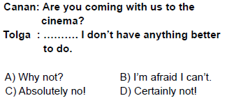
5)

6)Diyaloğu doğru sıraya koyunuz.
I- Ok, then. Would you like to come over? We are going to watch movies at my home.
II- Oh, I prefer thrillers.
III- I have good sci-fi movies and thrillers.
IV- Sounds fun! What kinds of movies do you have?
V- Are you doing anything tomorrow evening?
VI- No, nothing special.
A) V, II, I, III, IV, VI B) III, II, I, V, IV, VI
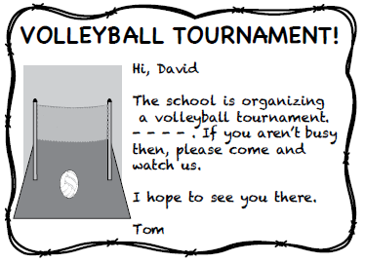
C) V, VI, I, IV, III, II D) I, IV, VI, II, V, III
7)

Metindeki boşluğa hangisi gelmelidir?
A) It starts on Sunday.
B) I'd love to come.
C) Just call on me.
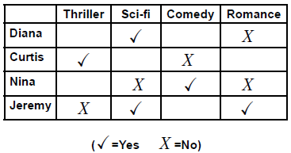
D) I'm sorry but I can't.
8)

Tabloya göre hangisi doğrudur?
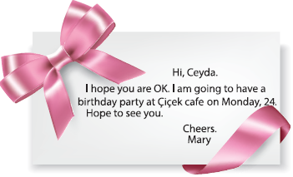
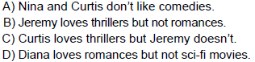
9)

Davetiyede hangi sorunun yanıtı yoktur?
A) Who is the sender? B) When is the party?
C) Where is the party? D) What time is the party?
10) What is the date today? 13/10/2016
A) September the thirtieth, two thousand sixteen
B) October the thirteenth, two thousand sixteen
C) October the thirtieth, two thousand sixteen
D) September the thirteenth, two thousand sixteen
11) You invite Mary to watch a movie at home, but she refuses because she is sick. She makes her excuse. What does she say?
A) It would be fun but my father is ill today.
B) I'd really love to but I have to study for Maths.
C) I'm afraid, I can't come. I am not feeling well now.
D) That sounds awesome! Can I bring popcorn?

12) You have nothing to do tonight and you are bored at home. You want to do something fun with your friend, Jane. But first, you should ask Jane about her plans for tonight. What do you say?
A) Say Jane, do you have any blue ray movies?
B) Are you going to come over tomorrow, Jane?
C) Say Jane, how was your day?
D) Are you doing anything tonight, Jane?

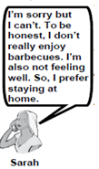
13. , 14. ve 15. soruları görsele göre cevaplandırınız.
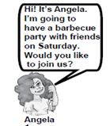

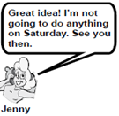
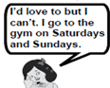

Amy
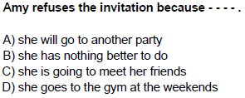
13)

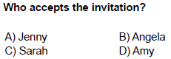
14)

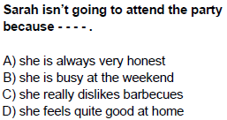
15)

