Fill in the blanks with the correct verb and paint the pictures:

I………………………….. in the morning.
Then, I………………………………………. 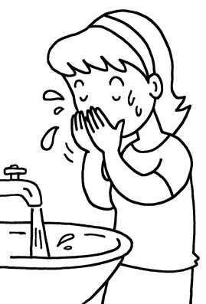
I………………………….. at 8.30am. 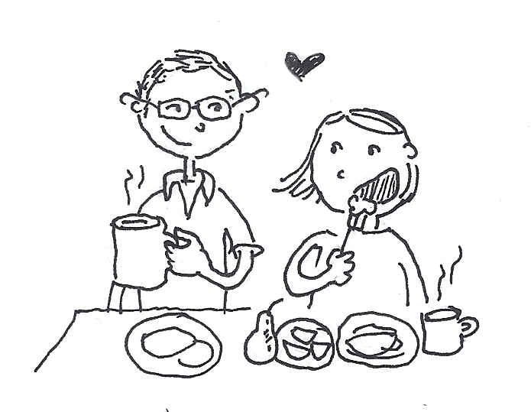
I……………………….. from 9 to 11am.

I…………………… at 12.30.
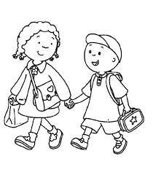
I…………………… at 3.10pm.

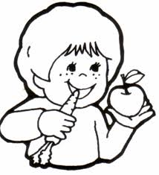
I…………………… around 6.50pm.
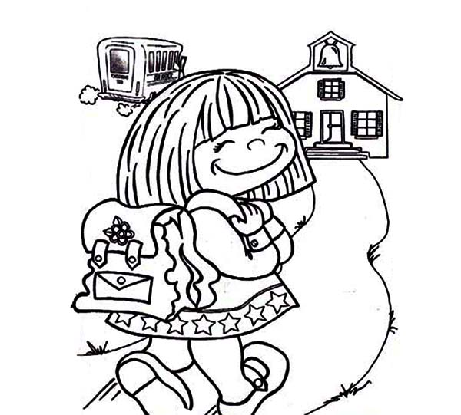

I …………………………...
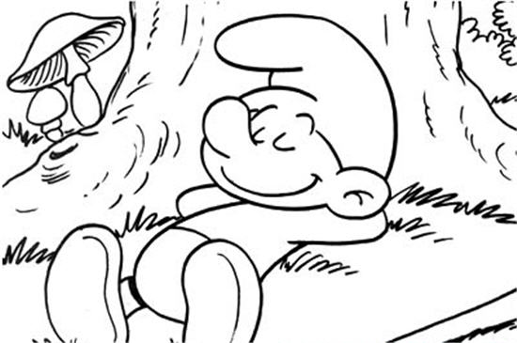

We ………………………. at 7.30pm.

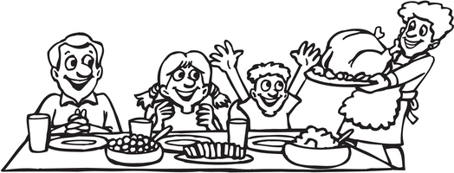

I ………………………….. after dinner.
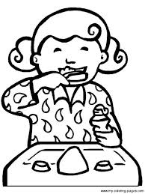

Then I ………………………….TV.
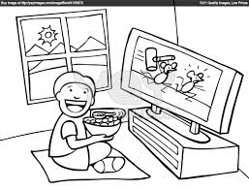
I……………………….. from 9 to 10pm.
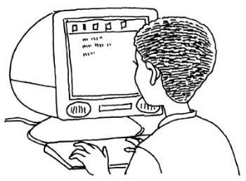

I…………………………from 10 to 10.30pm.
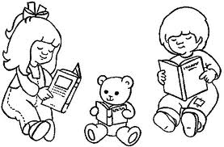I…………………………bed at 10.30pm.
