**2013-2014 EDUCATION YEAR** **TEZER TAŞKIRAN SECONDARY SCHOOL**

**1st TERM 1st WRITTEN ENGLISH EXAM FOR 5th GRADE**

**Name:**

**Surname:**

**Number:**

**Class:**

|  |  |  |
| --- | --- | --- |
| **HOSPITAL** | **CAFE** | **BAKERY** |
| **ATATÜRK STREET** | | |
| **BANK** | **CINEMA** | **LIBRARY** |
| **SCHOOL** | | **POLICE STATION** |

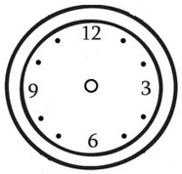**A. What time is it?** (Saat kaç?) **6×2=12p.**

1. It is half past seven. 2. It is quarter past two.

3. It is six o’clock. 4. It is quarter to three.



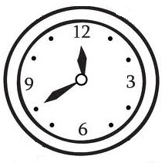



5…………………………………. 6……………….………………………….

**B. Match the regions on the map.**

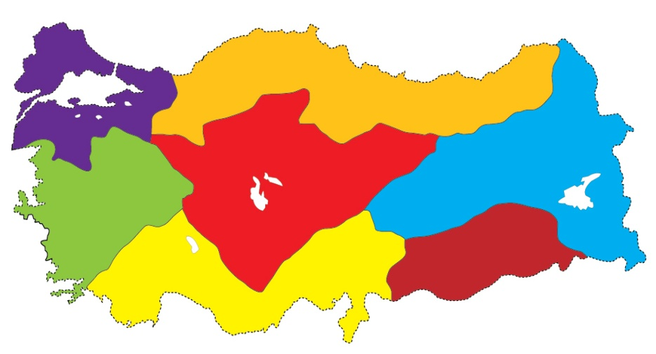(Bölgeleri harita üzerinde eşleştiriniz.) **7×1=7 p.**

**1. What time do you go to school?**

**......................................................**

**2. Where is Ali?**

**............................................**

**3. Where is the cat?**

**............................................**

4. **What time is it?**

**..................................................**

**1-The Black Sea Region**

**2-The Marmara Region**

**3-The Eastern Anatolia Region**

**4-The Mediterranean Region**

**5-The Central Anatolia Region**

**6-The Aegean Region**

**7-The Southeastern Anatolia Region**

**C. Fill in the blanks according to the map below.**

(Haritaya göre boşlukları doldurunuz.) **5×3=15p.**

1. The hospital is ……………………………the cafe.

2. The library is ………………………….the bakery.

3. The cinema is…………………………the bank and library.

4. The school is ………………………….the cinema.

5. The library is ………………………….….the police station.

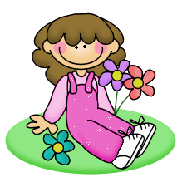

**D. Answer the questions.**

**(**Soruları cevaplayınız.**) 4×4=16p.**

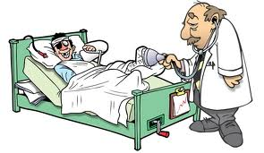

**C:\Users\İBRA-9\Desktop\catundertable.GIF**

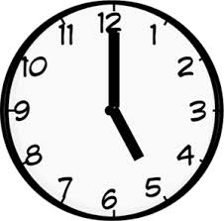

**E. Write the daily routines in the box under the correct picture.**

(Günlük işleri doğru resmin altına yazınız.)**6×2=12p.**

|  |
| --- |
| **- play football - get up**  **- go to school - have a shower**  **- have lunch - watch TV** |



**1)**________________ **2)**________________



**3)** __________________ **4)**__________________



**5)** ___________________ **6)**__________________

**F. Write the directions.** (Yönleri yazınız.) **4×2=8p.**

** ……..….**

**...……. ..……..**

**....……..**

**Duration: 40 min.**

**İBRAHİM ÖZTÜRK**

**ENGLISH LANGUAGE TEACHER**

**G. Choose the correct option.**

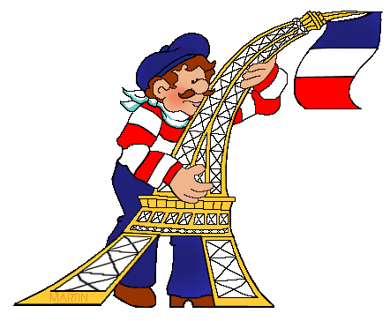 (Doğru seçeneği işaretleyiniz.) **10×3=30p.**

**1.**………….. is the capital city of

France.

a) Madrid b) Paris

c) Berlin d) Rome

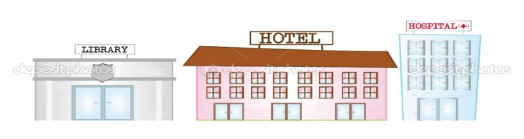

**2.** The Hotel is.............. the hospital and the library.

a) Between b) Behind c) On d) Next to



**3.** I ……………. my teeth everyday.

a) go b) comb

c) wake up d) brush

**4.** Boşluğa hangisi gelmelidir?

“I sleep……………eleven o’clock.”

1. on b) at c) by d) in



**5.** I play …………………..

a) basketball b) baseball

c) chess d) football

**6.** ....……………is the capital city of Italy.

a) Madrid b)Paris

c)Ankara d)Rome

**7.** I comb my ………………….

a) garden b) dinner

c) hair d) teeth

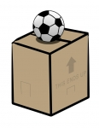

**8.** The ball is ………. the box.

a) on b) in

c) under d) between

**9.** Resimdeki bayrak hangi ülkeye

aittir ?

a) Spain b) Germany

c) Turkey d) The U.S.A.

**10.** Ankara is the …………….. of Turkey.

a) chemist’s b) capital city

c) breakfast d) school bus

**C:\Users\İBRA-9\AppData\Local\Microsoft\Windows\Temporary Internet Files\Content.IE5\0HZM52U6\MC900423171[1].wmfC:\Users\İBRA-9\AppData\Local\Microsoft\Windows\Temporary Internet Files\Content.IE5\0HZM52U6\MC900423171[1].wmf**

**GOOD LUCK !**