## **2017-2018 EDUCATION YEAR ………………. SECONDARY SCHOOL**

**5TH GRADE 1ST TERM, 1ND WRITTEN ENGLISH EXAM**

**Name : Class:5/__**

**Surname: Number:**

**Write the words under the pictures. (Kutudaki kelimeleri resimlerin altına yazın)**

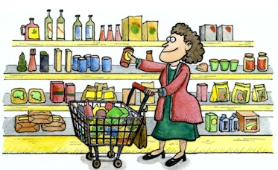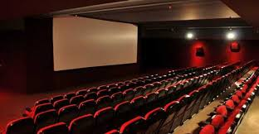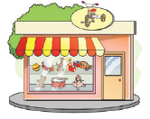**toy shop – supermarket – restaurant - school – hospital – cinema – stationery - playground – bank – police station**

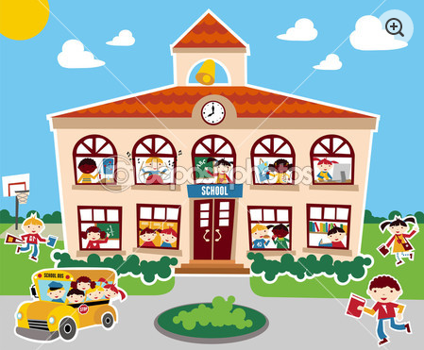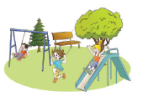

**Choose the correct answers to the questions given below.**

**1**.How are you doing?( ) A)I’m eleven.

**2**.How many languages do you speak?( ) B)She is from England.

**3**.Where is she from?( ) C)Very well ,thank you.

**4**.How old are you?( ) D)I really love English.

**5**.What is your favourite class?( ) E)Two.Turkish and English.

**FILL IN THE BLANKS WITH “ in , under , near , on , in front of, behind”**

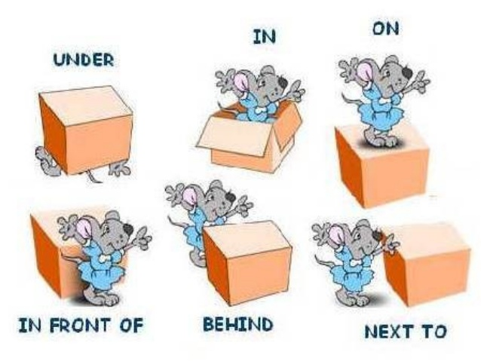

**Write the names of the classes.(derslerin isimlerini yazınız)**

***Physical education - Art - Science - Social studies - English***

 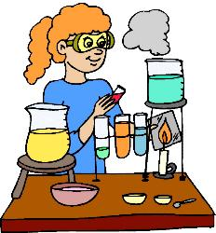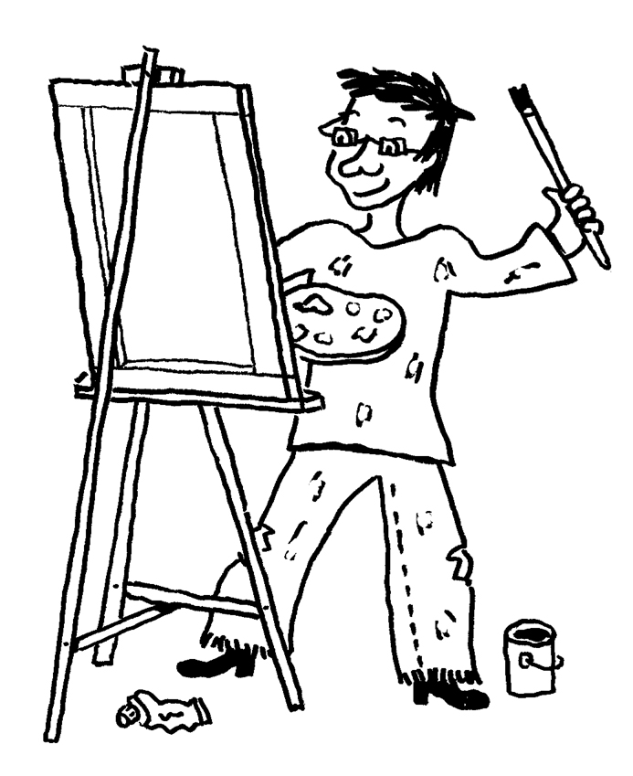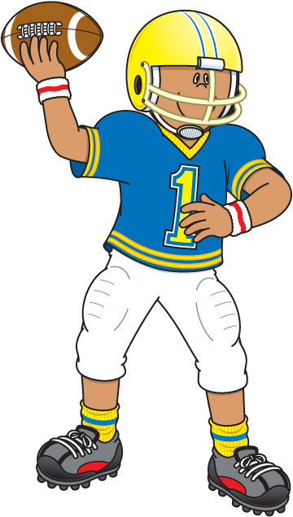

**………………………… ……………………… …………………………. ……………………… ……………………………**

**Fill in the blanks.(boşlukları doldurunuz)**

**COUNTRIES LANGUAGES**

**Saatler ile okunuşlarını eşleştiriniz.**

**12:00 _______ a. It is ten past seven .**

**04:30 _______ b. It is twenty past two.**

**09:15 _______ c. It is twelve o’clock .**

**05:45 _______ d. It is half past four.**

**07:10 _______ e. It is quarter past nine.**

**02:20 _______ f. It is quarter to six .**

**09:55 _______ g. It is eight o’clock.**

**08:00 _______ h. It is five to ten.**

England …………………..

France ………………….

…………….. Spanish

……………… Russian

China …………………

**Choose the correct word.(tabloya göre doğru olan kelimeyi seçiniz.)**



|  |  |  |  |  |  |  |
| --- | --- | --- | --- | --- | --- | --- |
|  | **swimming** | **climbing** | **cooking** | **science** | **English** | **P.E** |
| **Ayşe** | **☹** |  |  |  | **☺** |  |
| **Sibel** |  | **☹** |  |  | **☺** |  |
| **Esra** |  |  | **☺** |  | **☺** |  |
| **Fatma** |  |  |  | **☹** | **☺** |  |
| **Nil** |  |  |  |  | **☺** | **☺** |

**1.**Ayşe **enjoys** **/ dislikes** swimming.

**FILL IN THE TABLE ABOUT YOURSELF AND WRITE A SHORT PARAGRAPH ABOUT YOURSELF.**

|  |  |
| --- | --- |
| **Name** |  |
| **Age** |  |
| **Country** |  |
| **Nationality** |  |
| **Language** |  |
| **Favourite subjects** |  |

**2.**Sibel is **good at** **/ bad at** climbing

**3.**Esra **loves / doesn’t like** cooking.

**4.**Fatma is **bad at /good at** science.

**5.**Nil **likes / hates** P.E.

