**Name / Surname:**

**Class / Number:**

**ORDUZU ELMASUYU ORTAOKULU 2017-2018 EĞİTİM-ÖĞRETİM YILI 5.SINIFLAR İNGİLİZCE 1.DÖNEM 2.YAZILI SORULARI**

**A) Günlük yapılan aktiviteleri uygun resmin altına yazınız. (10x2=20pts.)**

do homework / brush your teeth / read a book / go to school / have a shower/ watch TV / get up / have breakfast / wash your face / go to bed

 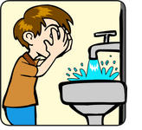  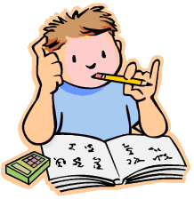 1.______________ 2. _______________ 3._____________ 4. _____________ 5. _____________

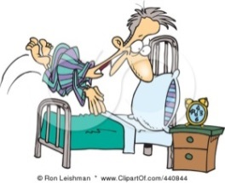  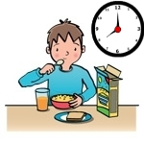  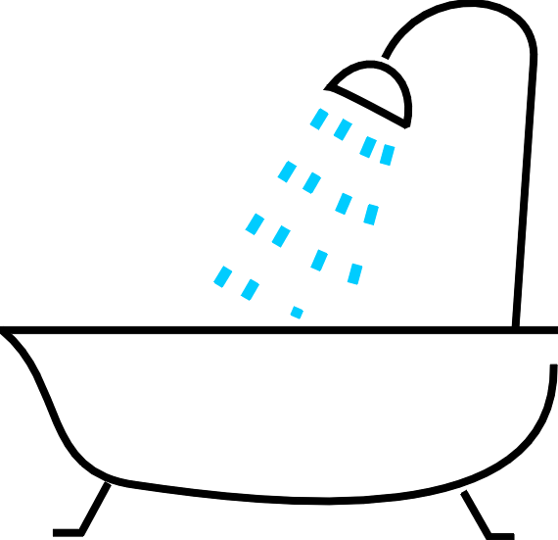

6. _______________ 7. ______________ 8. ______________ 9. ______________ 10. ______________

**B) Saatleri eşleştiriniz. (7x2=14pts.)**

1. 7:00 a) It’s half past eight
2. 8:30 b) It’s ten past nine
3. 10:45 c) It’s ten to three.
4. 03:15 d) It’s seven o’clock.
5. 02:50 e) It’s twenty past four.
6. 04:20 f) It’s quarter to eleven.
7. 09:10 g) It’s quarter past three.

**C) Parantez içinde verilen eylemleri geniş zamana göre doğru şekilde yerleştiriniz.(8x2=16pts)**

1) My sister-------------------------**(wash)** her hands and face every morning.

2) We -----------------------------**(drink)** milk everyday.

3) Berna-----------------------**(go)** shopping every weekend.

4) They----------------------**(work)** in a supermarket every summer.

5) Tom--------------------------**(come)** home at 3 p.m in the afternoons.

6) He-----------------**(study)** English at weekends.

7) I--------------------------**(get)** up at 8 a.m every morning.

8) She-------------------**(have)** dinner at 8 o’clock in the evenings.

**D) Boşlukları can ya da can’t ile doldurunuz.(5x2=10 pts)**

a) Fish…….……walk.

b) Birds………………..fly.

c) A dog…………… speak.

d) A cat………..climb a tree.

e) Horses ……… run very fast.

**E) Doğru şıkkı seçiniz.(5x3=15pts)**

1) Arda: ____________does Nilgün get up in the mornings?

Sema: At nine o’clock.

a) What time b) What c) Where d) How often

2) Bob: ___________do you go swimming?

Mark:I go swimming on Saturdays.

a) Where b) When c) What d) How

3) Sibel: What does Hale do after school everyday?

Selin: She___________English with her mother.

a) study b) studies c) do d) does

4) Clara:__________you like listening to music?

Sam: No,I don’t.

a) Does b) Can c) Do d) Is

5) Melek: When do you go shopping?

Nuray: We_________shopping on Fridays.

a) go b) goes c) gos d) is go

**F) Aşağıdaki oyunların isimlerini yazınız.(5x2=10pts)**

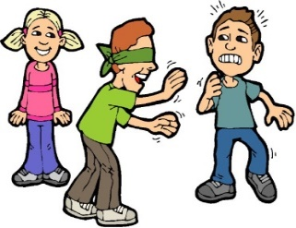

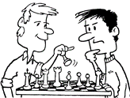 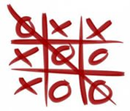 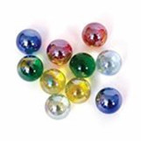

**1……………… 2………………… 3…………………… 4…………………. 5………………..**

**G) Parçayı okuyun ve cümlelerin yanına doğruysa“TRUE” yanlışsa FALSE” yazınız.(5x3=15pts)**

**Mary’s Daily Routine**

Mary is ten years old. She gets up at 7 o’clock in the mornings. She has breakfast with his brother. She eats an egg,olives,cheese .She drinks milk. She goes to the school by car. She studies Math,Science,English at school. She does her homework after school at 3 o’clock. She doesn’t go online on weekdays. She goes to bed at 10:15 every night.

1) She gets up at half past seven in the mornings...................................

2) She goes to the school by bus.................................

3) She does her homework in the afternoon..........................

4) She eats olives,cheese ,an egg and drinks milk at breakfast..............................

5) She goes to bed at quarter past ten every night.......................