DADAY ANADOLU İMAM HATİP ORTAOKULU
2017-2018 EDUCATIONAL PERIOD ENGLISH LESSON GRADE 5 FIRST TERM SECOND EXAM QUESTIONS
NAME=____________________________SURNAME=________________________NUMBER=______
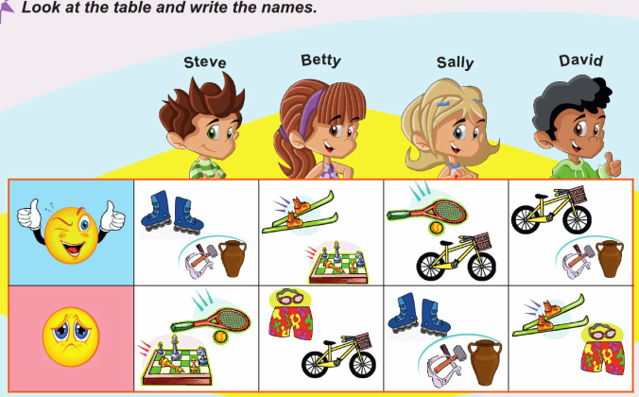
1.BÖLÜM (TABLOYA BAKARAK TABLONUN ALTINDAKİ CÜMLELERİ KİMLERİN SÖYLEDİĞİNİ BULMAYA ÇALIŞALIM. YALNIZ EN İYİ BİLDİĞİNİZ 5 TANESİNİ YAPALIM. 5X4=20
2.BÖLÜM (AŞAGIDA VERİLEN CÜMLELERİ KENDİLERİ İÇİN İKİYE AYRILMIŞ OLAN ALANA DOĞRU OLARAK YAZALIM. 10 TANESİNİ YAPALIM. 10X2=20
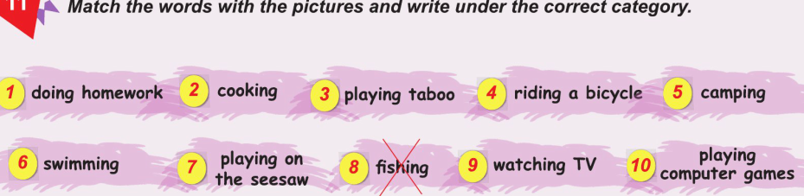
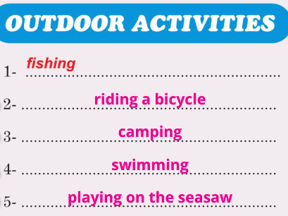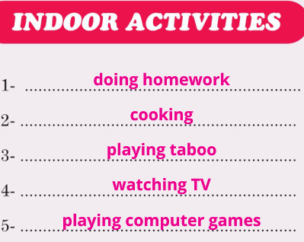

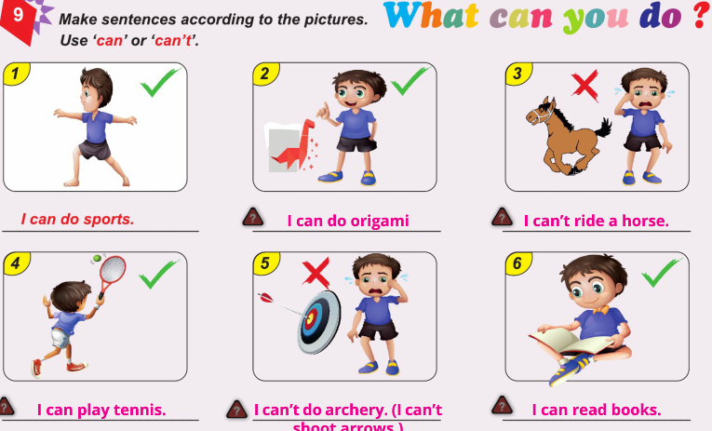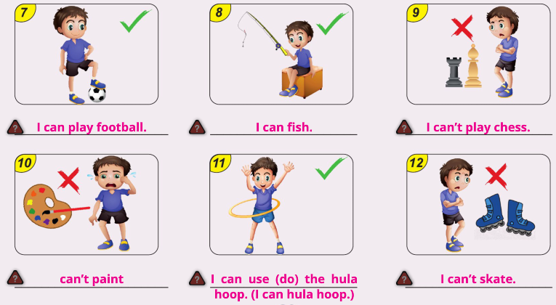
3.BÖLÜM (AŞAGIDA VERİLEN RESİMLERİN ALTINA can ya da can’t KULLANARAK ÖRNEKTE VERİLDİĞİ GİBİ RESİMDEKİ EYLEMİ ANLATAN CÜMLELER KURALAIM. 10 TANESİNİ YAPALIM. 10X2=20

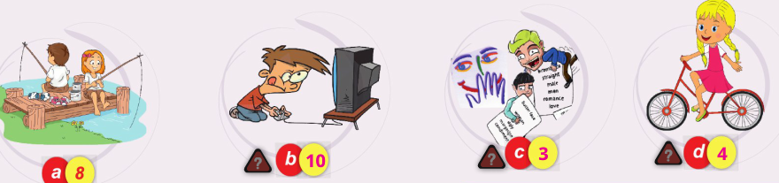
4.BÖLÜM (AŞAGIDA VERİLEN KELİMELERİ RESİMLERLE EŞLEŞTİRELİM. 10X2=20

5.BÖLÜM (AŞAGIDA İNGİLİZCE OLARAK VERİLEN SAAT AÇIKLAMALARINI KENDİSİNİ ANLATAN RESİMLERİ İLE EŞLEŞTİRELİM. YALNIZ 10 TANE YAPALIM 10X2=20
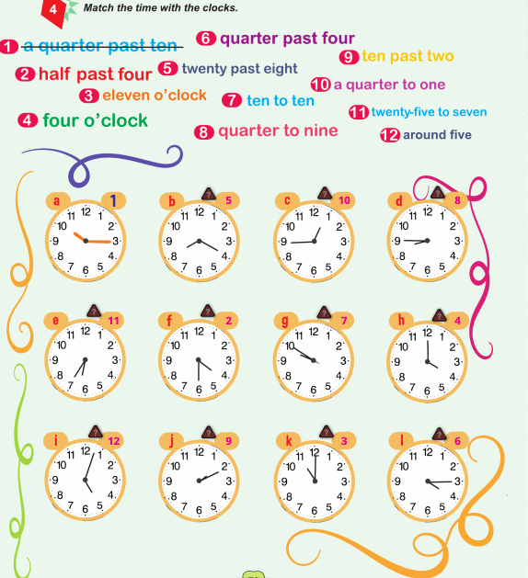
a.10.15=It is _1_ b.08.20=It is __5___ c.12.45=It is__10___ d.08.45=It is__8____
e.06.35=It is_11___ f.04.30=It is __2___ g.09.50=It is__7___ h.04.00=It is__4____
i. 05.00=It is_12___ j.02.10=It is __9___ k.11.00=It is__3___ l.04.15=It is ___6___

02.01.2018
Uygundur

AYDIN DEMİRAL
DADAY AİHL MÜDÜRÜ

