2017-2018 EĞİTİM ÖĞRETİM YILI DOĞANSU ORTAOKULU
5. SINIF İNGİLİZCE DERSİ 1. DÖNEM 2. YAZILI
NAME and SURNAME: …………………………………. CLASS: ……

- GÜNLÜK AKTİVİTELERİ RESİMLERİYLE EŞLEŞTİR.
- Get dressed
- Brush teeth
- Have breakfast
- Get up
- Read books
 | 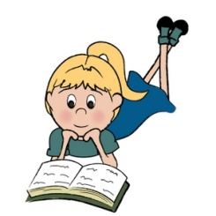 |  |  | 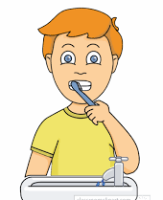

- SAATLERİ YAZILIŞLARINI NUMARALAR İLE EŞLEŞTİR.
- It is ten o’clock.
- It is half past two.
- It is quarter to twelve.
- It is quarter past seven.
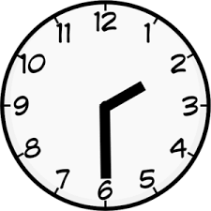 | 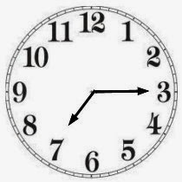 | 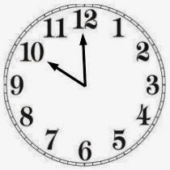 | 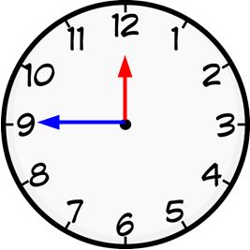

- AKTİVİTELERİN YAZILIŞLARINI EŞLEŞTİR.
- play | ___ hiking
- climb | ___ photos
- go | ___ a horse
- skip | ___chess
- take | ___ mountains
- ride | ___ rope
- do | ___ roller skating

- YERLERİN YAZILIŞLARINI DOĞRU BİR ŞEKİLDE TAMAMLA.
 |  | 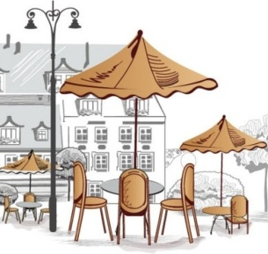 | 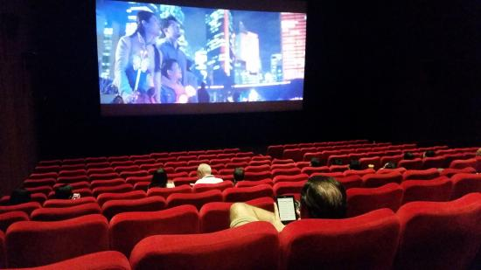
H _ S P I T _ L | P H _ R M _ C Y | C _ F E | C I _ E _ A

- HER BÖLÜM 5’ ER PUANDIR.

GÖZDE ÖZBAHÇIVAN
English Teacher

