Name – Surname:__________________________ Class:_______ Number:_______

**2017-2018 Academic Year Zubeyde Hanim Secondary School 5th Grades 1st Term 2nd Exam**

1. **Soruları uygun cevap ile eşleştiriniz**. **Her soru 2 puandır.

1-What is your name?( ) a-This is a pencil.

2-Are you Japanese?( ) b-No,I can’t because I don’t have a bike.

3-What is this?( ) c-My name is Kevin.

4-Can you ride a bike?( ) d-Yes, she can.

5-Can your sister speak French?( ) e-No,I’m not. I’m French.

**B) Hobi ve oyunları; boşluklara doğru şıkkı yazarak, resimleriyle eşleştiriniz.**

a)camping b)ride a bike c)take photos d)play chess e)hide and seek f)do origami

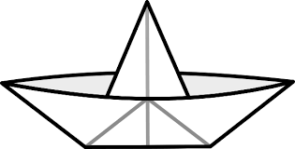 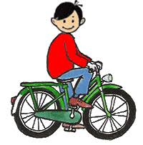 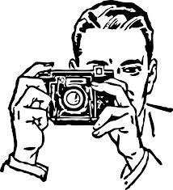 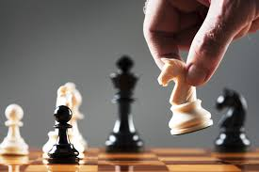 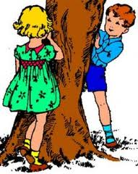

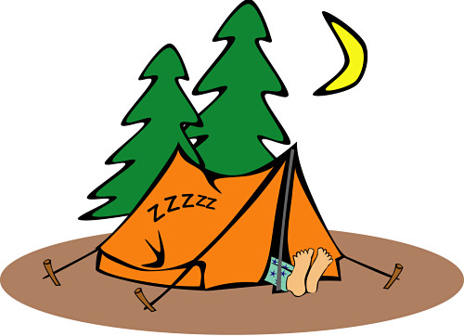

1-( ) 2-( ) 3-( ) 4-( ) 5-( ) 6-( )

**C)Koyu yazılan fiillerden doğru olanı yuvarlak içine alınız.**

1-Linda **swim – swims** in the pool. 5-We **brush – brushes** our teeth after dinner.

2-I **go – goes** to school every day. 6-Ali **do – does** his homework every morning.

3-My mother **cook – cooks** fish every week. 7-Tom and Bill **like – likes** chess.

4-The dog **sleep – sleeps** in the garden. 8-They **drink – drinks** tea at breakfast.

**D) Aşağıdaki ifadeleri doğru resmin altına yazınız.**

**Sleep – Wash hands – Get on the bus – Get off the bus – Brush teeth - Go online – Get dressed – Do homework – Comb hair – Wash face**

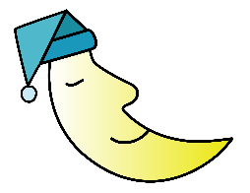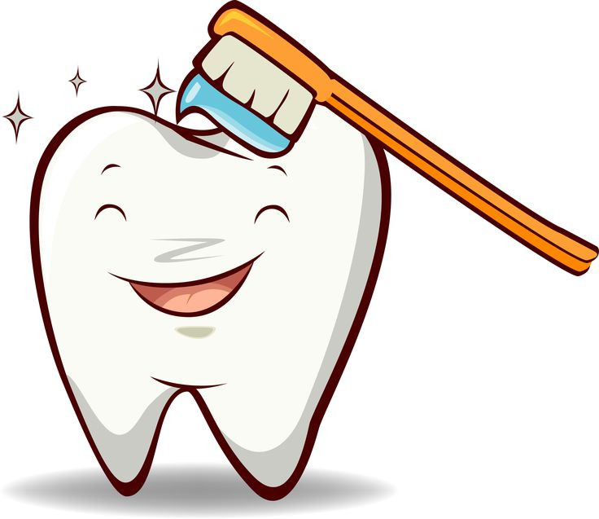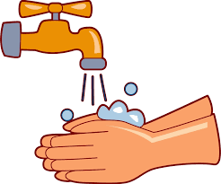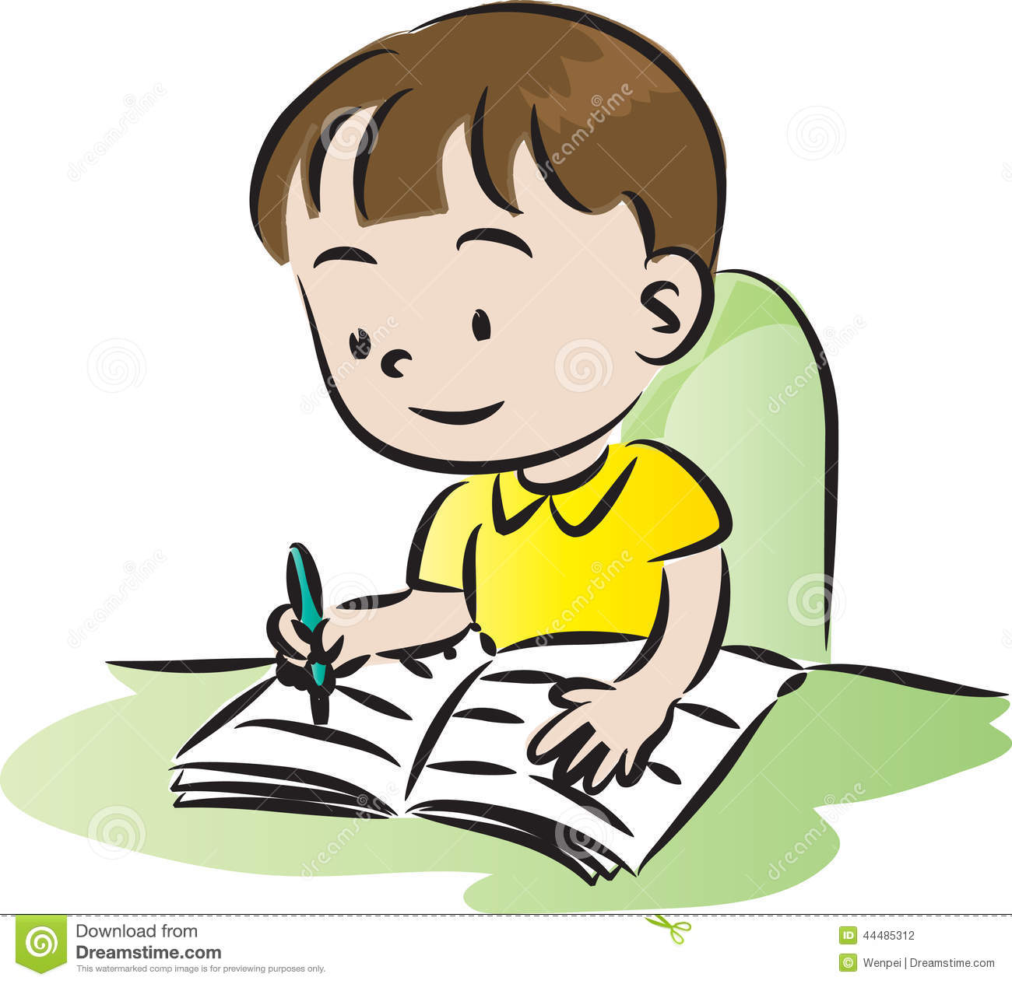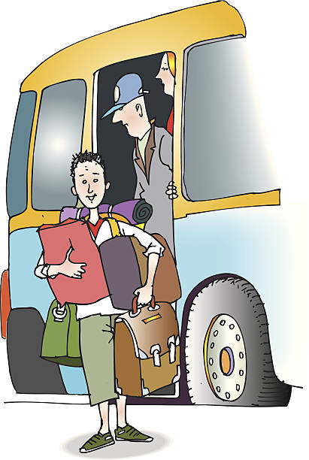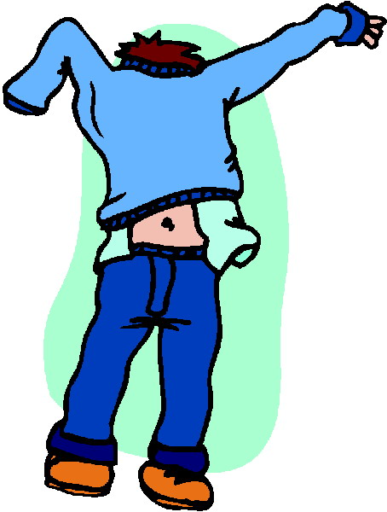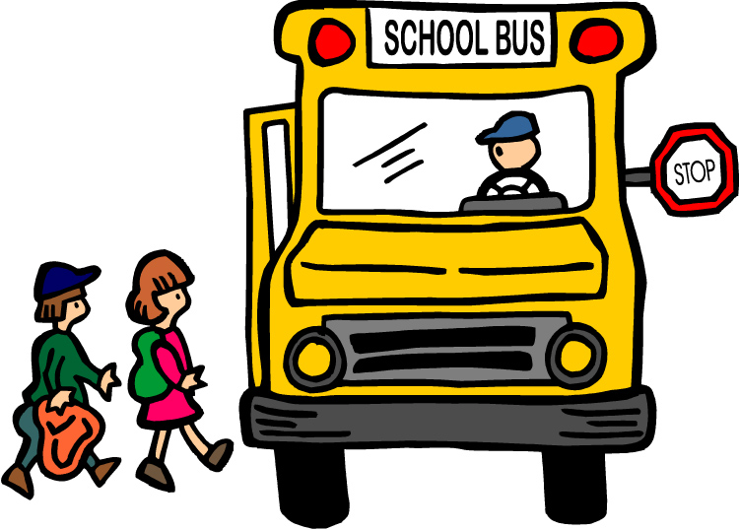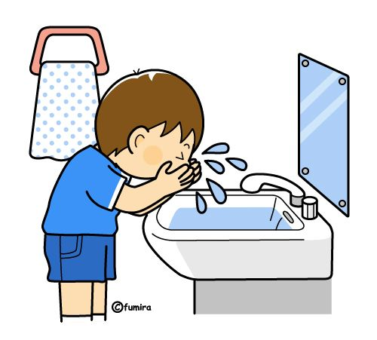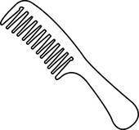

1-………………………… 2-……………………… 3-………………………….. 4-…………………………. 5-…………………………

6-…………………………. 7-………………………… 8-………………………….. 9-…………………………. 10………………………

**E) Verilen resmi inceleyip, boşluklara between – next to – opposite yazınız.**

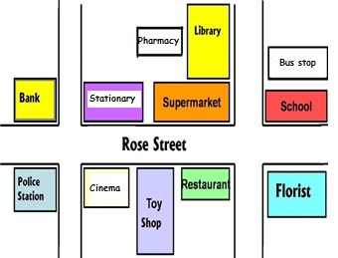

1-The school is__________the florist.

2-The toy shop is___________the cinema and

the restaurant.

3-The stationary is___________the supermarket.

**F) Aşağıdaki metni okuyup, cümlelerin yanına doğruysa T (True), yanlışsa F (False) yazınız.**

Hello! My name is Hans. I’m ten years old. I’m from Germany. I get up early. I wash my face and have breakfast. I eat cheese and egg, I drink milk at breakfast. I get on the school bus and go to school at 09:00. I have lunch at the school canteen. I arrive home at 16:00. I do my homework before dinner. I have dinner with my family. Then, I read books and watch TV. I brush my teeth and I wear my pyjamas. I go to bed at 09:30.

1-He is 10 years old._____ 5-He has lunch at home.______

2-He gets up late._____ 6-He does homework before dinner.______

3-He drinks tea at breakfast.______ 7-He eats cheese and egg at dinner.______

4-He goes to school by bus.______ 8-He reads books and watches TV after dinner._____

**G)Boşlukları verilen kelimelerden uygun olanıyla doldurunuz**.

1-You read books in the____________

2-You can buy toys at the___________

3-Doctors and nurses work at the___________

4-You can have lunch or dinner at the___________

5-You can watch movies at the___________

**H)Boşlukları uygun şekilde doldurunuz.**

Hello! I _____Aslı. I’m ______Türkiye. I ______to school. I 😊________Art, but I ☹________Science.

**BONUS:** What is your favourite color?___________________

What is your surname?________________________

English Teacher Sebnem CILINGIROGLU 