## **2017-2018 EDUCATION YEAR**

## **HAMİT ÖZDAĞ İMAM HATİP SECONDARY SCHOOL**

**5TH GRADE 1st TERM, 2nd WRITTEN ENGLISH EXAM**

**Name : __________________ Class:5/D**

**Surname: ________________ Number:_____**

**A) Kutucuk içinde verilen oyunları uygun resmin altına yazınız. 30pts**

|  |
| --- |
| **Dodge ball –Skip rope –Sculpting- Chinese Whisper –Climbing mountain-** **Checkers**  **Chess** - **Hopscotch –Camping- Fishing- Blind man’s buff – Play Tag- Puzzle - Origami –Play marbles** |

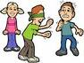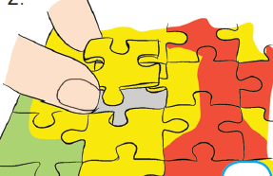[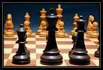](http://images.google.com.tr/imgres?imgurl=http://www3.telus.net/chessvancouver/images/chess.jpg&imgrefurl=http://www3.telus.net/chessvancouver/&usg=__ejM2Q7qFlnV62E_wmppz1aoy8mg=&h=550&w=800&sz=64&hl=tr&start=1&tbnid=XvX2roFS1d_91M:&tbnh=98&tbnw=143&prev=/images?q=CHESS&gbv=2&hl=tr) [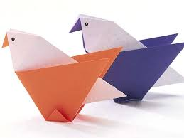](http://www.google.com.tr/imgres?sa=X&hl=tr&qscrl=1&rlz=1T4SUNC_trTR395TR395&biw=769&bih=574&tbm=isch&tbnid=COV5sq98eoSlrM:&imgrefurl=http://sanliurfabilsem.com/haberler-130-1-Origami_(Kagit_Katlama_Sanati).html&docid=OXdsTqr51MwqDM&imgurl=http://sanliurfabilsem.com/resimler/haber/orighami.jpg&w=600&h=450&ei=SQ2eUpHfEIWzywOSo4D4Cw&zoom=1&ved=1t:3588,r:13,s:0,i:137&iact=rc&page=2&tbnh=178&tbnw=238&start=8&ndsp=11&tx=72&ty=52)  

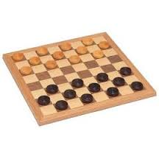 **____________ _____________ _____________ _____________ ____________**

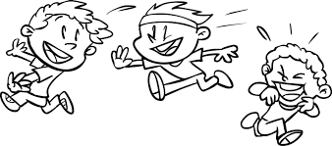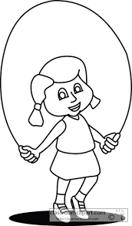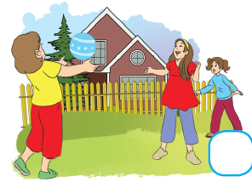

___________ ________________ _______________ _____________ _________________________

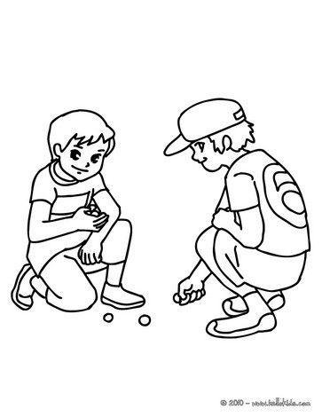

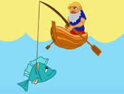 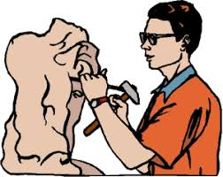 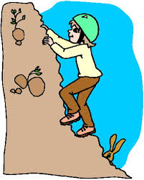 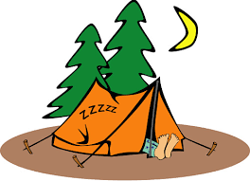

__________ _____________ ________________ ______________ ________________

**B)Yukarıdaki aktiviteleri kullanarak hangisini sevip hangisini sevmediğinizi ‘BUT’ kullanarak yazınız** .**16pts**

**1) I like __________________________but I don’t like _______________________**

2) _________________________________________________________________

3) __________________________________________________________________

4) __________________________________________________________________

C) **Match the words with the pictures. Kelimelerle resimleri eşleştir altına yaz. 24**

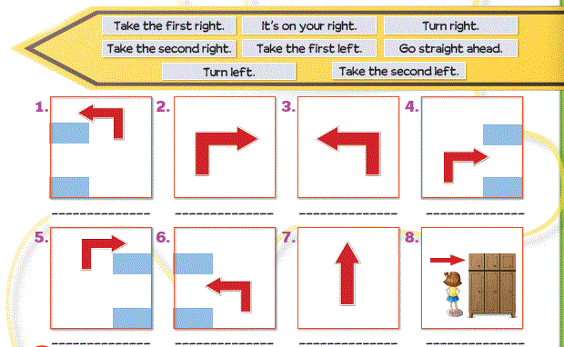



**D) Haritaya bakarak istediğiniz bir yeri seçin öncelikle oraya nasıl gideceğinizi sorun ve yol tarifi yapın tarif etmeye çarpı işareti olan yerden başlayacaksınız. Kibar bir giriş ve kibar bir kapanış olsun lütfen =)) 12pts**

|  |
| --- |
| A:____________________________________________?  B:_____________________________________________.  A: ____________________________________________.  B:_____________________________________________.  A:_____________________________________________. |

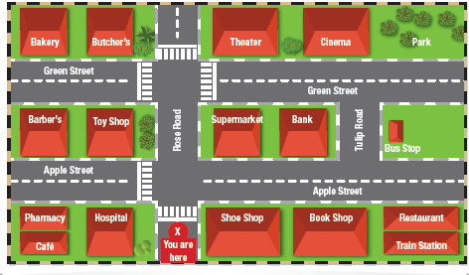

**E) Konuşmayı sırasına göre numaralandırınız.Order the conversation. 6pts**

____Yes, a supermarket.

____Thank you.

____ Excuse me, is there a supermarket near here?

____You are welcome.

____Well, go straight ahead. Turn left. It’s on your right.

____Supermarket?

**F)12pts** 