Name: Surname: Class: Number:

A. **Write the names of the games from the box below.**

(Aşağıdaki kutudan oyunların adlarını yazınız.)(5x2=10pts)

|  |
| --- |
| **Blind man’s buff - Checkers - Hopscotch**  **- Leapfrog**  **-Jigsaw Puzzle** **– Chess – Puzzle - Seesaw** |

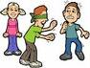**[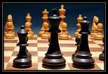](http://images.google.com.tr/imgres?imgurl=http://www3.telus.net/chessvancouver/images/chess.jpg&imgrefurl=http://www3.telus.net/chessvancouver/&usg=__ejM2Q7qFlnV62E_wmppz1aoy8mg=&h=550&w=800&sz=64&hl=tr&start=1&tbnid=XvX2roFS1d_91M:&tbnh=98&tbnw=143&prev=/images?q=CHESS&gbv=2&hl=tr)[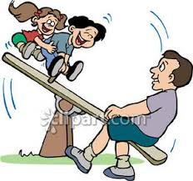](http://www.google.com.tr/imgres?hl=tr&biw=1366&bih=589&tbm=isch&tbnid=fxkoY0U3ugupRM:&imgrefurl=http://www.picturesof.net/pages/090412-001866-725042.html&docid=JHAf5E4jgmr23M&imgurl=http://www.picturesof.net/_images_300/Kids_and_Their_Dad_on_a_See_Saw_Royalty_Free_Clipart_Picture_090412-001866-725042.jpg&w=300&h=281&ei=_wyeUpmyMqGTywOGg4GIDg&zoom=1&ved=1t:3588,r:15,s:0,i:122&iact=rc&page=2&tbnh=176&tbnw=188&start=9&ndsp=9&tx=79&ty=53)**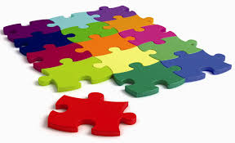

............................... ............................... ............................. .............................. ................................

B. Circle the correct one from the underlined words.

(Altı çizili sözcüklerden doğru olanı yuvarlak içine alınız.) (10x2=20pts)

1- I **like / likes** playing hopscotch. 2- My mother **like / likes** eating fish.

3- A bird **can / can’t** fly. 4- He **doesn’t / don’t** like going to school.

5- Justin Bieber is from **the U.S.A / American**. 6- A dog **can / can’t** speak English.

7- Ceren and Melisa **like / likes** doing homework 8- My teacher doesn’t **like / likes** milk.

9- They **don’t / doesn’t** like playing marbles. 10- Paris is the capital city of **France / England**

C. Match the school lessons with the pictures.(Derslerle resimleri eşleştiriniz.)5x2=10pts

|  |
| --- |
| **Science – Computer – Maths – Turkish - Visual Arts – Physical Education – Social Sciences - English** |

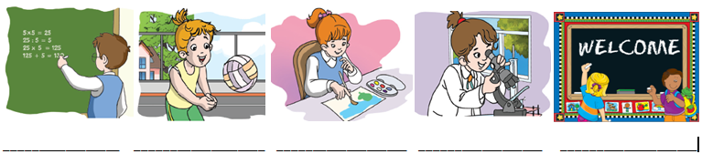

D. Answer the questions. (Soruları cevaplayınız.) 5x4=20 pts.

1- What is your nationality ? .................................................................................

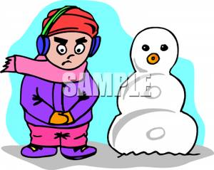2- Can you play “Hide and Seek” ? Yes / No, ................................................................

3- Where is Bahadır ? . ..................................................... the snowman.

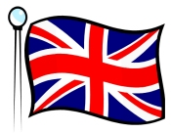

[](http://www.google.com.tr/url?sa=i&rct=j&q=&esrc=s&frm=1&source=images&cd=&cad=rja&docid=S1ekOoncqUnO-M&tbnid=6vB3vp3bgomDHM:&ved=0CAUQjRw&url=http://www.frequencycast.co.uk/pc_or_mac.html&ei=YcygUoWOFMTD0QW1p4HADQ&bvm=bv.57155469,d.ZGU&psig=AFQjCNGGFc0ujhShXt7aO76vn_LqJGB0iQ&ust=1386356170090726)4- Where are you from ? ........................................................................

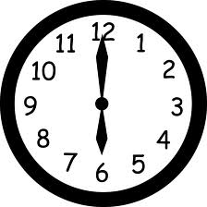5- What time is it ? ........................................................................