2017-2018 EDUCATIONAL YEAR SANCAKTAR IMAMHATIP MIDDLE SCHOOL
THE 1ST TERM THE 2ND EXAM FOR GRADE 6
NAME/SURNAME: NUMBER: CLASS:
A)RESİMLERLE KELİMELERİ EŞLEŞTİRİNİZ. (6x1 = 6PTS)
* sausages *bagel *croissants *cucumber *muffin *cheese

__________ ____________ ___________ __________ ___________ _____________
B) Match the places with the definitions. (Eşleştirerek harfleri rakamların yanına yazınız) (8x2=16pts)
- You wait for a bus here.
- You can see different animals.
- You put money here.
- You can read books there.
- Doctors and nurses take care of ill people here.
- You can buy stamps, send your letter here.
- You can have lunch or dinner here.
- You can watch movies here.
- Bank_______
- Cinema________
- Post Office_____
- Zoo________
- Bus Stop_______
- Restaurant_____
- Library_______
- Hospital_______

C)Resimlerle hava durumlarını eşleştiriniz.(5*2=10P)
a)foggy b)cloudy c)hot d)sunny e)stormy f)snowy g)windy h)rainy

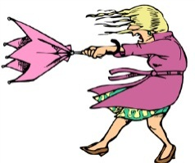
1)……………. 2)……………….. 3)………………… 4)………………….. 5)……………………

D) Ayları mevsimlere göre yazınız.(12*1=12P)
December - July - August - January - April - October - May - February - November - March - June - September
1)Summer
_____________
_____________
_____________

2)Autumn
_____________
_____________
_____________

3)Winter
_____________
_____________
_____________

4)Spring
_____________
_____________
_____________

E)RESİMLERİN ALTINA DUYGU İFADELERİNİ YAZINIZ.(6*2=12P)
A. SCARED B. HUNGRY C. UPSET D. SLEEPY E. HAPPY F. ANXIOUS
F) Make comparisons. Karşılaştırmalar yapınız. ( 4x2:8 pts)
*Ferrari is _________________________Fiat. (expensive)
*Russia is __________________________ Spain.. (big)
*An apple is _________________________ a hamburger. (healthy)
*İzmir is ______________________________ Kütahya .( beautiful)
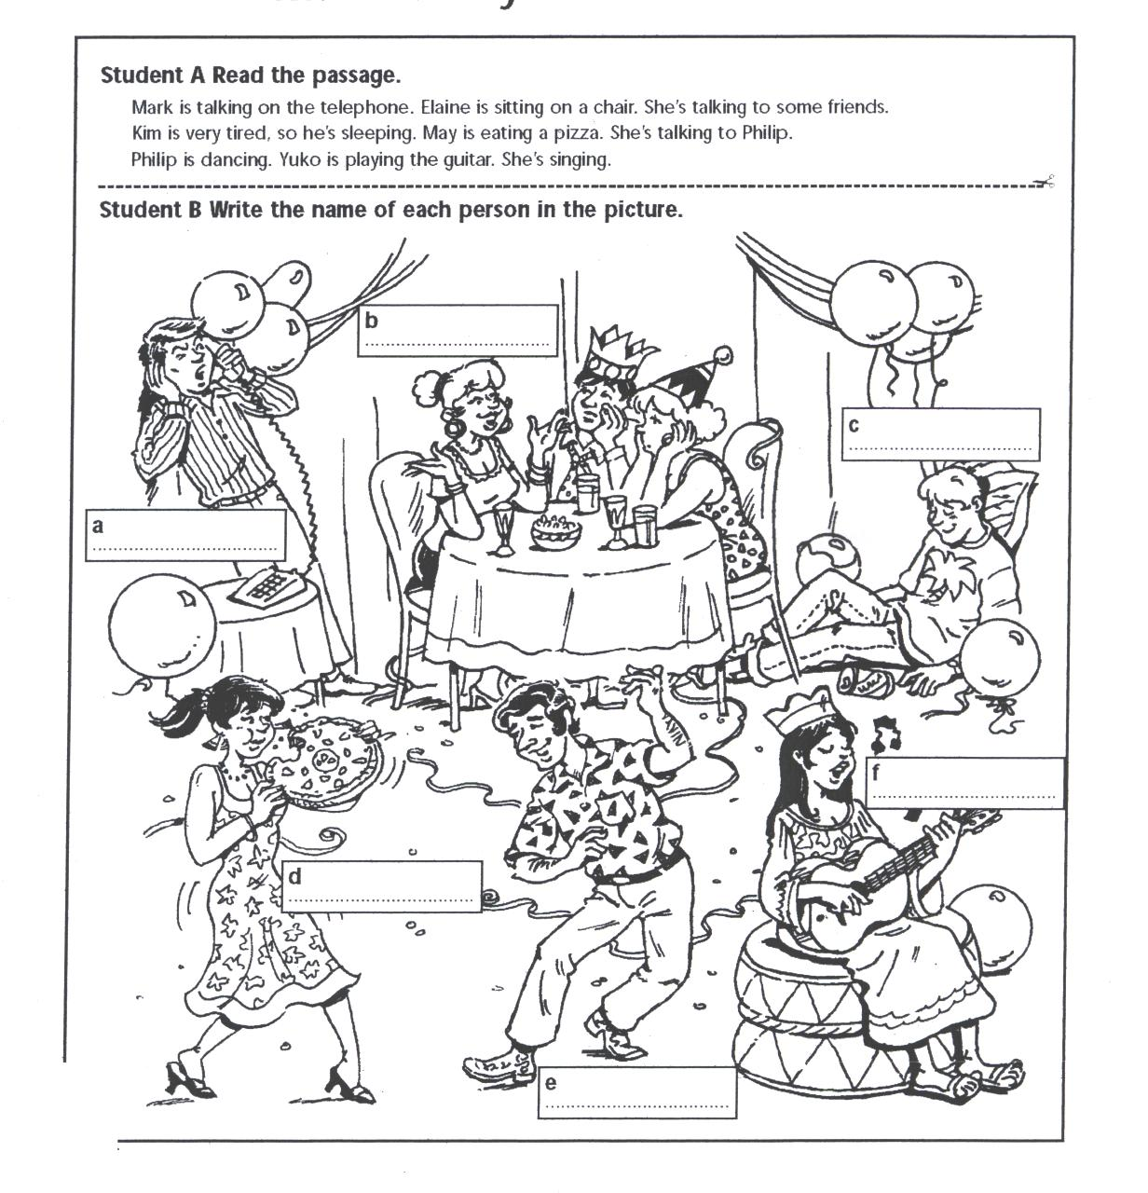
G) PARAGRAFI OKUYARAK RESİMDEKİ KİŞİLERİN İSİMLERİNİ YAZINIZ. (6x1=6pts)
Mark is talking on the phone. Elaine is sitting on a chair. She’s talking to some friends. Kim is very tired, so he’s sleeping. Mary is eating a pizza. She’s talking to Philip. Philip is dancing. Carol is playing the guitar.

H)Aşağıdaki saatleri yazınız.(4*2=8P)
02:15=_____________________________________________ 18:30=____________________________________
21:00=_____________________________________________ 04:45=____________________________________

- Match the pictures with the words. (6x2=12)
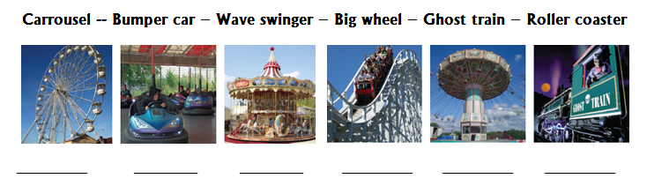

J)AŞAĞIDAKİ SORULARI METNE GÖRE CEVAPLAYINIZ.(2*5=10P)
Hi! I’m Judy. My family and I live in a country but today we are downtown(Şehir merkezi). There are many people around. They are in a hurry. My little sister, Sally and I are in the playground. Sally is sliding. I’m feeding the street cats. Mom is in the shopping centre. She is buying some new clothes for herself. What’s my elder brother, Ted doing? Poor Ted! He is waiting in a line to get theatre tickets. Dad is drinking coffee with Uncle Martin.
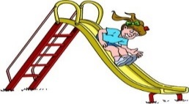
1) Konuşmada aşağıdaki görsellerin hangisinden bahsedilmemiştir?
a) |  | b)
c) |  | 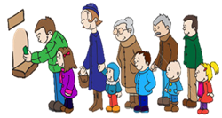  d)

2) Hangi seçenekte Judy ile ilgili yanlış bilgi verilmiştir?
a) Judy has got a sister and a brother.
b) Judy lives in a country.
c) She is feeding the street cats in the playground.
d) Judy is waiting in a line to get theatre tickets.

