Name: Surname: Class: Number:

A. **Match the quantifiers with food and drinks.**

**(**Miktar ifadeleriyle yiyecek içecek ifadelerini eşleştiriniz**) (5 x 2= 10 pts.)**

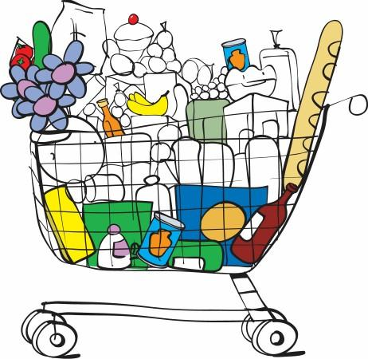 **1.** a can of (...............) **a.** Chocolate

**2.**a bottle of (...............) **b.** Coffee

**3.**a bar of (...............) **c.** Bread

**4.**a cup of (...............) **d.** Coke

**5.**a loaf of (...............) **f.** Milk

B. Circle the correct one from the underlined words.

(Altı çizili sözcüklerden doğru olanı yuvarlak içine alınız.) **(10 x 2= 20pts)**

1- He **wash/ washes**  his face every morning. 2- My mother **like / likes** eating fish.

3- **Do / Does** you make your bed ? 4- They **doesn’t / don’t** like going to school.

5- **Do / Does** Justin Bieber sing very well? 6- There **is /are** 28 students in 6-İ Class.

7- Öznur and Pınar **cooks /cook** soup and chicken 8- Our teacher doesn’t **speaks / speak** English

9- We **doesn’t / don’t** like doing homework. 10- **Are / Is** there any jam on the table ?

C. **Answer the questions**. (Soruları resimlere göre cevaplayınız.) **(5 x 3=15 pts)**

**never**

**usually**

**sometimes**

**always**

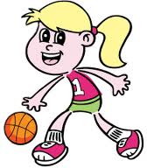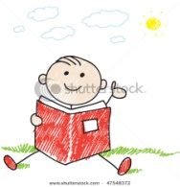

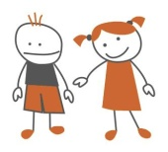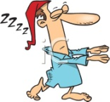

Mary&Tom Ece Mert Ulvi

1.How often does Ece play basketball? __________________________________________________

2.How often does Mert watch TV?_____________________________________________________

3.How often do Mary and Tom play game?_______________________________________________

4.How often does Ulvi sleep?__________________________________________________________

5.How often do you have breakfast?_____________________________________________________

D. Fill in the blanks with the words from the box . (Boşlukları doldurunuz.) **5 x 2=10 pts.**

|  |
| --- |
| on **In front of - Between - Behind**  **- In**  **- On**  **– Under – Opposite – Next to – Over** |



1- The rabbit is .................... the table. 2-The ball is ................. the packet.

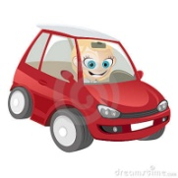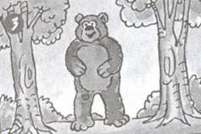

3-The bear is .........................two trees. 4- Şura is .................... her car.

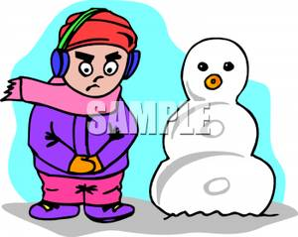

5- Özgür is ..................... the snowman.