Name: Mark:
Surname:
Class: 6/.....
Number:

ERTUĞRUL GAZİ SECONDARY SCHOOL
2017-2018 EDUCATION YEAR
1ST TERM 2ND ENGLISH EXAM FOR 6TH GRADES

A) Read the text and write TRUE or FALSE .(5x2=10 points)
Hi! My name is Lilly. I am a 6th grade student. My family and I live in a house with garden in Bibury,England. It is a small town. It is a quiet and lovely place. Today is Sunday and everybody is at home. Everybody is doing something different now. My father, Tom is reading newspaper. My mother, Sally is washing the dishes. My sister, Mary is listening to music. My little sister, Jane is sleeping on her bed and I am doing my homework now.

________ 1.Her father is reading a book now.
________ 2. Lilly’s family live in a house with garden.
________ 3. Mary is sleeping on her bed now.

______ 4. Lilly is doing her homework now.
______ 5. Lilly’s mother is washing the dishes now.

B) Fill in the blanks according to ‘Present Continuous Tense’(Boşlukları ‘Şimdiki Zaman’a ‘göre doldurunuz).( 5x2=10 points)
1. Aslı _________________________________ dinner. (prepare).
2.They ________________________________ at school (not run).
3.We ________________________________ Turkish Pilaf (eat).
4. __________they______________________ a cake? (make)
5. We _________________________ the shopping for the guests. ( not do )
C) Match the places with the definitions. ( 8x2=16 points)
- You wait for a bus here.
- They sell clothes in this shop.
- You put money here.
- You can buy medicine here.
- Doctors and nurses take care of ill people here.
- You can buy stamps or send your letter here.
- You can have lunch or dinner here.
- You can watch movies and eat popcorn here.
- Bank
- Cinema
- Post Office
- Boutique
- Bus Stop
- Restaurant
- Pharmacy
- Hospital

1- _____ 2-_____ 3-_____ 4-_____ 5-_____ 6-______ 7-_____ 8-_____

D) Make comparisons. Karşılaştırmalar yapınız. ( 5x2=10 points)

- Ferrari is ______________________________________(expensive) Fiat.

- Russia is _____________________________________ (big) Spain.

- Summer is _____________________________________(hot) Winter.

- My grades are __________________________________(good) Beyza’s marks.

- An apple is ____________________________________(healthy) a hamburger.
.

- 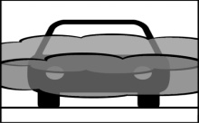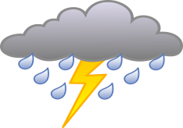Aşağıdaki haritada verilen şehir isimlerini uygun cümledeki boşluklara yazınız.(7x2=14 points)
Sinop 12°C

İstanbul 5°C

Van -7°C
İzmir 7°C
Ankara 8°C

Diyarbakır 4°C
Antalya 20°C

1.The weather is sunny in ………………………
2.It is snowy in ……………………………….. .
3.It is stormy in ………………………………. .

4.It is rainy in …………………………………….. .
5.It is foggy in …………………………………….. .
6.It is windy in …………………………………….. .
7.The weather is cloudy in ………………………… .

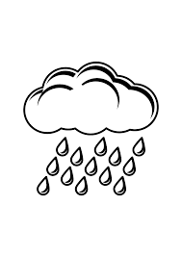
- Answer the questions (6x3=12 points)
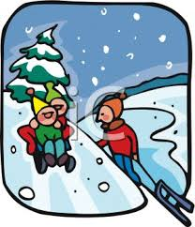

1)LONDON 10 2)MOSCOW -12 3)İSTANBUL 25 4) PARİS 17 5)MADRID 5

1)What is the weather in Moscow? | 2) How is the weather in London?
3)What is the weather in Paris? | 4) What is the weather in İstanbul?
5)How is the weather in Madrid? | 6) What is the temperature in London?

- Read and choose the right option. (Parçayı okuyun ve doğru seçeneği işaretleyin.)6x3=18 points

Hi, friends! I’m Clara. I like cold weather. My favourite season is winter. I feel energetic and happy in winter. I usually go skiing. I like playing snowball with my friends and making a snowman.But I don’t like hot weather. I feel moody and tired in summer.

1. Does Clara like hot weather? a) Yes, she does. b) No, she doesn’t.
2. What is her favourite season? a) Winter. b) Summer.
3. How does she feel in winter? a) She feels moody and tired. b) She feels energetic and happy.
4. Where does she usually go in winter? a) She goes skiing. b) She goes swimming.
5. Does she like making a snowman? a) Yes, she does. b) No, she doesn’t.
6. How does she feel in summer? a) She feels energetic and happy. b) She feels moody and tired.

- Choose the right activity (Doğru eylemi yuvarlak içine alın) 5x2=10 points
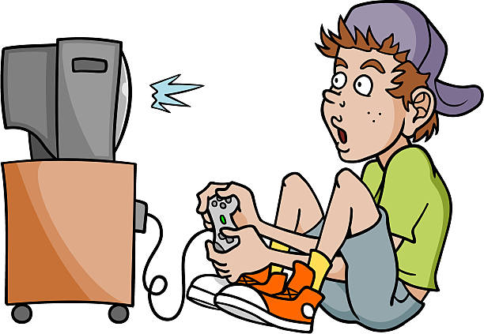

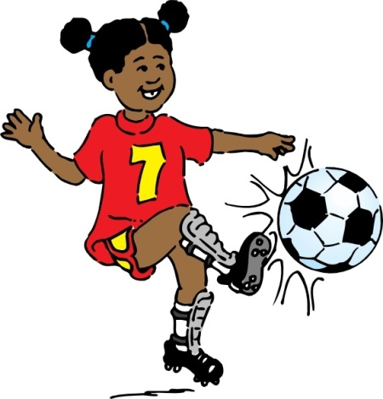
GOOD LUCK
ERTUĞRUL GAZİ ELT TEAM
BONUS ( 5 Points )
Answer the question:
How do you feel in snowy weather? Why?
________________________________
She is playing basketball / playing soccer.
He is washing the dishes / having a shower.
He is playing video games / watching TV.
She is having breakfast / helping her Mum.
She is doing karate / doing homework.

