**NAME SURNAME: NUMBER: CLASS: 6 / ___**

**2017 – 2018 EDUCATION YEAR HAMIT OZDAG SECONDARY SCHOOL 1ST TERM 2ND WRITTEN ENGLISH EXAM FOR 6TH CLASSES**

1. **Match the places with the definitions. (Eşleştirerek harfleri rakamların yanına yazınız)(8x3=24pts)**
2. You wait for a bus here.
3. You can see different animals.
4. You put money here.
5. You can read books there.
6. Doctors and nurses take care of ill people here.
7. You can buy stamps, send your letter here.
8. You can have lunch or dinner here.
9. You can watch movies here.
10. Bank
11. Cinema
12. Post Office
13. Zoo
14. Bus Stop
15. Restaurant
16. Library
17. Hospital

**1- _____ 2-_____ 3-_____ 4-_____ 5-_____ 6-______ 7-_____ 8-_____**

1. **Circle the correct choice (Doğru olanı yuvarlak içine alınız). (5x3=15 pts)**

**1.** I haven’t got **some /any** pizza**.**



**2.** There is **some /any** cheese on the table.

**3.** She hasn’t got **some /any** fruit.

**4.** Have you got **some /any** cakes?

**5.** Would you like**some /any** bananas?

1. **Match the pictures with the speech bubbles (Eşleştirin ve resimlerin altına isimleri yazınız)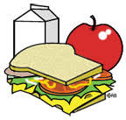 (5x4=20pts)**

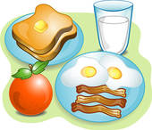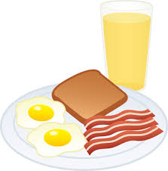

(____________) (____________) (_____________) (_____________) (_____________)



Hi! My name is **Onur**. I like eating eggs, sausages and toast at breakfast. My favourite drink is orange juice.

Hello! I’m **Sedat.** I always eat toast, eggs, sausages and an apple at breakfast. I drink a glass of milk every morning.



Hello! I’m **Yeşim**. My favourite food is pancake at breakfastand I like tea. I don’t drink milk or orange juice at breakfast.



Hello! My name is **Anıl.** I loveeatingcerealwithmilk at breakfast. I don’tlikecheese, olivesortomatoes at breakfast.



Hi! I’m **Emel**. I eat an apple and toast at breakfast. I don’t like tea or coffee. I like milk.

***D) FILL IN THE BLANKS WITH THE COMPARATIVE DEGREE OF ADJECTIVES. 12pts***

1. Cengiz is __________________________( tall) than Mustafa.
2. Said is _______________________( young) than Aziz Teacher.
3. The life in a city is _____________________(healthy) than the life in a country.
4. Ömer is ________________________(hansome) than Bekir.
5. The skyscrapers in a city are _______________(high) than houses in a country.
6. The life in a city is __________________( enjoyable) than the life in a village.

**E) Write ‘what are they doing’?8pts**

**Brush teeth –Play soccer –Wait in a line –Drive a car**

**What is Uğur doing? __________________ 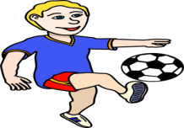What is Halil doing?____________________**

**What is Cem doing?__________________What are they doing?_________________**

**F)Choose the correct answer (7x3=21pts)**

1. **Antony: ___________________ ? Bertha: Bread,eggs,olives and cheese. a)** What time do you get up?  **b)** Who is your teacher? **c)** What do you have breakfast? **d)** Where do you go?
2. **Ahmet doesn’t like hamburger. He ___ eats hamburger .**

**a)** always **b)** often **c)** never **d)** usually

**3. Clara: Can I have some more cheese, please?**

**Sophie: I am sorry, ………………….**

**a)**It’s all gone. **b)**Yummy!

**c)**Enjoy your meal **d)**I am full

**4. Görseli ifade eden seçeneği işaretleyiniz.**

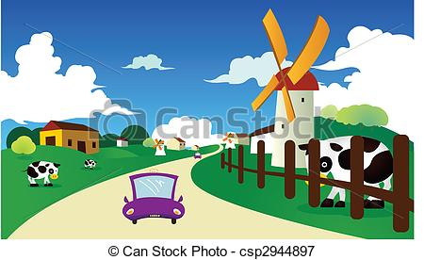

|  |  |  |  |
| --- | --- | --- | --- |
| **a)**downtown | **b)**city | **c)**country | **d)**shopping center |

**5. There ___ some sugar in the cupboard.**

**a)** is **b)** isn’t **c)** are **d)** aren’t

**6. Olivia: Buon appetite! Marsha: ________ Olivia: It means enjoy your meal in Italian.**

**a)**It’s all gone. **b)**Yummy!

**c)**Excuse me.  **d)**I am full.

**7. I don’t like ____. It’s not useful for you health.**

**a)**fruit  **b)**junk food

**c)**milk  **d)**honey

**BurcuErci &ELT**