NAME SURNAME: NUMBER: CLASS: 6 / ___
2017 – 2018 EDUCATION YEAR MEHMET İPGİN SECONDARY SCHOOL 1ST TERM 2ND WRITTEN ENGLISH EXAM FOR 6TH CLASSES
- Eşleştirerek harfleri rakamların yanına yazınız. (8x2=16p.)
- You wait for a bus here.
- You can see different animals.
- You put money here.
- You can read books there.
- Doctors and nurses take care of ill people here.
- You can buy stamps, send your letter here.
- You can have lunch or dinner here.
- You can watch movies here.
- Bank
- Cinema
- Post Office
- Zoo
- Bus Stop
- Restaurant
- Library
- Hospital

1- _____ 2-_____ 3-_____ 4-_____ 5-_____ 6-______ 7-_____ 8-_____

B:Parçaya göre cümleleri “True”(Doğru) veya “False”(Yanlış) olarak değerlendirin.(6x2=12p.)
George:Hi,David.How are you?
David:Hi,not bad,and you?Are OK. in New York?
George:Yes,I’m happy.I love living in big city.I think living big cities are more enjoyable than small towns.
David:I don’t agree with you.Big cities are more crowded and I don’t like living in crowded cities.
George:David,please come and stay with me for a week.Then you see New York is more beautiful than your town.
David:Oh,no thanks.People in my town are happier than people in New York.The life in my town is easier and
cheaper than the life in New York.
1.George lives in the town.( )
2.George thinks living in big cities are more enjoyable.( )
3.David likes crowded cities.( )
4.George invites David to New York.( )
5.David thinks people in town are happier than people in big cities.( )
6.George thinks the life in town is easier and cheaper than the life in New York.( )
C.Doğru olanı yuvarlak içine alın.(4x3=12p.)
1.Buildings in a city are higher/smaller than buildings in a town.
2.The weather in a city is dirtier/cleaner than a country.
3.The life in a country is easier/more difficult than the life in a city.
4.The life in a country is more unhealthy/healthier than the life in a city.
D.Hava durumlarını resimlerin altına yazın.( 8x2=16p. )
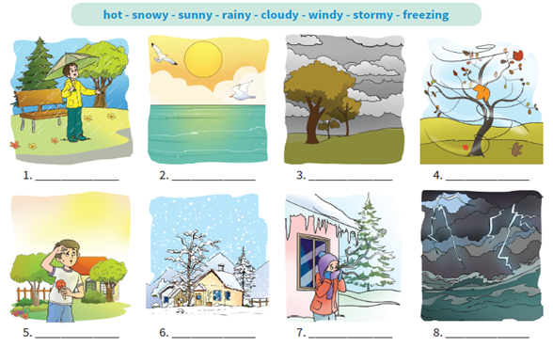
Snowy Windy Sunny Hot Cloudy Rainy Freezing Stormy

E. Resimlerin altlarına bineklerin isimlerini yazınız (5x2=10 p.)
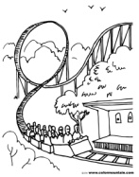  Bumper cars | Carousel | Roller coaster | Chairoplane | 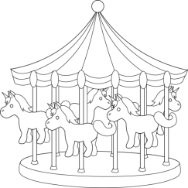  Ghost train
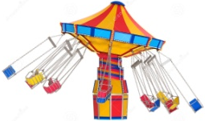
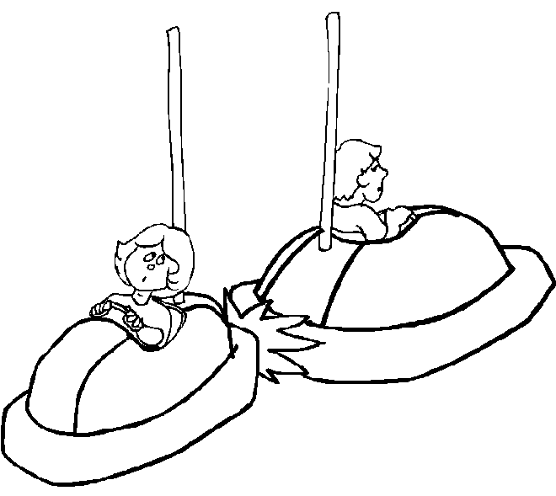
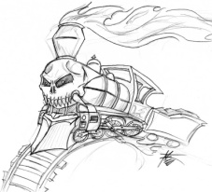
1) 2) 3) 4) 5)

............. ............. ............. ............. ............
F.Sorularla yanıtları eşleştirin.(7x2=14p.)
1.What is the weather like in London today?( ) a.Roller coaster is my favourite ride.
2.What is the temperature?( ) b.It is rainy.
3.How do you feel in stormy days?( ) c.I feel anxsious.
4.What do you need in London in spring?( ) d.No,they can’t.
5.Do you like carousel?( ) e.It’s 16 C.
6.What is your favourite ride in a fair?( ) f.A raincoat and an umbrella.
7.Can people over 9 get on roller coaster?( ) g.No,I don’t.I think it is boring.
G.Verilen kelimelerin anlamlarını bulun.(5x2=10p.)
1.”storm” means a.bad weather with strong wind and heavy rain. b.a lot of rain.
2.”pleasant” means a.too high temperature. b.not too high temperature.
3.”chilly” means a.a lot of snow. b.very cold.
4.”spring shower” means a.to rain heavily in spring. b.a short period of rain in spring.
5.”shine” means a.to give out bright light. b.to fire. G O O D L U C K !

