2017-2018 EDUCATION YEAR ......... MIDDLE SCHOOL THE 1ST TERM 2ND ENGLISH EXAM FOR THE 6TH GRADERS
Name&Surname: Class: Number:
A) Circle the correct answers.(Aşağıdaki soruların doğru seçeneklerini işaretleyiniz.)(3x12=36 pts)

1. It’s raining heavily. I need to wear my .....
a) raincoat b) umbrella
c) hat d) boots
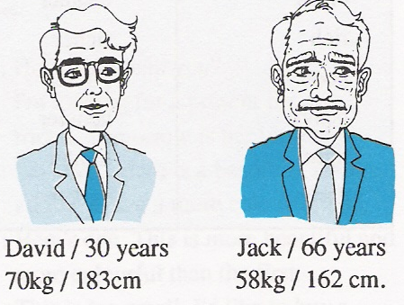
2) Doğru seçeneği işaretleyiniz.

a) David is older than Jack.
b) Jack is taller than David.
c) Jack is younger than David.
d) David is heavier than Jack.
3. I have ………….. at breakfast.
a) cheese b) croissants
c) muffin d) bread

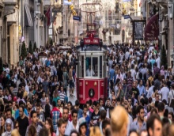

4. Cities are ........... than countries.
a) smaller than b) more crowded than
c) faster than d) older than
5. What’s he doing?
a) He’s having breakfast.
b) He’s going to school.
c) He’s reading a book.
d) He’s singing.
I need to buy some medicine. I can go to the .......
6.

a) post office
b) pharmacy
c) school
d) hospital

7. A: What time do you usually have lunch?
B: ................... .
a) At 12.20.
b) At school canteen.
c) Cheese and olives.
d) Yes, of course.

8 ve 9. Soruları parçaya göre cevaplayınız.
Hi. My name is Linda. I always get up at 7 on weekdays. I have breakfast and go to my school. After school, I have a snack and do my homework. I go to folk dance course on Saturdays and I go to the park with my friends on Sunday.

8. Linda .............. on weekdays.
a) takes guitar course
b) goes to the park
c) gets up at seven
d) watches television in the evening

9. Does she have a snack after school?
a) Yes, she does.
b) She has breakfast.
c) No, she doesn’t.
d) No, she does her homework.

10. Ahmet often has dinner at ........... .
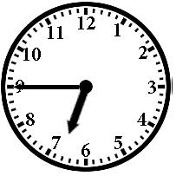
a) quarter past seven
b) fifteen to eight
c) quarter to six
d) quarter to seven

11. “I like sunny weather. I go out and play football with my friends. I feel .......... on sunny days.”
a) anxious b) scared c) sleepy d) happy

12. Aysun: .........................?
Mehmet: It’s rainy and windy.
a) What’s the weather like? b) How do you feel?
c) When is it rainy? d) Is it cold?

B- Look at the pictures and write their names. (Resimlere bakarak isimlerini yazınız)(5x3=15 pts)

Bumper cars | Umbrella | Roller coaster | Boots | Ghost train
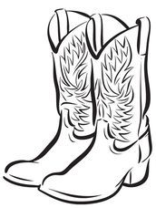
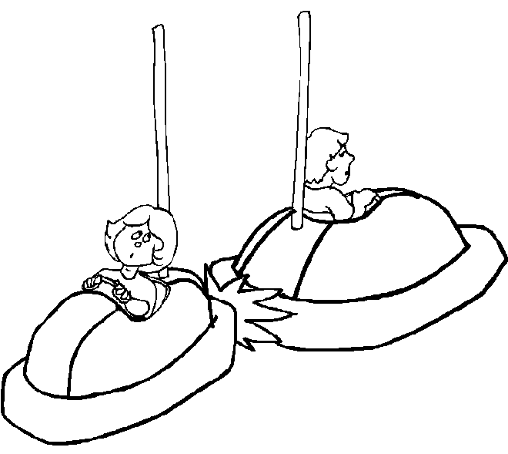
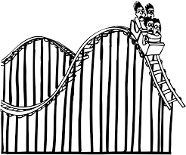
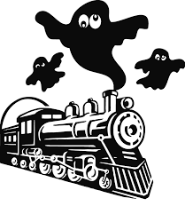
1) 2) 3) 4) 5)

............. ............. ............. ............. ............
C- Match the pictures and the words.(6x3=18)
Cloudy | Rainy | Chilly | Windy | Snowy | Sunny
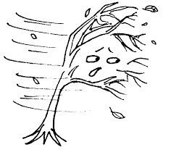
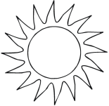
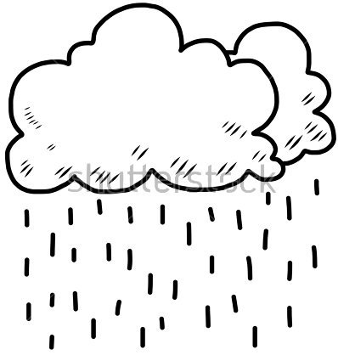
.............. ............ ............ .............. ................ .............
D- Look at the pictures and write the moods. (5x3=15 pts)

Bored | Upset | Scared | Sleepy | Happy

…................... …............... …................ …................ …................
E) Tablolara bakarak soruları yazınız. 3x3=6 pts
Dörtyol
14 ºC
Ağrı
-9 ºC

1-.....................................................................? 2-............................................................?
It’s rainy in Dörtyol. It’s minus nine degrees Celsius.
Winter | Spring | ................ | Autumn
December | March | June | .....................
.................... | April | July | October
February | ................ | ...................... | November
F) Boşlukları doldurunuz.5x2=10 pts.

Good Luck
.........
ELT

