E. Fill in the blanks according to the “Simple Past Tense” (Boşlukları “Geçmiş Zaman”a göre doldurunuz.) 5×3= 15 p.
1.) Mr. Jakob .................... (buy)
a new car yesterday.

2.) My students ....................... (study)
for English exam last weekend.

3.) I .................. (see) a rabbit in the garden.

4.) Arda Turan ........................ (encourage)
a lot of Turkish boys to play football.
5.) 5 years ago, I ................... (am)
a soldier in Cyprus.
°°°°°°°°°°°°°°°°°°°°°°°°°°°°°°°°°°
F. Choose the best option.
(Doğru seçeneği işaretleyiniz.) 10 × 2=20 p.

1. A: ........ your father like sleeping?
B: Yes, he ............ sleeping.
a) Is / is c) Does / likes
b) Do / like d) Do / likes
-----------------------------------------------------
2. My sister likes watching TV very much.
I think she is a .......................................
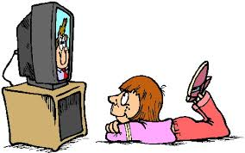
a) couch potato
b) shy
c) lawyer
d) bookworm
-----------------------------------------------------
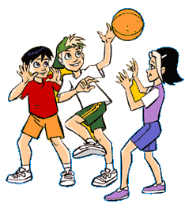
3. Yesterday, I .................... my homework quickly and went out with my friends.

a) opened b) finished
c) cried d) wanted
-----------------------------------------------------
4. An ................... can run faster
than a ...........................
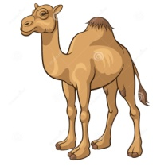
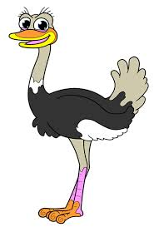
a) whale / monkey
b) snail / giraffe
c) turtle / horse
d) ostrich / camel
5. curly / She / ginger / has got / hair / long
Yukarıdaki kelimelerden anlamlı bir cümle oluşturunuz.
a) She has got curly, long, ginger hair
b) She has got long, curly, ginger hair
c) She has got ginger, long, curly hair
d) She has got curly, long, hair ginger
-----------------------------------------------------
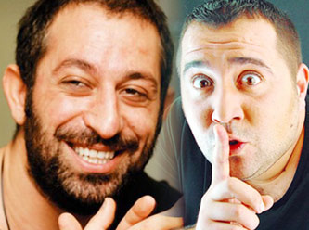
6. Cem Yılmaz and Ata Demirer are famous Turkish comedians. We ........................ them very much.
a) laugh at c) teach
b) send d) break
-----------------------------------------------------
7. My sister ........... up very late,
but I ...........
a) gets / doesn’t
b) get / don’t
c) gets / don’t
d) get / doesn’t
-----------------------------------------------------
A: What is your ..................?
B: I am an English Teacher.
8.

a) classmate b) art
c) occupation d) moustache
-----------------------------------------------------
9. He-man is a ................ cartoon character.
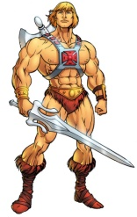
He’s very strong and brave.

a) well-built b) clumsy
c) forgetful d) selfish
-----------------------------------------------------
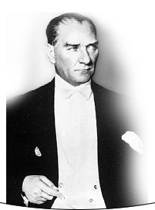
10. At the age of 57, Atatürk ................... in Dolmabahçe Palace on November 10, 1938.
a) worked b) died
c) enjoyed d) was born
-----------------------------------------------------
Duration: 40 mins.

